 

**MIDDLE SCHOOL**

**Green Chemistry**

***The Story of Cosmetics***

**Video Assessment**

**Teacher Background Information:** *The Story of Cosmetics* is a video produced by The Story of Stuff Project (<http://www.storyofstuff.com/>) and created by Stacy Malkan and Annie Leonard. This controversial video highlights how cosmetics are made and regulated. The goal of this lesson is to introduce students to these concepts and inspire them to become educated consumers.

**Goal:** To allow students to use critical thinking skills to analyze *The Story of Cosmetics* video

**Student Objectives:** Students will…

* Identify fact and opinion
* Investigate personal bias and bias in the video
* Be introduced to regulations and how they apply to the cosmetics industry
* Understand their role and responsibilities as a consumer

**Materials:**

* Access to internet
* Computer and LCD projector
* Copies of Fact & Opinion Organizer
* Copies of Bias Organizer

**Time required:** 45–60 minute class period

**Standards Met:**

* Science as inquiry: Abilities necessary to do scientific inquiry
* History and nature of science: Science as a human endeavor

**Green Chemistry Principles Addressed:**

* Chemical products should be designed to preserve efficacy of function while reducing toxicity.

**Procedure:**

IN CLASS

* Explain to the students that they will be watching a video about cosmetics called The Story of Cosmetics
* Give each student a fact & opinion organizer
  + Review the terms fact and opinion
  + Give examples of both
* Show video by accessing the website: <http://storyofstuff.org/cosmetics/>
* Ask students to share their facts and opinions from the video
  + Make a list on the board
* Ask students if there are any items in the wrong category and move things accordingly
* Give students the Bias Organizer
  + Review the directions
  + Explain the definition of bias
  + Give examples of bias
* Allow time for students to complete the sheet
* Ask students to share their answers
* Make a list of their action suggestions on the board
  + Ask how many students are currently doing each one
  + Discuss benefits and obstacles to each
* Encourage students to do one action item!

**Assessment:**

* Completed fact & opinion organizer
* Completed bias organizer
* Completed action items
* Participation in class discussions

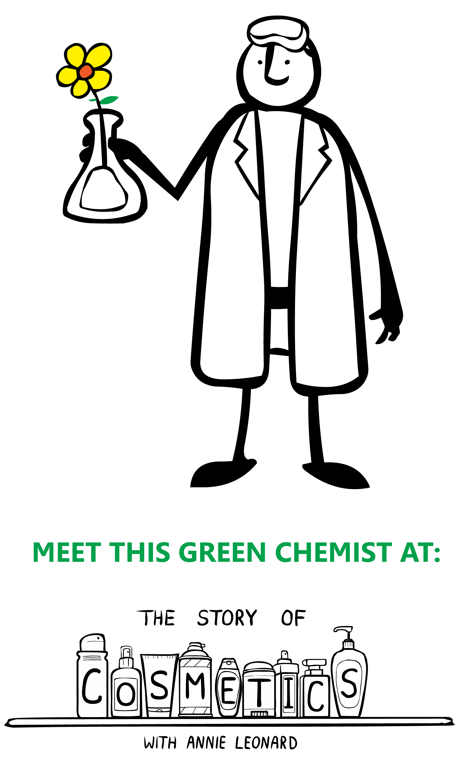***The Story of Cosmetics* Video Assessment:**

**Fact & Opinion Organizer**

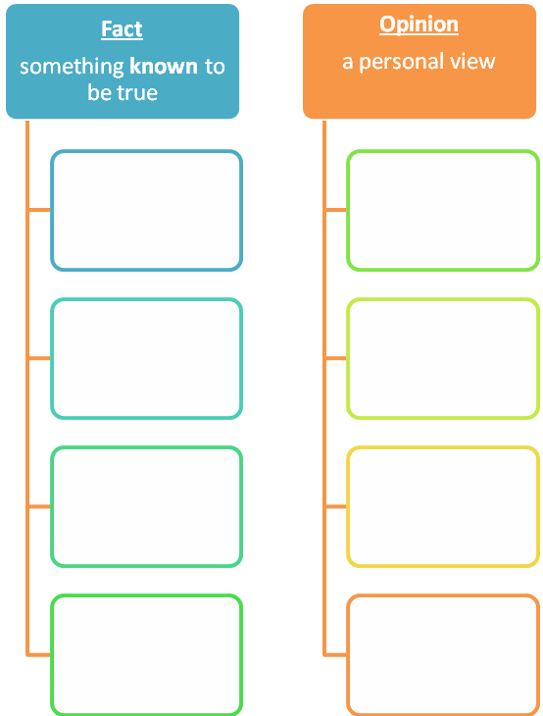While watching *The Story of Cosmetics,* write 5 facts and 5 opinions shared in the video.

***The Story of Cosmetics* Video Assessment:**

**Bias Organizer**

We all have biases, and they are not always bad. However, it is important that we recognize biases in ourselves and others. In the spaces below, write down:

* What biases were represented in the video, and
* 1 specific example from the video that prove that bias exists in the video
* One bias you have as a consumer
* 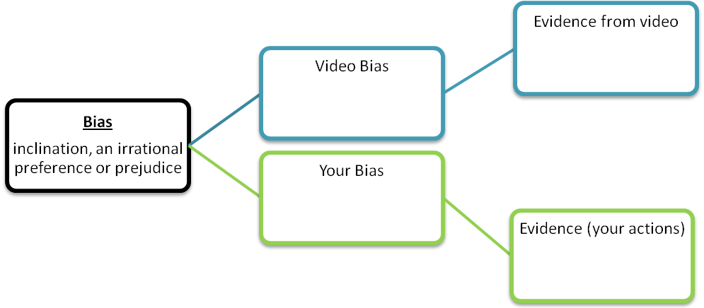1 example of an action that you take as a consumer that prove you have that bias

List 2 actions you can take to limit the amount of toxins in your personal care products:

1.

2.

***The Story of Cosmetics* Video Assessment:**

**Teacher Key**

Facts may include:

* There is lead in lipstick
* Some cosmetics have toxic chemicals in them
* The average woman uses approximately 12 cosmetic products a day
* The average man uses approximately 6 cosmetic products a day
* We don’t know what some chemicals do to us
* There is no legal definition for words used on cosmetic’s labels
* FDA doesn’t assess all ingredients in cosmetics
* Europeans have demanded the removal of many toxic chemicals

Opinions may include:

* Green chemists know how to make these products toxic free and effective
* Companies only care about making money
* Important decisions don’t happen when you choose a product off the shelf
* We are a system in crisis
* We aren’t having fun
* A bathroom is a minefield of toxins
* It isn’t our fault that these toxic substances are in our bathrooms
* Chemists don’t worry about human health

Video biases & evidence may include:

* Consumer protection – shows babies with toxins in their bodies
* Legislation is a key way to get safe products – shows lack of legislation in current process
* Companies only care about making money – cartoon characters with $
* Industry is bad – only gives examples of bad products. Aren’t there any good ones?
* Consumers are helpless – states that consumers can’t make a good choice based on products

Personal biases & evidence may include:

* Brand– I only buy Cool Guy Shampoo because it works best
* Cost (a product is better if it’s more expensive) – I buy the most expensive sunscreen for maximum sun protection
* Cost (cheaper) – the brand & packaging don’t matter – I buy the sale item
* Green – I only buy Enviro-Shampoo because it is environmentally friendly
* Non-Green – I never buy Enviro-Shampoo because environmentally friendly products don’t work
* Packaging – I like glass bottles so I only buy lotion that comes in a glass bottle

2 actions may inclue:

* Read label
* Buy brands I trust
* Research specific products
* Make my own products
* Use fewer products
* Use products less often