 **Surefire Sharklet Lab**

**MIDDLE SCHOOL**

**Green Chemistry**

**Background:** Sharks are one of the oldest life forms on Earth, with the first sharks predating the appearance of dinosaurs. Over time, sharks have evolved to become fierce predators with fascinating natural defences. For example, instead of normal scales, sharks have *dermal denticles*, which are made of cartilage and prevent other organisms from adhering to their surface. These denticles help reduce drag on the shark, promoting their ability to swim fast. Recently, scientists and engineers have designed a variety of products, including swimsuits and submarines, to mimic sharks’ unique skin. Sharklet film, a biomimicry technology inspired by shark denticles, is a surface micro-pattern used to prevent the growth of bacteria on various surfaces, from cell phone cases to medical devices.

*Biomimicry* is the science and art of taking inspiration from nature in designing new technologies. Often, biomimicry technologies are guided by nature’s ability to create unique materials and perform complex chemical processes at normal pressure, normal temperature, and without creating any environmentally persistent waste. Sharklet film helps to prevent bacterial resistance to common cleaners and antibiotics by reducing their use.

In this lesson, students will be introduced to biomimicry and Sharklet film. They will then investigate how Sharklet works through a hands-on experiment that simulates the accumulation of bacteria on surfaces with and without the pattern.

**Additional Resources:**

*Sharklet®*

<http://sharklet.com/>

*Shark skin inspires new product to fight infections*

<https://www.youtube.com/watch?v=rXrGwpG0I3c>

*Making Stuff: Smarter* (first ten minutes)

<https://www.pbs.org/video/nova-making-stuff-smarter/>

**Objectives:** Students will….

* Investigate diffraction patterns and compare how light transmits through different surfaces
* Develop and evaluate a hypothesis for why bacteria cannot grow on Sharklet film

**Key terms:** Sharklet, bacteria, biomimicry

**Materials:**

* Puffy paint
* Half-sheets of transparency film
* White paper (for tracing Sharklet pattern)
* Tape
* 1 piece of Sharklet film (1- to 2-inch-square piece available from Beyond Benign)
* 1- to 2-inch-square piece of overhead transparency film
* 1- to 2-inch-square piece of diffraction film
* laser pointer
* 30 binder clips
* 2 sticky notes

**Time Required:** 45-minute class period

**Standards Met:**

**MS-PS4-2.** Develop and use a model to describe that waves are reflected, absorbed, or transmitted through various materials.

**Keys to Success:**

* Teachers may wish to capture on the board the student data from testing the Sharklet models (Part 2 of the lab sheet) to evaluate the results of the entire class.
* Images of the Sharklet pattern to use as a stencil are provided at the end of this document
* Instead of running this activity as an experiment in groups, it is also effective to perform it as a demo in front of the class.
* If this lesson is run alongside the biodegradable cell phone case unit, add discussion questions to help students decide whether or not they would choose to incorporate Sharklet film in their prototype.

**Teacher Preparation:**

* Teachers should prepare the Sharklet simulation models ahead of time. Once the pattern has been traced on white paper, making the model with the puffy paint only takes a few minutes. Note that the models need to dry overnight; they can then be used multiple times.

**Procedure:**

5E Procedure:

*Engage:*Students reflect on their prior knowledge of bacteria and define biomimicry.

* Invite students to share what they know about bacteria. Guide students with the following questions:
  + What are some of the problems?
  + What are some of the benefits?
  + How do we typically control problem bacteria?
* Tell the class that today they will think about one way that nature controls bacteria.
* As a class, define the word biomimicry. Encourage breaking the word into its components and defining each individually before putting them together. Biomimicry is taking inspiration from nature in the design of new technology.
* Ask the class to think about which animals never get sick and why they don’t get sick. Have students brainstorm in pairs for 1–2 minutes. Share a few groups’ ideas with the class.
* If no groups mentioned sharks, ask if any group thought of sharks in their discussions. Explain that sharks rarely get sick and that one of the major reasons they are so healthy is that their dermal denticles (the scale-like cartilage that makes up their skin) have a unique, microscopic diamond pattern that prevents bacteria from growing on them. Show the class a picture of denticles so they can see the pattern. A high-quality image can be found here: <https://asknature.org/strategy/scales-protect-skin/#.WyFMLRJKi1s>

*Explore:*Students explore the unique surface pattern of Sharklet.

* Introduce Sharklet film but do not yet reveal its pattern. Sharklet is a biomimicry technology based off of the unique properties of shark denticles that is used to prevent the growth of bacteria on spaces where problem bacteria accumulates.
* Ask students to think of places where they might want to put Sharklet film.
* Explain to the class that companies like Steelcase, Inc. are using Sharklet on the surfaces of things like office and classroom furniture. Sharklet Technologies was bought in 2017 by Peaceful Union, a company that manufactures medical devices.
* Have students work in pairs and follow the instructions on the Student Lab Sheet to investigate the pattern of Sharklet film by comparing a piece of transparency film, a piece of diffraction grating, and a piece of Sharklet film.
* Tell students that they will be working with a laser pointer and let them know the lasers are to be pointed down. It is dangerous to point the laser in their eyes or their classmates’.
* As students explore the interactions of the light from the laser pointer through each type of film, they will answer the questions on their Lab Sheets and record their observations.
* On their Lab Sheets, students will propose what they think the Sharklet pattern must look like, based on their observations and the pattern of the shark denticles.

*Explain:*Students consider the Sharklet pattern and establish a hypothesis for how the film prevents the growth of bacteria.

* Show the class the actual pattern of the Sharklet film to compare to their drawings. A high-quality image of the pattern can be found here: <https://www.popsci.com/science/article/2009-10/saving-skin>
* Ask each pair of students to develop a hypothesis for why they think this pattern prevents bacteria from growing on sharks, then have them record it on their Student Lab Sheet.

*Elaborate/Extend:*Students compare the ability of weighted sticky notes to stick to the Sharklet pattern and to a flat surface.

* Using their lab sheets for instructions, students will use post-its, binder clips, and the pre-made models of the Sharklet diamond pattern made with puffy paint to test their hypothesis and determine why things can’t stick the pattern.
* OPTIONAL: Students may make their own models of the pattern.
  + One partner will need to keep the laser stationary while the other partner traces the outline of the Sharklet image onto a piece of white paper.
  + Once the image has been traced, overlay the transparency on top of the paper
  + The students will then use puffy paint to create a pattern on the overhead transparency film.
  + Students will make 3 (1-inch) diamond shapes from the pattern using puffy paint. Allow models to dry overnight.

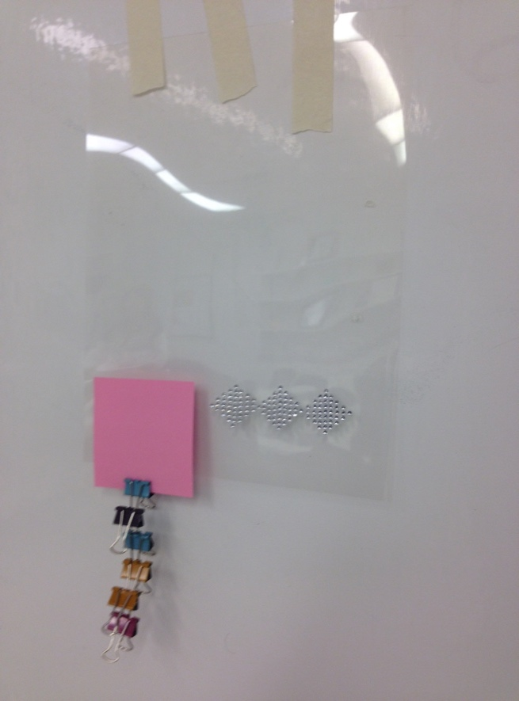

* Students will then use their observations from this experiment to evaluate their hypothesis about why things can’t stick to the pattern.

*Evaluate:*

* Ask students to share the results of their experiment with the class. Invite the class to share their conclusions.
* Explain to the class that bacteria (and everything else!) can’t get enough of a hold on the pattern to securely grow on the surface of the sharks’ skin—or on the Sharklet film.
* Ask the class to reflect on how Sharklet film may help promote human and environmental health.
* Explain that because bacteria simply cannot grow on the surface of Sharklet film, there is no need for any antimicrobials. Human health is protected from harmful bacteria and the environment is protected from excess antibiotics.

**Extension Option:**

* Students may decide to incorporate Sharklet film into their cell phone case design to prevent bacteria growth on their phone cases.

**Surefire Sharklet Lab: Student Handout**

**Name_______________________________________ Date ___________________**

***CAUTION: Shine the laser pointers DOWN ONLY—never toward eyes*.**

***Part 1***

**Materials:**

* Piece of Sharklet film
* Piece of transparency film
* Piece of diffraction grating film
* Laser pointer

**Prediction:**

Consider the denticles of sharks. If Sharklet is based off of shark skin, what might it look like if we looked at it under a microscope?

**Procedure:**

Shine the laser pointer through each piece of film (transparency, diffraction, and Sharklet) and describe what you see in Table 1.

|  |  |  |
| --- | --- | --- |
| **Table 1** | | |
| Transparency film | Diffraction film | Sharklet film |
|  |  |  |

**Results and Discussion:**

Explain what is happening to the light as it passes through each film.

**Conclusion:**

Based on the pattern you observed using the laser pointer and the pattern of shark skin that you were shown, draw what you think the microscopic pattern of the Sharklet film looks like.

***Part 2***

**Materials:**

* Sharklet pattern model
* Piece of transparency film
* 30 binder clips
* 2 sticky notes

**Prediction:**

Develop a hypothesis that explains why bacteria cannot stick to the surface of shark skin or to Sharklet film.

**Procedure:**

1. Using the puffy-paint Sharklet pattern model from your teacher, you will test the how well a sticky note can adhere to the Sharklet pattern, as compared to a smooth surface (transparency film).
2. Tape the Sharklet model to a vertical flat surface so that the Sharklet pattern is horizontal, not vertical. Tape the piece of transparency film next to the Sharklet model, as in the image on the right.
3. Place one sticky note across the Sharklet pattern and another sticky note across the smooth transparency film directly next to it.
4. Predict how many binder clips each sticky note will hold and write the numbers in Table 2.
5. Place binder clips—one at a time—on the Sharklet pattern’s sticky note until it falls off (see the picture on the right for reference). Capture the actual number of binder clips held in Table 2. Repeat these steps for the sticky note on the smooth transparency film.

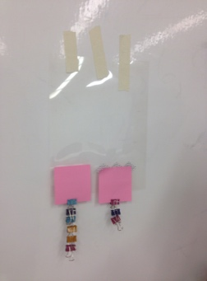

|  |  |  |
| --- | --- | --- |
| **Table 2** | | |
|  | Sharklet pattern | Transparency film |
| Predicted |  |  |
| Actual |  |  |

**Results and Discussion:**

1. Summarize the results of your experiment to explain what you observed.
2. How do the results of your experiment help to explain why the pattern of their skin helps sharks survive?
3. How do the results of your experiment explain why using Sharklet film can help humans fight problem bacteria?

**Conclusion:**

Evaluate your hypothesis. Do you believe your hypothesis is confirmed? Why or why not? Do you have a new hypothesis?

