Lesson 4
Orb-It Analysis of Your Product

Activator/Bell Ringer/Starter
🔔
Balancing equity, environment and economics is key to sustainability. What might be a challenge to balancing equity, the environment and economics when creating a product?

Your answer:

Orb-It
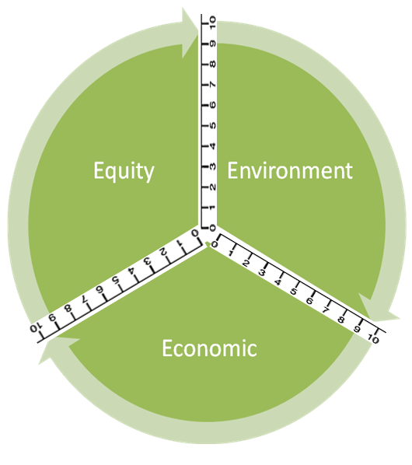

Orb-It Tool
Directions
- Think about your product as group.

- Use personal experience and information from your prototype to fill in the second column (Info from research or personal experience to support the rating).

- Refer to the rating scale below to rate each criteria:
10 – Perfect (it couldn’t be better!)
9 – Excellent (impressive, but could still improve slightly)
8 – Great (better than expected, but could improve a little)
7 – Good (average performance)
6 – Pretty good (good, significant improvements could be made)
5 – Adequate (it’s just okay)
4 - Partially proficient (needs much improvement)
3 – Falls short
2 – Tries, but still does not succeed
1 – Barely (it’s unsatisfactory)
0 – Doesn’t (it failed miserably!)

Social Impact (Equity) | Info from research or personal experience to support the rating | Ratings
Ingredients
Use of Renewable Feedstocks
Health
Designing Safer Chemicals
Environmental Impact | Info from GoodGuide or personal experience to support the rating | Ratings
Air pollution
Waste Prevention & Design for Degradation
Energy Use
Design for Energy Efficiency
Toxic Waste
Waste Prevention & Design for Degradation
Water Quality
Waste Prevention & Design for Degradation
Climate Change
Waste Prevention
Economic Impact | Info from GoodGuide or personal experience to support the rating | Ratings
Cost
Quality
Designing Safer Chemicals
Philanthropy
Gives back to the community

- Now, label the Orb-It Orb by following the steps below:
STEP 1: Place your rating for Equity on both the number lines bordering “Equity”.
STEP 2: Use a compass to make an arc connecting those two points.
STEP 3: Shade the area you created within the arc.
STEP 4: Repeat steps 1 – 3 for both Environment and Economic.
Ticket-Out
🎫
What are three positive aspects to working on your invention and/or your pitch as a member of a group versus conducting the assignment as a single person.

1 | 2 | 3

