Lesson 2
Creating Prototypes

Activator/Bell Ringer/Starter
🔔

Identify the most important property or characteristic of my product to my client.

Lab: Creating Prototypes from a Blueprint

Directions:
- Form into your groups of 3-4 individuals and select your lab roles.
  - Project Coordinator and Lead
  - Project Architect
  - Project Resource Manager
  - Project Documentation Specialist

- Read through the WHOLE lab first!

- Read through the lab safety rules. Please ask any questions about this lab’s rules if you have any.
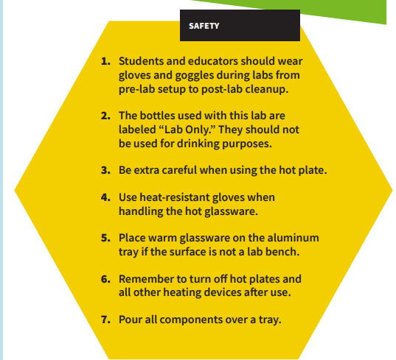
- Gather and organize all the items you will need for this lab based on the optimized formulation you documented in your blueprint sheet.

Lab Protocol
- Use the wax pencil to label your beaker with the plasticizer, additive, and starch you’ll use.

- Tape wax paper onto the tabletop.

- Select appropriate molds (cookie cutter forms) for your prototype shape or make your own out of clay.

- Apply a thin layer of coconut oil to wax paper and to the molds (cookie cutter forms or clay). This will help with removing the bioplastic once it hardens.

- In your 250-mL beaker, use a teaspoon to measure 5mL of your starch and 2.5mL of your acid or base. Mix with the stirring rod.
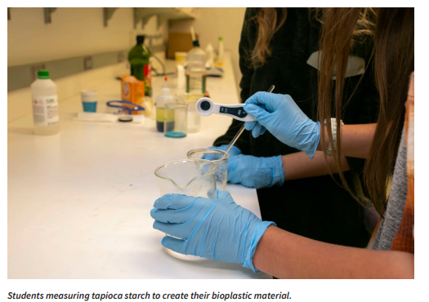
- Measure 5mL of water and add to your beaker. Mix with the stirring rod.

- Measure 5mL of your plasticizer and add to your beaker. Mix with the stirring rod.

- Mix the solution until uniform.

- Using the hot plate and a timer, heat the solution on medium heat for 6–10 minutes, stirring for 15 seconds every minute until it starts to thicken.
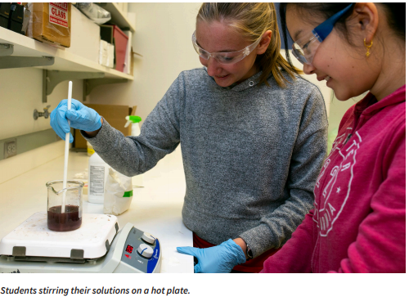
- Using your stirring rod, transfer the material from the beaker into the syringe.

- Push the material as close to the end as you can.

- Insert the plunger and flip the syringe upward.

- Push out excess air.

- Using your syringe, transfer the material from the beaker into your desired form.
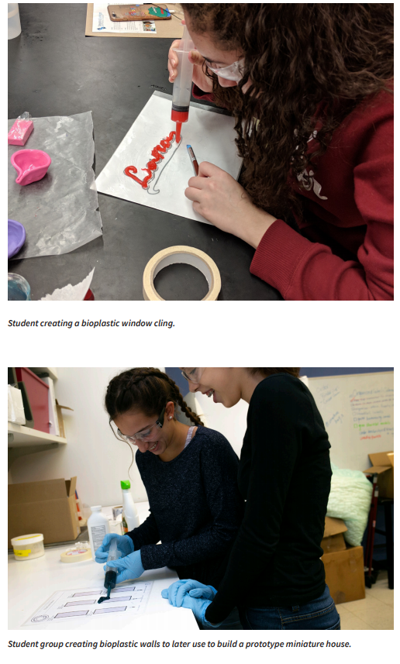
- Let your bioplastic material sit overnight to form.

- Label your bioplastic prototype and set it on the tray to store for the next meeting.

Post-Lab Clean-Up

▶ All materials are safe to pour down the drain.
▶ Wipe down your lab bench or tabletops.
▶ Clean beakers, teaspoons, and stirring rods in a warm, soapy water bath with 30 mL of vinegar added.
▶ Dry the tools and lab equipment, then store them properly in an educator-designated area.

Ticket-Out
🎫
What do you think makes your group’s project unique? What will your client most value about your product?

Your answer:

