Sustainable Invention: An Exploration of Bioplastics
Module 4

Table of Contents
- Teacher Resources
- Overview of Lesson 1: Planning for Prototyping a Bioplastic Product
- Overview of Lesson 2: Creating Prototypes
- Overview of Lesson 3: Analysis of Your Product
- Overview of Lesson 4: Orb-It Analysis of Your Product
- Overview of Lesson 5: Developing Your Product Pitch
- Overview of Lesson 6: Pitch Presentation: Practice Protocol
- Overview of Lesson 7: Pitch Fest and Peer Feedback
- Lesson 1 Planning for Prototyping a Bioplastic Product
  - Bell Ringer
  - Planning Your Bioplastic Inventions
  - Ticket-Out
- Lesson 2 Creating Prototypes
  - Bell Ringer
  - Lab: Creating Prototypes from a Blueprint
  - Ticket-Out
- Lesson 3 Analysis of Your Product
  - Bell Ringer
  - Hook Sheet, Your Turn!
  - Ticket-Out
- Lesson 4 Orb-It Analysis of Your Product
  - Bell Ringer
  - Orb-It and Tool
  - Ticket-Out
- Lesson 5 Developing Your Product Pitch
  - Developing Your Pitch
    - Criteria for Success
    - Grading Rubric
  - Ticket-Out
- Lesson 6 Pitch Presentation: Practice Protocol
  - Bell Ringer
  - Practice Presenting Your Pitch
  - Ticket-Out
- Lesson 7 Pitch Fest and Peer Feedback
  - Pitch Presentations and Peer Feedback
  - Warm & Cool Feedback Note-taking Sheets
  - Improvements to Pitch and Product
  - Ticket-Out

Desired Results
Enduring Understanding from Unit:
- Green Chemistry allows us to create products that are safer for us and the environment, contributing to a sustainable future.
- Bioplastics can be used to create novel products and/or better versions of already existing products.

Essential Question from Unit:
- Why should inventors care about sustainable materials?

Standards Addressed (Content and ELP)
NGSS Science Standards:
- ETS1-5(MA): Create visual representations of solutions to a design problem. Accurately interpret and apply scale and proportion to visual representations.
- MS-ETS1-7(MA): Construct a prototype of a solution to a given design problem.
- MS-ETS2-2(MA): Given a design task, select appropriate materials based on specific properties needed in the construction of a solution.

Science and Engineering Practices:
1. Asking questions and defining problems
2. Developing and using models
6. Constructing explanations and designing solutions
8. Obtaining, evaluating, and communicating information

Overview
Task overview: Students will practice the steps to work through the invention process by refining their formula and procedure for a bioplastic product. Through iteration, students will understand the importance of prototyping a product, evaluating the prototype, and making adjustments based on feedback. Part of that evaluation will focus on understanding the potential impact of the product on the environment. Students will be able to effectively communicate the features and benefits of their new product in relation to a similar petroleum-based product. Furthermore, students will gain practice in providing, receiving and reflecting on feedback about their product and presentation.

Language focus
Communicating through verbal and written language by all participants. Small group discussions will also occur.
- Written communication of ideas for creating a new product, the design process, and marketing the product
- Verbal and written evaluation of the effectiveness of the marketing strategy and the product created by other groups.
- Reading about the engineering design and marketing process.
- Verbal discussion amongst small groups to complete tasks.
- Written and verbal communication of marketing ideas via the creation and production of a commercial.

Learning Targets | Formative Assessment
- Content-focused:  - Blueprint  - Prototype  - Language-focused:  - Hook | - See provided closures below  - The blueprint document  - The lab activity itself (creation of the product following the group’s own instructions can be an assessment)  - The commercial the group produces.

Key Content Vocabulary | Cross-Disciplinary Vocabulary
- Formulation  - Plasticizer  - Starch  - Additive | - Blue-print  - Prototype  - Hook

Materials or Apps
Teachers:  - Chart Paper  - Sticky Notes  - Photocopies of Student Hand-Outs  - Hot plate, 1 per student group  - Syringe, 1 per student group  - Aluminum tray, 1 per student group  - Heat-resistant gloves, 1 pair per student group  - 250-mL beaker, 1 per student group  - Digital scale, 1 per group  - Protective gloves, 1 pair per student  - Protective goggles, 1 per student  - Wax pencil, 1 per student group  - Additives: white vinegar, baking soda  - Plasticizer: sorbitol  - Starches: tapioca, potato, corn  - Coconut oil  - Modeling clay  - Wax paper | Students:  - pens/pencils  - Lab Safety Rules  - Cellphone Timer
Lesson Preparation
Instructor needs to pre-print photocopies of worksheets if not a one-to-one school or for students who require hard copies as an accommodation to the curriculum. Instructor also needs to pre-print the loops and needs to make sure clay is malleable and stored in a container to maintain its freshness.

Instructor may want to have all the lab materials set-out in an organized manner to make it easier for the material manager of each group to both gather the materials and put them away at the end of the lab days.

Instructor will want to have chart paper available for student use during several days of this unit.

Estimated Time:
(7) 45-minute class periods with all resources used
Lesson Sequence
Lesson 1: Planning for Prototyping a Bioplastic Product
- Whole Group (5 minutes): Instructor has the students do the bell ringer activity which asks: “Looking at your last time working with bioplastics, what properties will be important to include in your product? Create a list below and be prepared to explain why.”

- Small Group (5 minutes): The instructor then has the students share their answers with one another as pairs or small groups.

- Small Group (2 minutes): The instructor then has the students re-join their lab groups from the previous activity.

- Whole Group (5 - 10 minutes): Once groups are established, the instructor should go over instructions for how to proceed with the “Planning Your Bioplastic Inventions” activities, especially clarifying directions for creating their own formulas and procedures.

- Small Group (20 minutes): The students will then work for the next 20 minutes with the instructor functioning as a facilitator and assisting any groups that are struggling.

- Independent (3 minutes): The students are then redirected to a group Ticket-Out, where they reflect on their formula and procedure.

Lesson 2: Creating Prototypes
- Whole Group (3 minutes): Bell Ringer: Identify the most important property or characteristic of my product to my client.

- Small Group (20 - 25 minutes): The students will then rejoin their lab groups. They will be asked to conduct a lab experiment where they will use their procedure to create a first version of their prototype. The instructor should perform as a facilitator at this time, rotating around the room to check in on students and help those that are struggling.

- Small Group (15 minutes): Design data sheets with this worked, this did not work, this is what I will try tomorrow. Could this include hypothetical experiences from a company with a focus on certain green chemistry principles?

- Independent (2 minutes): At the end of class, the students should then engage in their ticket-out activity. The students will be asked to reflect on how their client may view their product.

Lesson 3: Analysis of Your Product
- Whole Group (2 minutes): Bell Ringer

- Small Group (10 minutes): Record properties of yesterday’s product. Identify needed changes to materials or procedure.
- Small Group (15 minutes): Iterate to develop a second prototype, following the same lab experiment protocol.

- Small Group (15 minutes): Pair up with client & another group to get feedback-- another layer of feedback and get at empathy--did you meet the clients demands/needs/wants (students need to share their key product properties with other teams). Within the team there is a client.

- Ticket-out (3 minutes): reflection question on client session.

Lesson 4: Orb-It Analysis of Your Product
- Whole Group (5 minutes): Bell Ringer

- Small Group (10 minutes): Record properties of yesterday’s product.

- Small Group (15 minutes): Conduct an Orb-It analysis (see Module 1, Lesson 5 for additional information).

- Whole Group (10 minutes): Reflection on analysis, implications for pitch.

- Independent (5 minutes): The students will work on their ticket-out where they will reflect on this part of their invention process and document three positive aspects to working on their invention and/or the commercial as a member of a group versus conducting the assignment as a single person.

Lesson 5: Development of Your Product Pitch
- Independent (5 minutes): For the bell ringer.

- Small Group (35 minutes): Students will then be told to work on producing a 2-3 minute pitch to present to the class. The pitch can be performed live in class or pre-recorded. There is a guideline for what must be in the students’ commercials as well as a criteria for success for them and a grading rubric for the instructor. The pitch can be treated as a summative assessment. Students should make it clear that their bioplastics are being used to create a novel product and/or a better version of an already existing product. Edit to ensure students use their idea, peer data and reasoning using bioplastic & green chemistry on why their product should be funded. Consider key elements to include: What is my product, How it addresses a need, How is it addressing green chem principles, How impact eco footprint.

- Independent (5 minutes): The ticket-out is for each work group to compose a question they have for their instructor for the next day.

Lesson 6: Pitch Presentation: Practice Protocol
- Small Group (5 minutes): For this day’s bell ringer, the students will be asked to form into their work groups and to practice their presentation for 5 minutes.

- Small Group (20 minutes): Students rejoin their lab groups and then are assigned to work with another lab group to engage in a practice run of their projects. A practice protocol is provided for the students. The protocol is: (1) While each group presents their project, they are to pretend the other group is the client. (2) During this time, the “client” will grade them using the project grading rubric and take notes as to why they are assigning each grade on sticky notes. (3) Once both of the pitches have been presented, the groups will separate and create a single grading sheet with the average grades supplied by each group member for each grading category. The sticky notes will be moved to this new averaged grading sheet for the other group to review. (4) At the end of 10 minutes, the groups will exchange their averaged grading sheets.

- Small Group (15 minutes): The two lab groups will separate and will spend most of the remainder of the class time reading through the feedback together and using it to make alterations to their pitch.

- Individual (5 minutes): The students will fill out their ticket-out, which asks “How did the pitch go today? What did you improve using your peer feedback?”

Lesson 7: Pitch Fest and Peer Feedback
- Whole Group (35 minutes): The students will present their projects to one another and follow a modified tuning protocol. The protocol will be as follows:
  - Each student group receives a piece of chart paper, they will bring this with them to the front of the room when they present.
  - Each student group takes turns presenting their inventions. As they present, other groups will write down warm and cold feedback, which they document on a feedback sheet.
  - Then, each student creates a sticky note with 1 piece of warm feedback (on a yellow sticky note) and 1 piece of cool feedback (on a blue sticky note) and gives those to the teacher when the group has completed their presentation. During this time, it would be best for the instructor to quickly read through the sticky notes and remove any that are inappropriate or utilize hurtful language. These are then placed on the chart paper by the instructor and shared when the students are ready to review it.
  - Once each group is done presenting and receiving their warm and cold feedback sticky notes, the groups may then receive their chart paper and evaluate the data provided. They are encouraged to ensure they understand the feedback and to ask questions about the feedback if they do not.
  - Finally, they are asked to create a list from the feedback they will use to either improve their product or their commercial.

- Independent (10 minutes): Once each group has completed this task, the students will reflect on their invention and on their experience as their ticket-out.
Lesson 1
Planning for Prototyping a Bioplastic Product

Activator/Bell Ringer/Starter
🔔
Looking at your last time working with bioplastics, what properties will be important to include in your product? Create a list below and be prepared to explain why.

My answers: | My classmates’ answers:

Planning Your Bioplastic Inventions

- Re-join your labs groups from our last activity.

- Evaluate the results from your Optimizing Bioplastic activities from our last class meeting. This information will help you determine the final version of the formulation of your group’s bioplastic product. To do this:

  - Record the properties of the loops you created in our last activity, such as stickiness, hardness, brittleness, and flexibility.

  - Note if any of the properties changed since you last observed them.

- Note the product you would have chosen to actually make (from module 1). List the properties that are important for this product, and why.
Product:
Properties | Why important

- Start the Bioplastic Formulation sheet below. Your goal today is to create a rough draft for a bioplastic formula that will result in the properties you need for your product.

As your brainstorm, think about how you might pitch your product. We will talk more about this later, so keep it in the back of your mind as you plan.

Materials and Methods
Materials for Formulation

Procedure for Formulation

Ticket-Out
🎫
Looking at your materials and procedure, list one thing that may be a challenge to making your product tomorrow? Why might that be a challenge?

Your answer:

Lesson 2
Creating Prototypes

Activator/Bell Ringer/Starter
🔔

Identify the most important property or characteristic of my product to my client.

Lab: Creating Prototypes from a Blueprint

Directions:
- Form into your groups of 3-4 individuals and select your lab roles.
  - Project Coordinator and Lead
  - Project Architect
  - Project Resource Manager
  - Project Documentation Specialist

- Read through the WHOLE lab first!

- Read through the lab safety rules. Please ask any questions about this lab’s rules if you have any.
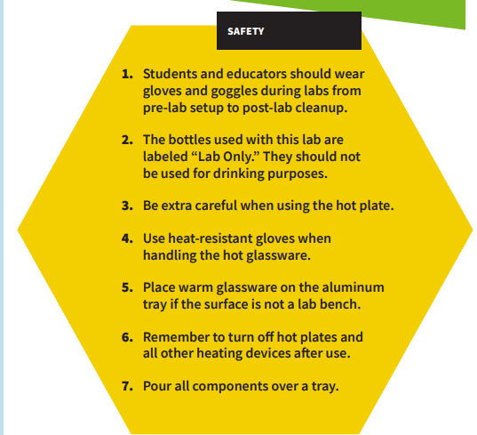
- Gather and organize all the items you will need for this lab based on the optimized formulation you documented in your blueprint sheet.

Lab Protocol
- Use the wax pencil to label your beaker with the plasticizer, additive, and starch you’ll use.

- Tape wax paper onto the tabletop.

- Select appropriate molds (cookie cutter forms) for your prototype shape or make your own out of clay.

- Apply a thin layer of coconut oil to wax paper and to the molds (cookie cutter forms or clay). This will help with removing the bioplastic once it hardens.

- In your 250-mL beaker, use a teaspoon to measure 5mL of your starch and 2.5mL of your acid or base. Mix with the stirring rod.
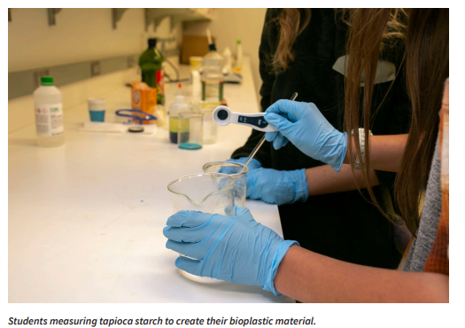
- Measure 5mL of water and add to your beaker. Mix with the stirring rod.

- Measure 5mL of your plasticizer and add to your beaker. Mix with the stirring rod.

- Mix the solution until uniform.

- Using the hot plate and a timer, heat the solution on medium heat for 6–10 minutes, stirring for 15 seconds every minute until it starts to thicken.
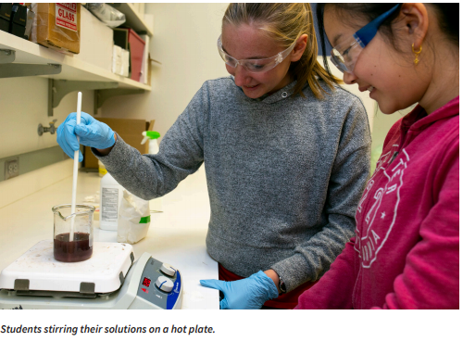
- Using your stirring rod, transfer the material from the beaker into the syringe.

- Push the material as close to the end as you can.

- Insert the plunger and flip the syringe upward.

- Push out excess air.

- Using your syringe, transfer the material from the beaker into your desired form.
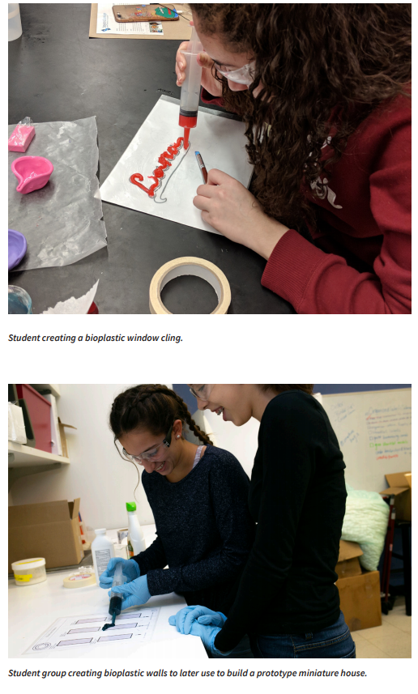
- Let your bioplastic material sit overnight to form.

- Label your bioplastic prototype and set it on the tray to store for the next meeting.

Post-Lab Clean-Up

▶ All materials are safe to pour down the drain.
▶ Wipe down your lab bench or tabletops.
▶ Clean beakers, teaspoons, and stirring rods in a warm, soapy water bath with 30 mL of vinegar added.
▶ Dry the tools and lab equipment, then store them properly in an educator-designated area.

Ticket-Out
🎫
What do you think makes your group’s project unique? What will your client most value about your product?

Your answer:

Lesson 3
Analysis of Your Product

Activator/Bell Ringer/Starter
🔔
Why do you think someone should be interested in buying your product?

Your answer:

Hook Sheet, Your Turn!

Question | Answer
1. Why did you choose to make your invention?
2. What does it do?
3. Why is it useful?
4. What problem does it solve?
5. Who would use it?
6. Does it replace an object?
7. What makes it appealing to a consumer?
8. What makes it useful to a consumer?
9. What tools are needed to make the product?
10. What materials are needed to make the product?
11. Estimated cost of inventing?
(You would create this based on the cost of the raw materials divided by the number of items you would be able to produce)
12. What is your product’s one-liner or hook to get a person interested in it?
Ticket-Out
🎫
What do you think are the top 3 selling points for your product?

Your answer:

Lesson 4
Orb-It Analysis of Your Product

Activator/Bell Ringer/Starter
🔔
Balancing equity, environment and economics is key to sustainability. What might be a challenge to balancing equity, the environment and economics when creating a product?

Your answer:

Orb-It
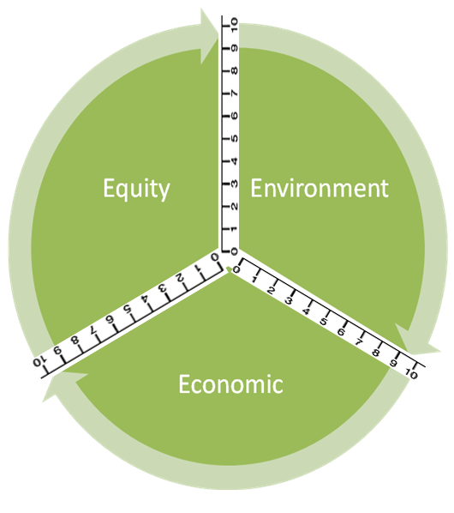

Orb-It Tool
Directions
- Think about your product as group.

- Use personal experience and information from your prototype to fill in the second column (Info from research or personal experience to support the rating).

- Refer to the rating scale below to rate each criteria:
10 – Perfect (it couldn’t be better!)
9 – Excellent (impressive, but could still improve slightly)
8 – Great (better than expected, but could improve a little)
7 – Good (average performance)
6 – Pretty good (good, significant improvements could be made)
5 – Adequate (it’s just okay)
4 - Partially proficient (needs much improvement)
3 – Falls short
2 – Tries, but still does not succeed
1 – Barely (it’s unsatisfactory)
0 – Doesn’t (it failed miserably!)

Social Impact (Equity) | Info from research or personal experience to support the rating | Ratings
Ingredients
Use of Renewable Feedstocks
Health
Designing Safer Chemicals
Environmental Impact | Info from GoodGuide or personal experience to support the rating | Ratings
Air pollution
Waste Prevention & Design for Degradation
Energy Use
Design for Energy Efficiency
Toxic Waste
Waste Prevention & Design for Degradation
Water Quality
Waste Prevention & Design for Degradation
Climate Change
Waste Prevention
Economic Impact | Info from GoodGuide or personal experience to support the rating | Ratings
Cost
Quality
Designing Safer Chemicals
Philanthropy
Gives back to the community

- Now, label the Orb-It Orb by following the steps below:
STEP 1: Place your rating for Equity on both the number lines bordering “Equity”.
STEP 2: Use a compass to make an arc connecting those two points.
STEP 3: Shade the area you created within the arc.
STEP 4: Repeat steps 1 – 3 for both Environment and Economic.
Ticket-Out
🎫
What are three positive aspects to working on your invention and/or your pitch as a member of a group versus conducting the assignment as a single person.

1 | 2 | 3
Lesson 5
Developing Your Product Pitch

Activator/Bell Ringer/Starter
🔔
List 2 product slogans that stand out to you. What is it about those slogans that make them stand out and grab your attention?

Your answer:

Developing Your Pitch
Directions
- Return to your lab groups.

- You are going to make a commercial about your product. Determine if you would like to perform that commercial live in class or if you would like to pre-record it and show it in class. For those pre-recording, if there is not time during class tomorrow, feel free to stay after and do it during after-school help.

- Your commercial must:
  - Be 30 - 90 seconds long.
  - Explain what your product does.
  - Demonstrate your product being used
  - Explain and/or show why your product is better than a similar product or an item with a similar use (like Ooho replacing water bottles and disposable cups).
  - Explain and/or show to the consumer why it is greener than the original product it replaces.
  - Make appropriate use of your product’s tagline

- Use your Hook documents from yesterday and today’s Activator/ Bell Ringer/ Starter to assist you in creating your commercials.

- You may want to consider writing a script to track your ideas, your person and product placement, and your lines. Try to not read from the script while performing your commercial.

- Have fun while making your commercial! You will be presenting them at the next class. Use the check-list below to assist you.

COMMERCIAL CHECKLIST
- Is 30 - 90 seconds long.
- Explains what your product does.
- Demonstrates your product being used
- Explains and/or show why your product is better than a similar product or an item with a similar use
- Explains and/or shows to the consumer why it is greener than the original product it replaces.
- Makes appropriate use of your product’s tagline

Criteria for Success
Criterion | Available Points | Student Self-Assessment | Points Earned (Teacher Assessment)
Commercial Length  The commercial is between 30 - 90 seconds long. | 20 | /20 | /20
Product Purpose  The commercial explains what the product does. It is clear, concise, and easy to understand. | 20 | /20 | /20
Product Use  The commercial shows the product being used. | 20 | /20 | /20
Product Superiority  The commercial explains and/or shows why the product is better than a similar product. The commercial also explains and/or shows why the product is greener than a competitor’s product. | 20 | /20 | /20
Tagline  The commercial makes appropriate use of the tagline. | 20 | /20 | /20
Score | N/A | /100 | /100
Grading Rubric
Criterion | 4 | 2 | 0
Commercial Length | The commercial is between 30 - 90 seconds long. | The commercial is more than 90 seconds long. | The commercial is less than 30 seconds long
Product Purpose | The commercial explains what the product does. It is clear, concise, and easy to understand. | The commercial explains what the product does. It is NOT necessarily clear, concise, and easy to understand. | The commercial does not explain what the product does OR it is not understandable what the product does.
Product Use | The commercial shows the product being used. |  | The commercial does not show the product being used.
Product Superiority | The commercial explains and/or shows why the product is better than a similar product. The commercial also explains and/or shows why the product is greener than a competitor’s product. | The commercial explains and/or shows why the product is better than a similar product. OR, The commercial explains and/or shows why the product is greener than a competitor’s product (but not necessarily why that makes it better). | The commercial DOES NOT explain and/or show why the product is better than a similar product. The commercial also DOES NOT explain and/or show why the product is greener than a competitor’s product.
Tagline | The commercial makes appropriate use of the tagline. |  | The tagline is not present in the commercial.
Score | TOTAL POINTS x 5 = score: __________ x 5 = /100

Ticket-Out
🎫
What is one question that you have for me about developing your pitch?

Your answer:

Lesson 6
Pitch Presentation: Practice Protocol

Activator/Bell Ringer/Starter
🔔
Spend 5 minutes prepping for your commercial presentations

Practice Presenting Your Pitch

Directions
- You will be assigned into work groups for today consisting of two project teams: your original lab group from these past few days and another lab group,

- Within your work group, you are to present your projects to each other. To do this, you will:
  - Share your product criteria (properties) with the other group, your “client.”
  - As you present to your client, the other group, they will individually be grading you using the grading rubric for the project. They will also write down sticky notes next to each category to indicate why you earned your score for each project category.
  - Next, you will swap places and now you will be the client and the other group will be pitching their product. Repeat steps a and b.
  - Now that both groups have presented, break out into two separate groups for about 10 minutes. On a clean rubric paper, create an average score for each category of the project from your team’s grading rubrics. Relocate the sticky notes you each made to this paper so that the next group can read them. If any of the notes have similar messaging, condense the message into a new, single sticky note.
  - When ready, bring both groups together and take turns politely sharing your feedback with each other.

- You will use any remaining class time to make adjustments to your commercial based on the provided feedback from your classmates.

Grading Rubric
Criterion | 4 | 2 | 0
Commercial Length | The commercial is between 30 - 90 seconds long. | The commercial is more than 90 seconds long. | The commercial is less than 30 seconds long
Product Purpose | The commercial explains what the product does. It is clear, concise, and easy to understand. | The commercial explains what the product does. It is NOT necessarily clear, concise, and easy to understand. | The commercial does not explain what the product does OR it is not understandable what the product does.
Product Use | The commercial shows the product being used. |  | The commercial does not show the product being used.
Product Superiority | The commercial explains and/or shows why the product is better than a similar product. The commercial also explains and/or shows why the product is greener than a competitor’s product. | The commercial explains and/or shows why the product is better than a similar product. OR, The commercial explains and/or shows why the product is greener than a competitor’s product (but not necessarily why that makes it better). | The commercial DOES NOT explain and/or show why the product is better than a similar product. The commercial also DOES NOT explain and/or show why the product is greener than a competitor’s product.
Tagline | The commercial makes appropriate use of the tagline. |  | The tagline is not present in the commercial.
Score | TOTAL POINTS x 5 = score: __________ x 5 = /100

Ticket-Out
🎫
How did the pitch go today? What did you improve using your peer feedback?

Your Answer

Lesson 7
Pitch Fest and Peer Feedback

Pitch Presentations and Peer Feedback

Directions: Today, we will follow the same peer review protocol that we did in our first lesson together about invention. Below are the steps.

Step 1: Each group will select a blank piece of chart paper. You will bring this with you to the front of the room when you present.

Step 2: You will take turns presenting your commercial to the class. As you present, your classmates will take notes on your ideas. They will then provide at least one piece of warm (positive) feedback they have for you on a yellow sticky note as well as one piece of cold (ideas for improvement) on a blue sticky note. The presentation feedback should be both about the product created and the pitch presentation.

Step 3: Once a group has completed presenting, give your sticky notes to the teacher who will post those on the chart-paper the presenting group brought to the front of the class. The chart paper will be handed to the instructor until we are ready for step 4.

Step 3: The next group will now present and steps 2 - 3 will be repeated. This will repeat until each group has had a chance to present.

Step 4: All of the groups will now read the warm and cold feedback they received. As a group, they should review and discuss the feedback to determine if they have any questions about it that they need to put forth for clarification amongst their classmates.

Step 5: Finally, the group uses the feedback to construct a list of improvements they could either make to their commercial for their product or for the product itself.

Warm and Cold Feedback
Commercial Note-Taking Sheets
Group Presenting:
Warm Feedback | Cold Feedback

Group Presenting:
Warm Feedback | Cold Feedback

Group Presenting:
Warm Feedback | Cold Feedback

Group Presenting:
Warm Feedback | Cold Feedback

Group Presenting:
Warm Feedback | Cold Feedback

Group Presenting:
Warm Feedback | Cold Feedback

Step 5: List of Improvements for the Pitch and the Product

Pitch Improvements | Product Improvements

Ticket-Out
🎫
Reflection on your day
- What do you like about your Pitch and/or your product? Please use content-specific vocabulary in your answer.
Your answer:

- What do you think you might change based on your peer feedback and your observations of other people’s work?
Your answer:

- What is one positive outcome you have experienced from the invention process?
Your answer:

- Where is one place where you see room for improvement in the invention process? Please use content-specific vocabulary when you answer.
Your answer:

