Lesson 4
CER Development

Activator/Bell Ringer/Starter
🔔
Fill in the KWLS chart below about Claims-Evidence-Reasoning writing.
Aim for 1 item per column.

K  What do you know? | W  What do you wonder? | L  What have you learned? | S  What are you still curious about?

Claims, Evidence, Reasoning
The fun starts here!

What is it?
It is a scientific explanation.

A claim is a statement that answers a question.

Evidence is the observations collected about a phenomenon. It can be communicated as scientific data, photographs, charts, tables, graphs, written observations, etc...

Reasoning is how your evidence supports or justifies your claim. It ties them together.

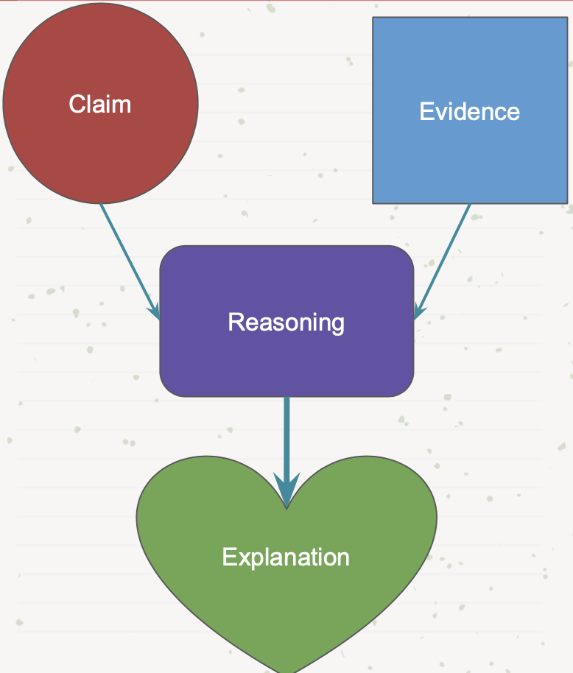
Let’s Try a CER Together!

Watch the video The Life Cycle of a Plastic Bottle
https://www.youtube.com/watch?v=_6xlNyWPpB8

Question: What is the impact of plastic that gets thrown away?
CLAIM
Write a statement that answers the question.
(Please write the claim in blue)

Single use plastics when disposed of improperly are harmful to the environment.
EVIDENCE  Scientific data from investigations or research to support your claim.  (Please write the evidence in orange)  Plastic takes up to 1,000 years to decompose.  Leachate is contaminated water from solid waste that leaks out and pollutes surrounding water and soil.  Plastic pollution ends up breaking into microplastics.  Microplastics cause starvation for some ocean animals.  When plastic is recycled it can be transformed into the raw materials for other products. | REASONING  Explain how the evidence supports the claim.  (Please write the evidence in purple)  Plastic bottles go into landfills as trash, waterways as pollution or can be recycled.  Plastic contamination impacts ecosystems.  Recycling reduces the negative impacts of plastics ending up in landfills or the ocean.

Put it All Together!
Below, put together your bullets from before to create your Claim, Evidence, and Reasoning paragraph.

Question: What is the impact of plastic that gets thrown away?

Loop Formulation CER
You are going to compose a CER statement about your loop invention process. For your CER, you may use all of the information and observations you have collected since the start of the invention and green chemistry topic. You may also refer to the previous lab activity in which you made loops for the first time.

You will conduct activity in two parts: the first is a note catcher or outline of what you will write. The second is your CER statement in a paragraph format.

Question:
What is the best formulation for the properties you have tried to produce?
CLAIM
Write a statement that answers the question.
(Please write the claim in blue)

EVIDENCE  Scientific data from investigations or research to support your claim.  (Please write the evidence in orange) | REASONING  Explain how the evidence supports the claim.  (Please write the evidence in purple)

Put it all together!
Below, put together your bullets from before to create your Claim, Evidence, and Reasoning paragraph.

Grading Rubric for a CER

 | 1  (On your way) | 2  (almost there) | 3  (Complete & Correct) | 4  (Above & Beyond)
Claim | Claim is missing | Claim is inaccurate and incomplete. | Claim is accurate but vague. | Claim is accurate and specific.
Evidence | Evidence not provided or uses irrelevant or incorrect evidence | Some evidence is included, but not all is relevant or provides insufficient number of facts, data, and observations | Identifies key evidence with appropriate facts, data, and observations | The evidence includes information about the validity or quantity of the data
Reasoning | Does not provide reasoning | Reasoning does not provide link between the claim and the evidence | Reasoning does link the claim to the evidence, but incompletely - there are not enough details | Reasoning includes justification of the source of evidence.

Ticket-Out
🎫
3-2-1
3 parts of writing a CER I am most confident about:

2 areas I think I need to continue to develop:

1 question I still have:

