Lesson 3
Testing the Optimized Formula

Activator/Bell Ringer/Starter
🔔
For each variable you’re adjusting, provide a sentence justifying how the adjustment is consistent with your original design/client request.

Concentration of solution (how much water)
We are adjusting the concentration __________________________________ because ________________________________________________________________________.

Temperature
We are adjusting the temperature __________________________________ because ________________________________________________________________________.

Starch used
We are adjusting the starch to be __________________________________ because ________________________________________________________________________.

pH
We are adjusting the pH __________________________________ because ________________________________________________________________________.

LAB: Testing the Optimized Formula

Materials:
- 250-mL beakers (3)
- Heat-resistant gloves
- Aluminum tray
- Hot plate
- Stirring rod
- Syringes
- Graduated cylinder
- Wax pencil
- Wax paper, 1 8x11 sheet
- Protective gloves, 1 pair per student
- Protective goggles, 1 per student
- Photocopies of Tracing Loops sheet, 1 per student
- Tapioca starch
- Corn starch
- Rice starch
- White vinegar (pure)
- Diluted white vinegar (50% water, 50% vinegar)
- Sorbitol
- Wax paper
- Tape
- pens/pencils
- Lab Safety Rules
- Cellphone timer

List below the formula components you will be using:
Starch: _________________
Acid:________________
Heat:_______________
Water:_______________
Alcohol: _________________
Plasticizer: _______________

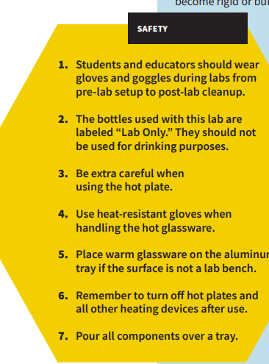
Remember, safety first!

Procedure:
- Have your Resource Manager gather the supplies for the lab.

- Put on your safety goggles. You may also request a safety apron to wear.

- Place wax paper over your loop tracing sheet and tape it to the tabletop.

- Set up your tray for pouring over.

- In a 250-mL beaker, use a digital scale to measure 5g of tapioca starch
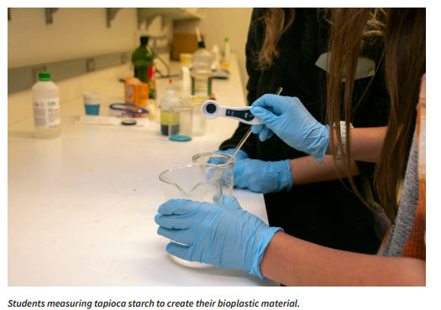
- Use a graduated cylinder to measure out __ mL white vinegar (an acid). Add it to the beaker with the starch. Mix with the stirring rod.

- Measure ______ mL of water and add to your beaker. Mix with the stirring rod.

- Measure __ mL of sorbitol (plasticizer) and add to your beaker. Mix with the stirring rod.

- Stir the solution until uniform.

- Turn on the hot plate and set to medium. Using a timer, heat the solution for 6–10 minutes, stirring for 15 seconds every minute until the solution starts to thicken. (formatting will adjust pictures to be offset to keep the flow of instructions)
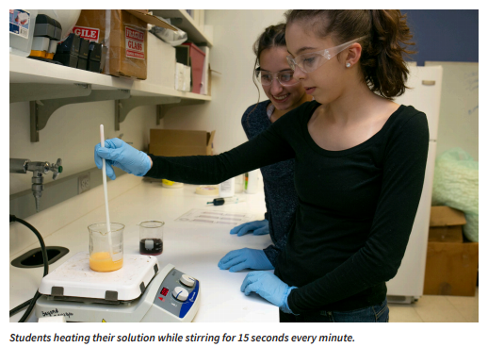
- When the solution reaches a gel-like consistency, put on your heat resistant safety gloves, turn off the hot plate, and remove the beaker from the heat.

- Using your stirring rod, transfer the material from the beaker into the syringe.

- Insert the plunger and flip the syringe upward. Push out excess air.

- Fill in the loop outlines on the tracing sheet using your syringe. Aim to make at least 3.

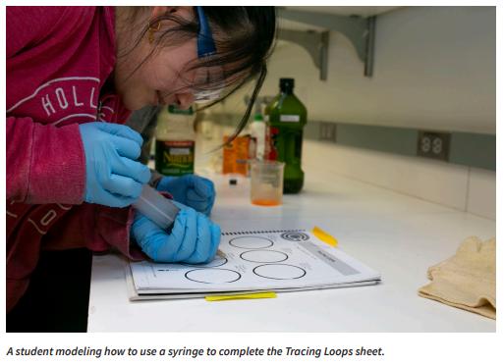

- Let your bioplastic material sit overnight to form.

Post-Lab Clean-Up
▶ All materials are safe to pour down the drain.
▶ Wipe any residue with a paper towel before washing the labware.
▶ Clean the beakers, teaspoons, and stirring rods in a warm, soapy water bath with 30 mL of vinegar.
▶ Dry the tools and lab equipment, then store them properly in the appropriate areas of the lab

Ticket-Out
🎫
Now that you have made your final loops after making several practice rounds beforehand, what are some edits you would make to your lab procedure to help future scientists replicate your work.

