Lesson 1
Optimizing Your Formulation

Activator/Bell Ringer/Starter
🔔
Reading about starches

Biological material, or living materials, can be grown and harvested above ground. This makes biological material more accessible, and they have a smaller environmental impact. Many companies have used biological material sources to make plastics to be more cost effective and sustainable than traditional petroleum based plastics.

Depending on where you are in the world, different starches are used as the bios in bioplastics. In this lab, you will use tapioca starch as your starch material. Tapioca starch is understudied in the bioplastic field, which gives you a lot of opportunities to discover novel formations for creating new products.

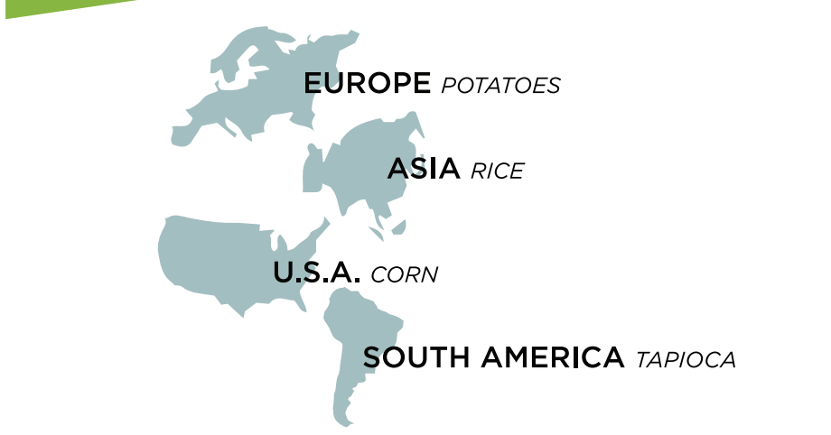
Even with this understanding of how different factors change bioplastic properties, it is difficult to predict results. This is because there are still other variables to consider:
- Water interacts with the starch molecules to determine the viscosity of the solution.
- The surface area of the starch granules contributes to how much the water is able to interact with the starch molecules. Water can interact more with starch that has smaller granules, thus dissolving the starch easier.
- The type and size of the starch impacts chemical reactions.
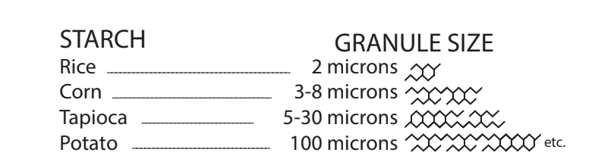

Hypothesize which starch will yield the most flexible loops. Include a reason why you think that.

The most flexible loop will be made with ___________________________ starch because ______________________________________________________________.

Lab: Optimizing Your Formulation

My group’s starch: ____________________

Materials:
- 250-mL beakers (3)
- Heat-resistant gloves
- Aluminum tray
- Hot plate
- Stirring rod
- Syringes
- Graduated cylinder
- Wax pencil
- Wax paper, 1 8x11 sheet
- Protective gloves, 1 pair per student
- Protective goggles, 1 per student
- Photocopies of Tracing Loops sheet, 1 per student
- Tapioca starch
- Corn starch
- Rice starch
- White vinegar (pure)
- Diluted white vinegar (50% water, 50% vinegar)
- Sorbitol
- Wax paper
- Tape
- pens/pencils
- Lab Safety Rules
- Cellphone timer

List below the formula components you will be using:
Starch: _________________
Acid:________________
Heat:_______________
Water:_______________
Alcohol: _________________
Plasticizer: _______________
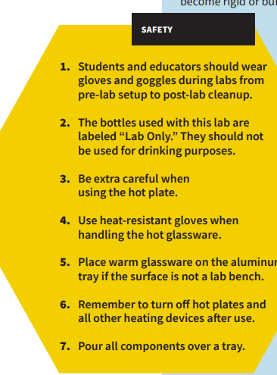
REMEMBER: Safety first!

Procedure:
- Have your Resource Manager gather the supplies for the lab.

- Put on your safety goggles. You may also request a safety apron to wear.

- Place wax paper over your loop tracing sheet and tape it to the tabletop.

- Set up your tray for pouring over.

- In a 250-mL beaker, use a digital scale to measure 5g of _________ starch
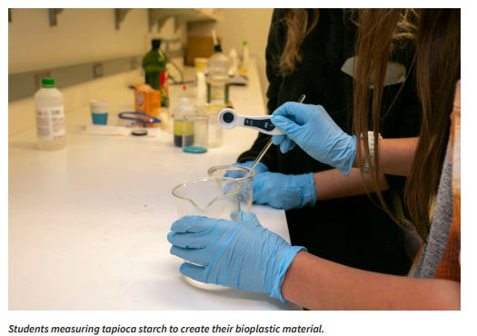
- Use a graduated cylinder to measure out 5mL of __________ (pure or dilute) white vinegar (an acid). Add it to the beaker with the starch. Mix with the stirring rod.
- Measure ______ mL of water and add to your beaker. Mix with the stirring rod.

- Measure 5mL of sorbitol (plasticizer) and add to your beaker. Mix with the stirring rod.

- Stir the solution until uniform.

- Turn on the hot plate and set to _____________ (High, medium, low or off). Using a timer, heat the solution for 6–10 minutes, stirring for 15 seconds every minute until the solution starts to thicken.
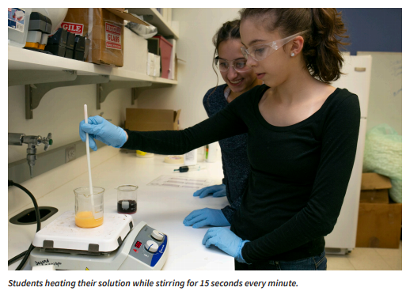
- When the solution reaches a gel-like consistency, put on your heat resistant safety gloves, turn off the hot plate, and remove the beaker from the heat.
- Using your stirring rod, transfer the material from the beaker into the syringe.

- Insert the plunger and flip the syringe upward. Push out excess air.

- Fill in the loop outlines on the tracing sheet using your syringe. Aim to make at least 3.

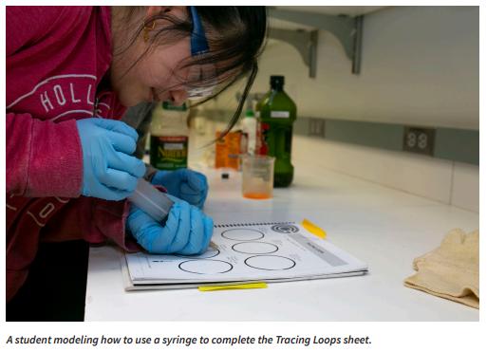

- Let your bioplastic material sit overnight to form.

Post-Lab Clean-Up
▶ All materials are safe to pour down the drain.
▶ Wipe any residue with a paper towel before washing the labware.
▶ Clean the beakers, teaspoons, and stirring rods in a warm, soapy water bath with 30 mL of vinegar.
▶ Dry the tools and lab equipment, then store them properly in the appropriate areas of the lab.

Ticket-Out
🎫
In the space below, make notes of any places in the procedure where your group deviated from what was written in case there are inconsistencies in our results tomorrow.

