Sustainable Invention: An Exploration of Bioplastics
Module 3

Table of Contents
- Teacher Resources
- Overview of Lesson 1: Optimizing Your Formulation
- Overview of Lesson 2: Material Testing, Analysis, and Conclusions
- Overview of Lesson 3: Testing the Optimized Formula
- Overview of Lesson 4: CER Development
- Lesson 1 Optimizing Your Formulation
  - Bell Ringer
  - Lab: Optimizing Your Formulation
  - Ticket-Out
- Lesson 2 Material Testing, Analysis, and Conclusions
  - Bell Ringer
  - Lab: Material Testing, Analysis, and Conclusions
  - Ticket-Out
- Lesson 3 Testing the Optimized Formula
  - Bell Ringer
  - Lab: Testing the Optimized Formula
  - Ticket-Out
- Lesson 4 CER Development
  - Bell Ringer
  - Claims, Evidence, Reasoning
  - Let’s Try a CER Together!
  - Loop Formulation CER
  - Grading Rubric for a CER
  - Ticket-Out

Desired Results
Enduring Understanding from Unit:
- Inventing a new technology involves coming up with an idea, developing that idea with the use of peer feedback, and re-designing based on testing.
- Bioplastics can be used to create novel products and/or better versions of already existing products.

Essential Question from Unit:
- How can we make a product that is good for people and the environment?

Standards Addressed (Content and ELP)
NGSS Science Standards:
- MS-ETS1-1: Define the criteria and constraints of a design problem with sufficient precision to ensure a successful solution.
- MS-ETS1-2: Evaluate competing solutions to a given design problem using a decision matrix to determine how well each meets the criteria and constraints of the problem.
- MS-ETS1-3: Analyze data from tests to determine similarities and differences among several design solutions to identify the best characteristics of each that can be combined into a new solution to better meet the criteria for success.
- MS-ETS2-2(MA): Given a design task, select appropriate materials based on specific properties needed in the construction of a solution.

Science and Engineering Practices:
1. Asking questions and defining problems
3. Planning and carrying out investigations
6. Constructing explanations and designing solutions
8. Obtaining, evaluating, and communicating information

Overview
Task overview: Students will be introduced to the concepts of polymers, pH, acids, bases, pH scale, and crosslinking in a series of thought and reading activities. They will then apply those concepts to a lab activity where they will attempt to create an optimized version of their polymer loops after engaging in an evaluative session of material testing their loops as well as the loops of other members of their class. They will then evaluate their new loops as well as their classmates’ loops and use that to create a CER (claim-evidence-reasoning) about why their loop ended up being created with its specific set of properties.

Language focus
Communicating through verbal and written language by all participants. Small group discussions will also occur.
- Written communication of what is pH, acids, and bases.
- Verbal and written evaluation of properties of loops created in a previous class
- Reading about polymers, pH and its associated language, and cross-linking.
- Verbal and written evaluation of properties of loops created during these lessons
- Written reflection of each day as well as hypothesizing what the next day may be like.
- Written evaluation of the lab process and the lab products
- Verbal communication to achieve team-work based tasks.

Learning Targets | Formative Assessment
- Content-focused:  - Polymers  - pH  - Acids  - Bases  - pH scale  - crosslinking  - Language-focused:  - Written communication  - Verbal / written evaluation  - Written reflections  - Verbal communication  - Associating readings with activity language | - See provided closures below  - Matching activity  - Compare/Contrast chart with feedback on what each group did to achieve their desired loop properties  - CER on why their loops did/did not have the properties they were seeking to achieve.

Key Content Vocabulary | Cross-Disciplinary Vocabulary
- Polymers  - pH  - Acids  - Bases  - pH scale  - Crosslinking  - optimized | - Material Testing

Materials or Apps
Teachers:  - 250-mL beakers, 3 per student group  - Aluminum tray, 1 per student group  - Heat-resistant gloves, 1 pair per student group  - Hot plate, 1 per student group  - Stirring rod, 1 per student group  - Syringes, 1 per student group  - Graduated cylinders, 1 per student group  - Digital scale, 1 per student group  - Wax pencil, 1 per student group  - Protective gloves, 1 pair per student  - Protective goggles, 1 per student  - Wax paper  - Tape  - Additives: white vinegar, baking soda  - Coconut oil  - Sorbitol  - Tapioca starch  - Tracing Loops Sheet | Students:  - pens/pencils  - Lab Safety Rules  - Cellphone Timer or Stopwatch
Lesson Preparation
**Teacher needs to hold onto results from testing in the previous Meeting in such a way as can be displayed for the class**
Options: Google Classroom, butcher paper chart, white board, display board, etc.

Instructor needs to pre-print photocopies of worksheets if not a one-to-one school or for students who require hard copies as an accommodation to the curriculum. Instructor also needs to pre-print the loop outlines for each lab group.

Instructors may want to have all the lab materials set-out in an organized manner to make it easier for the material manager of each group to both gather the materials and put them away at the end of the lab days. Alternatively, if there are enough materials, groups can keep their materials together in a box at their work station to lessen time spent collecting materials each day.

Students should already know how to prepare a Claims-Evidence-Reasoning Statement. If not, the instructor may want to add a day to model and practice with the students using the provided extended learning activity.

Estimated Time:
(5) 45-minute class periods with all resources used
Lesson Sequence
Lesson 1: Optimizing Your Formulation
- Independent Bell ringer (10 minutes): Reading about the different starches (corn, tapioca. potato and rice) and their impact on various properties of the loops. Students hypothesize the impact of using different starting materials.

- Whole Group (5 minutes): We spent the last week testing several different variables for their impact on the flexibility of our loops. If you remember, we also thought that the starting materials might impact the qualities of the loops. Today, we are all going to go back to our original lab procedure so we can test and identify the impact the different starting materials (different starches) have on loop qualities. Each lab group chooses a different starch to use. Ideally, there will be two groups testing each starch.

- Small Group (20-25 minutes): The students work their way through the lab with the instructor functioning as the facilitator. Make sure students are following safety protocols (wearing goggles/glasses at all times and gloves as needed). During this time, the instructor functions as facilitator, engaging in frequent check-ins to ensure that everyone is progressing appropriately through the lab work. The instructor is also available to answer questions and assist groups that require more help than others.
  - Possible check in questions:
    - What are you noticing?
    - What step is next? How can you prepare for that step?
    - Are things going as expected? Can you pivot?
    - Sometimes questions aren’t needed, you can just watch and collect ideas for group questions at the end.
    - When students have questions, try to turn the question back to them, encouraging them to refer to their lab or their group mates.

- Small Group (5-10 minutes): The students clean up the lab activity following the directions posted at the end of the lab, returning materials to designated locations, setting their loops in an out of the way location for setting overnight. Remind groups to label their loops so they know which ones are theirs. Have students complete the ticket-out when they are cleaned up.

Lesson 2: Material Testing, Analysis, and Conclusions
- Individual or Small Group (5 minutes): answer the bell ringer regarding loop disposal.

- Small Group (10 minutes): Groups repeat their tests for flexibility using the lab procedures from earlier in the week. Have groups that tested the same starch work together and compare their results, discussing any inconsistencies between their findings.

- Whole Group (5 minutes): Share out results of flexibility testing based on different starting starches.
  - Have groups notice any other traits that were impacted--surface texture, color, etc.

- Whole Group/Small Group (10 minutes): Groups will choose their optimized formula regarding each of the following variables (modified worksheet):
  - Concentration of solution (how much water)
  - Temperature
  - Ingredients used (specifically which starch)
  - pH
    - For each variable, they will need to explain why they chose it and how they anticipate it impacting the final qualities of their loops.

- Whole Group (5 minutes): Refer back to the lab from day 3 of Module 2 where the steps impacting each variable were highlighted so groups know which steps they will need to adapt or pay close attention to depending on what variables they will be testing.

- Small Group (10 minutes): Groups plan and rewrite their lab procedure for testing their adjustments to each variable. **Groups will turn in their lab procedure for the teacher to check over before the next day.** Have students complete the ticket-out when they have turned in their lab procedures.

Lesson 3: Testing the Optimized Formula
- Small Group (5-10 minutes): Using the bell ringer, students articulate final adjustments to their procedure and justify how the adjustment is consistent with their original design/client request.

- Small Group (20-25 minutes): Students do the lab testing their chosen variable. During this time, the instructor functions as facilitator, engaging in frequent check-ins to ensure that everyone is progressing appropriately through the lab work. The instructor is also available to answer questions and assist groups that require help.

- Small Group (10 minutes): The students clean up the lab activity following the directions posted at the end of the lab, and complete the ticket-out.

Lesson 4: CER Development (2 days)
- Individual or Small Group (5 minutes): Complete the bell ringer, a K-W-L-S brainstorm

- Whole Group (10 minutes): Encourage and facilitate students sharing their individual K-W-L-S entries.

- Whole Group (5 minutes): If needed, describe what a CER is as a whole class. Use the provided CER text to illustrate.

- Whole Group/Small Group (20-25 minutes): Complete a CER together. Watch the video The Life Cycle of a Plastic Bottle: https://www.youtube.com/watch?v=_6xlNyWPpB8. The handout Let’s Try a CER Together! provides students example statements. Encourage students to add their own evidence and reasoning statements from the video or other sources. Students then individually or in pairs complete a paragraph using the statements from the group CER table. Use the Put it All Together! template for this. You can prepare a slide for students to type in so that students can provide feedback on peer’s work.

- Individual or Small Group (20 minutes): Once students are comfortable developing a CER paragraph, they will compose a CER paragraph about their loop invention process. They should use all of the information and observations collected since the start of the unit, and should be encouraged to refer to the previous lab activity in which they made loops for the first time. The question is “What is the best formulation for the properties you have tried to produce?”As with the sample Life Cycle of a Plastic Bottle example, students will develop this CER in two parts: first using a note catcher or outline of what they will write (the graphic can be provided to students as a slide that they can type into), then to write their CER statement in a paragraph format (Putting it all together!). A grading rubric for a CER is provided which can also be reviewed with students prior to the completion of their paragraph.

- Small Group (20 minutes): Students provide feedback on each other’s CERs.

- Ticket-Out (5 minutes): Students complete the 3-2-1 reflection.

Lesson 1
Optimizing Your Formulation

Activator/Bell Ringer/Starter
🔔
Reading about starches

Biological material, or living materials, can be grown and harvested above ground. This makes biological material more accessible, and they have a smaller environmental impact. Many companies have used biological material sources to make plastics to be more cost effective and sustainable than traditional petroleum based plastics.

Depending on where you are in the world, different starches are used as the bios in bioplastics. In this lab, you will use tapioca starch as your starch material. Tapioca starch is understudied in the bioplastic field, which gives you a lot of opportunities to discover novel formations for creating new products.

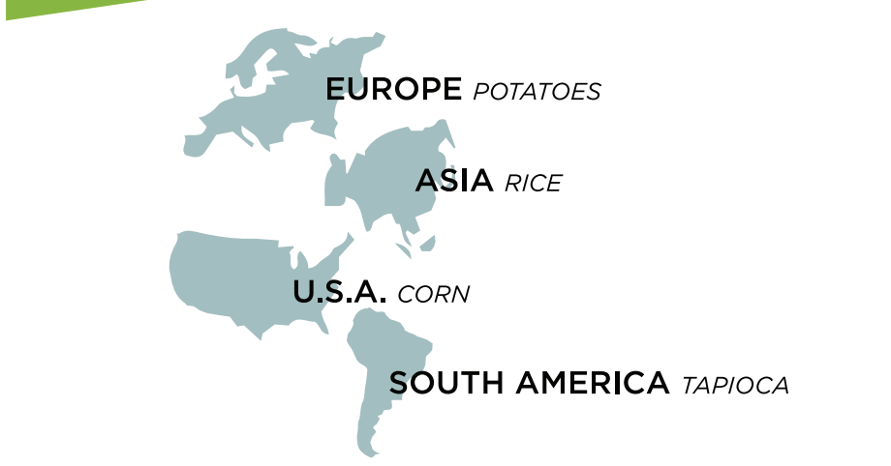
Even with this understanding of how different factors change bioplastic properties, it is difficult to predict results. This is because there are still other variables to consider:
- Water interacts with the starch molecules to determine the viscosity of the solution.
- The surface area of the starch granules contributes to how much the water is able to interact with the starch molecules. Water can interact more with starch that has smaller granules, thus dissolving the starch easier.
- The type and size of the starch impacts chemical reactions.
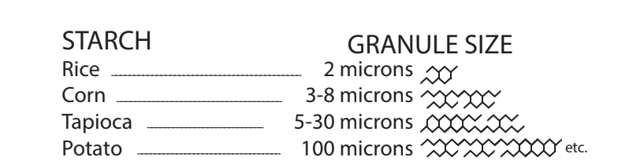

Hypothesize which starch will yield the most flexible loops. Include a reason why you think that.

The most flexible loop will be made with ___________________________ starch because ______________________________________________________________.

Lab: Optimizing Your Formulation

My group’s starch: ____________________

Materials:
- 250-mL beakers (3)
- Heat-resistant gloves
- Aluminum tray
- Hot plate
- Stirring rod
- Syringes
- Graduated cylinder
- Wax pencil
- Wax paper, 1 8x11 sheet
- Protective gloves, 1 pair per student
- Protective goggles, 1 per student
- Photocopies of Tracing Loops sheet, 1 per student
- Tapioca starch
- Corn starch
- Rice starch
- White vinegar (pure)
- Diluted white vinegar (50% water, 50% vinegar)
- Sorbitol
- Wax paper
- Tape
- pens/pencils
- Lab Safety Rules
- Cellphone timer

List below the formula components you will be using:
Starch: _________________
Acid:________________
Heat:_______________
Water:_______________
Alcohol: _________________
Plasticizer: _______________
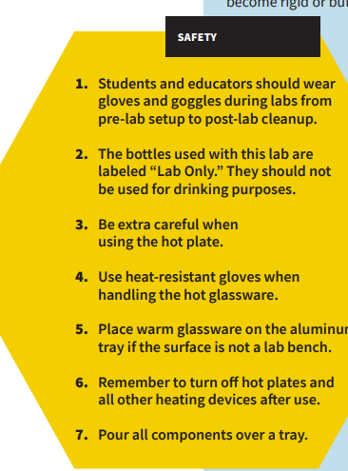
REMEMBER: Safety first!

Procedure:
- Have your Resource Manager gather the supplies for the lab.

- Put on your safety goggles. You may also request a safety apron to wear.

- Place wax paper over your loop tracing sheet and tape it to the tabletop.

- Set up your tray for pouring over.

- In a 250-mL beaker, use a digital scale to measure 5g of _________ starch
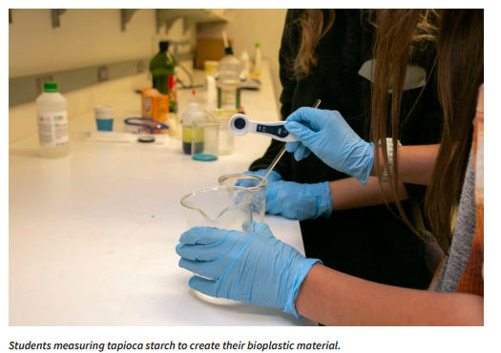
- Use a graduated cylinder to measure out 5mL of __________ (pure or dilute) white vinegar (an acid). Add it to the beaker with the starch. Mix with the stirring rod.
- Measure ______ mL of water and add to your beaker. Mix with the stirring rod.

- Measure 5mL of sorbitol (plasticizer) and add to your beaker. Mix with the stirring rod.

- Stir the solution until uniform.

- Turn on the hot plate and set to _____________ (High, medium, low or off). Using a timer, heat the solution for 6–10 minutes, stirring for 15 seconds every minute until the solution starts to thicken.
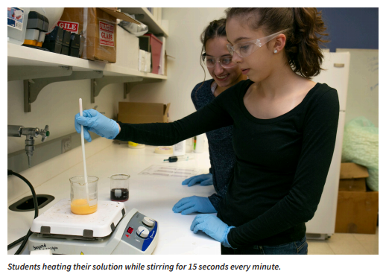
- When the solution reaches a gel-like consistency, put on your heat resistant safety gloves, turn off the hot plate, and remove the beaker from the heat.
- Using your stirring rod, transfer the material from the beaker into the syringe.

- Insert the plunger and flip the syringe upward. Push out excess air.

- Fill in the loop outlines on the tracing sheet using your syringe. Aim to make at least 3.

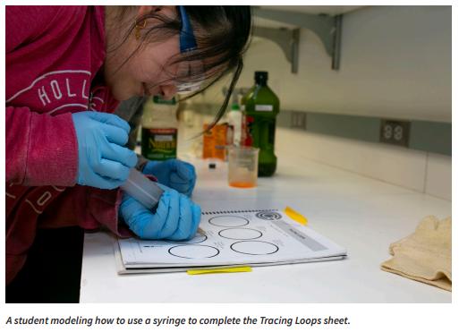

- Let your bioplastic material sit overnight to form.

Post-Lab Clean-Up
▶ All materials are safe to pour down the drain.
▶ Wipe any residue with a paper towel before washing the labware.
▶ Clean the beakers, teaspoons, and stirring rods in a warm, soapy water bath with 30 mL of vinegar.
▶ Dry the tools and lab equipment, then store them properly in the appropriate areas of the lab.

Ticket-Out
🎫
In the space below, make notes of any places in the procedure where your group deviated from what was written in case there are inconsistencies in our results tomorrow.

Lesson 2
Material Testing, Analysis and Conclusions

Activator/Bell Ringer/Starter
🔔
We’ve made quite a few loops at this point. What would be the greenest way to acquire starches? How does this change based on where you are located in the world?

Your answers:

Lab: Material Testing, Analysis and Conclusions
Fill in your data in the box that corresponds to the variable you tested. Add the data from other groups as well.
Observations | Flexibility Observations + Data:
Corn Starch Group #1:
Corn Starch Group #2:

Tapioca Starch Group #1:
Tapioca Starch Group #2:
Rice Starch Group #1:
Rice Starch Group #2:
Potato Starch Group #1:
Potato Starch Group #2:

Additional observations on the impact of Rice Starch on loops

Additional observations on the impact of Corn Starch on loops

Additional observations on the impact of Tapioca Starch on loops

Additional observations on the impact of Potato Starch on loops

Ticket-Out
🎫
Based on your lab findings, will you be able to supply the client with a product that provides the desired qualities? Please write a short update to your client about your progress.

Your Client Update

Lesson 3
Testing the Optimized Formula

Activator/Bell Ringer/Starter
🔔
For each variable you’re adjusting, provide a sentence justifying how the adjustment is consistent with your original design/client request.

Concentration of solution (how much water)
We are adjusting the concentration __________________________________ because ________________________________________________________________________.

Temperature
We are adjusting the temperature __________________________________ because ________________________________________________________________________.

Starch used
We are adjusting the starch to be __________________________________ because ________________________________________________________________________.

pH
We are adjusting the pH __________________________________ because ________________________________________________________________________.

LAB: Testing the Optimized Formula

Materials:
- 250-mL beakers (3)
- Heat-resistant gloves
- Aluminum tray
- Hot plate
- Stirring rod
- Syringes
- Graduated cylinder
- Wax pencil
- Wax paper, 1 8x11 sheet
- Protective gloves, 1 pair per student
- Protective goggles, 1 per student
- Photocopies of Tracing Loops sheet, 1 per student
- Tapioca starch
- Corn starch
- Rice starch
- White vinegar (pure)
- Diluted white vinegar (50% water, 50% vinegar)
- Sorbitol
- Wax paper
- Tape
- pens/pencils
- Lab Safety Rules
- Cellphone timer

List below the formula components you will be using:
Starch: _________________
Acid:________________
Heat:_______________
Water:_______________
Alcohol: _________________
Plasticizer: _______________

Remember, safety first!

Procedure:
- Have your Resource Manager gather the supplies for the lab.

- Put on your safety goggles. You may also request a safety apron to wear.

- Place wax paper over your loop tracing sheet and tape it to the tabletop.

- Set up your tray for pouring over.

- In a 250-mL beaker, use a digital scale to measure 5g of tapioca starch
- Use a graduated cylinder to measure out __ mL white vinegar (an acid). Add it to the beaker with the starch. Mix with the stirring rod.

- Measure ______ mL of water and add to your beaker. Mix with the stirring rod.

- Measure __ mL of sorbitol (plasticizer) and add to your beaker. Mix with the stirring rod.

- Stir the solution until uniform.

- Turn on the hot plate and set to medium. Using a timer, heat the solution for 6–10 minutes, stirring for 15 seconds every minute until the solution starts to thicken. (formatting will adjust pictures to be offset to keep the flow of instructions)
- When the solution reaches a gel-like consistency, put on your heat resistant safety gloves, turn off the hot plate, and remove the beaker from the heat.

- Using your stirring rod, transfer the material from the beaker into the syringe.

- Insert the plunger and flip the syringe upward. Push out excess air.

- Fill in the loop outlines on the tracing sheet using your syringe. Aim to make at least 3.

- Let your bioplastic material sit overnight to form.

Post-Lab Clean-Up
▶ All materials are safe to pour down the drain.
▶ Wipe any residue with a paper towel before washing the labware.
▶ Clean the beakers, teaspoons, and stirring rods in a warm, soapy water bath with 30 mL of vinegar.
▶ Dry the tools and lab equipment, then store them properly in the appropriate areas of the lab

Ticket-Out
🎫
Now that you have made your final loops after making several practice rounds beforehand, what are some edits you would make to your lab procedure to help future scientists replicate your work.

Lesson 4
CER Development

Activator/Bell Ringer/Starter
🔔
Fill in the KWLS chart below about Claims-Evidence-Reasoning writing.
Aim for 1 item per column.

K  What do you know? | W  What do you wonder? | L  What have you learned? | S  What are you still curious about?

Claims, Evidence, Reasoning
The fun starts here!

What is it?
It is a scientific explanation.

A claim is a statement that answers a question.

Evidence is the observations collected about a phenomenon. It can be communicated as scientific data, photographs, charts, tables, graphs, written observations, etc...

Reasoning is how your evidence supports or justifies your claim. It ties them together.

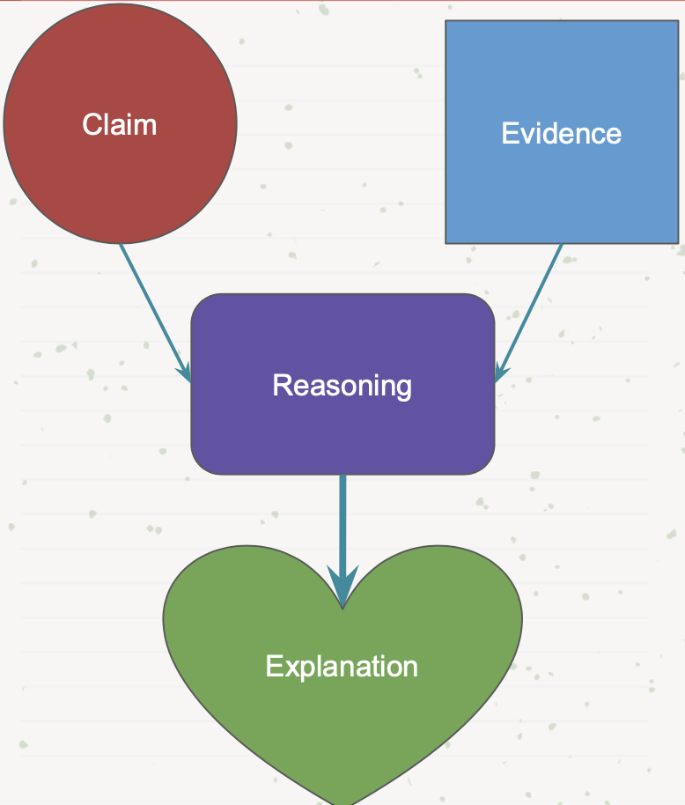
Let’s Try a CER Together!

Watch the video The Life Cycle of a Plastic Bottle
https://www.youtube.com/watch?v=_6xlNyWPpB8

Question: What is the impact of plastic that gets thrown away?
CLAIM
Write a statement that answers the question.
(Please write the claim in blue)

Single use plastics when disposed of improperly are harmful to the environment.
EVIDENCE  Scientific data from investigations or research to support your claim.  (Please write the evidence in orange)  Plastic takes up to 1,000 years to decompose.  Leachate is contaminated water from solid waste that leaks out and pollutes surrounding water and soil.  Plastic pollution ends up breaking into microplastics.  Microplastics cause starvation for some ocean animals.  When plastic is recycled it can be transformed into the raw materials for other products. | REASONING  Explain how the evidence supports the claim.  (Please write the evidence in purple)  Plastic bottles go into landfills as trash, waterways as pollution or can be recycled.  Plastic contamination impacts ecosystems.  Recycling reduces the negative impacts of plastics ending up in landfills or the ocean.

Put it All Together!
Below, put together your bullets from before to create your Claim, Evidence, and Reasoning paragraph.

Question: What is the impact of plastic that gets thrown away?

Loop Formulation CER
You are going to compose a CER statement about your loop invention process. For your CER, you may use all of the information and observations you have collected since the start of the invention and green chemistry topic. You may also refer to the previous lab activity in which you made loops for the first time.

You will conduct activity in two parts: the first is a note catcher or outline of what you will write. The second is your CER statement in a paragraph format.

Question:
What is the best formulation for the properties you have tried to produce?
CLAIM
Write a statement that answers the question.
(Please write the claim in blue)

EVIDENCE  Scientific data from investigations or research to support your claim.  (Please write the evidence in orange) | REASONING  Explain how the evidence supports the claim.  (Please write the evidence in purple)

Put it all together!
Below, put together your bullets from before to create your Claim, Evidence, and Reasoning paragraph.

Grading Rubric for a CER

 | 1  (On your way) | 2  (almost there) | 3  (Complete & Correct) | 4  (Above & Beyond)
Claim | Claim is missing | Claim is inaccurate and incomplete. | Claim is accurate but vague. | Claim is accurate and specific.
Evidence | Evidence not provided or uses irrelevant or incorrect evidence | Some evidence is included, but not all is relevant or provides insufficient number of facts, data, and observations | Identifies key evidence with appropriate facts, data, and observations | The evidence includes information about the validity or quantity of the data
Reasoning | Does not provide reasoning | Reasoning does not provide link between the claim and the evidence | Reasoning does link the claim to the evidence, but incompletely - there are not enough details | Reasoning includes justification of the source of evidence.

Ticket-Out
🎫
3-2-1
3 parts of writing a CER I am most confident about:

2 areas I think I need to continue to develop:

1 question I still have:

