Lesson 4
Redesigning Your Procedure

Activator/Bell Ringer/Starter
🔔
After reading Variation Between Loops, match the following words and definitions.
Term | Definition
1. _____ Acid | A. A long, repeated chain of something, like a sugar
2. _____ Base | B. The interaction of polymers with other polymers through bonding.
3. _____ Concentration | C. Measure of how acidic or basic a solution is.
4. _____ Cross-Linking | D. A solution that has a pH that is below 7.
5. _____ Dilute | E. A solution that has a pH that is at or around 7.
6. _____ Neutral | F. A solution that has a pH that is above 7.
7. _____ pH | G. A solution that has a pH at around 1.
8. _____ Polymer | H. A solution that has a pH at around 14.
9. _____ Rigid | I. A solution that does not have a lot of water in it - so the main part of it is strong.
10. _____ Strong Acid | J. A solution that does have a lot of water in it - so the main part of it is weak.
11. _____ Strong Base | K. Not flexible, hard to bend or move.

Variation Between Loops

As we have seen, the loops did not perform exactly the same between the groups. Some loops may have been more flexible while others may have been more rigid. These loops may have varied because of human variation! You all did slightly different executions of the same procedure. The bioplastic properties are determined by three factors:

- Presence of heat? the temperature of the solution at the time of heating,
- the concentration of the solution, and
- the acidity or basicity of the solution.

Temperature
Often in the manufacturing of substances, heat/temperature plays a role in how quickly a chemical change will take place. The hotter something is, the faster its particles will move, and the more reactions or changes that can occur. However, too much heat may damage the bonds that form during the reactions. Monitoring temperature to ensure that it is consistent throughout the multiple trials is necessary to potentially avoid an “error”, or mistake, in loop manufacturing.

Concentration
The bioplastic properties are also determined in part by how much water is in the solution.
- If more water is added into the solution, the solution becomes more dilute, or less concentrated. The less concentrated the solution, the more flexible the final product.
- If you added less water to the solution, then the solution would become less dilute, or more concentrated. The more concentrated the solution, the less flexible the final product. Items that are not flexible are referred to as rigid.

More 💧 means less concentrated (dilute) which means flexible!

Less 💧 means more concentrated which means rigid!

Acids and Bases
Plastics come in many shapes and forms, and their properties change based on the chemical reactions that occur when they are created. Our starting material, starch, is a polymer, or long chain, of molecules.

MONOMER
(A SUGAR)

POLYMER
LOOSE MONOMERS
The polymer chains of sugars interact with each other through bonding, or cross-linking. Lots of bonds between the chains create a rigid structure, while less bonds between the chains create a loose and flexible structure. If there is no cross-linking, there won’t be a solid plastic.

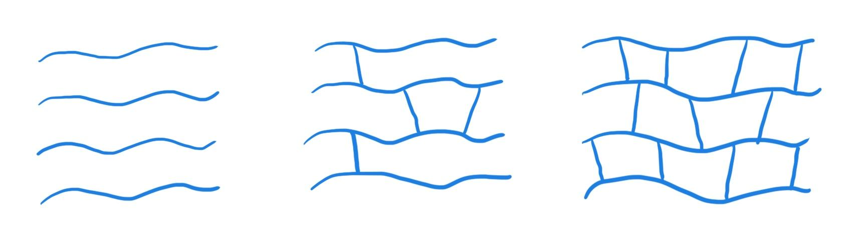

Polymers with NO cross-linking

Polymers WITH cross-linking

We measure how acidic or basic an environment is using pH. The pH scale ranges from 1 (strong acid) to 7 (neutral) to 14 (strong base). The further a pH is from 7, the stronger the acid/base is, while a pH closer to 7 indicates a weaker or more neutral acid/base. The pH impacts how much bonding (cross-linking) occurs. A strong acid or base blocks some cross-linking when creating your bioplastic, which would create a more flexible product. Putting your starch polymer in a weak acid or base environment will keep more of the cross-linking bonds intact, and create a more rigid product.. Stronger acids or bases create smaller pieces, or smaller polymers.
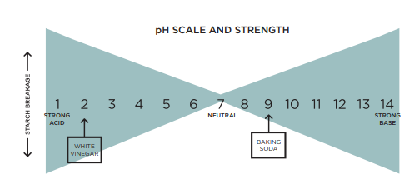

More Flexible | Less Flexible (Rigid)
___low____Concentration of starch (___high___) water | ___high___Concentration of starch (___low___) water
_______ temperature | _______ temperature
______ pH | ______ pH

My group’s variable:
Hypothesis:

Lab: Testing Variables With Bioplastics:
Temperature, Concentration, pH

My group’s variable:

Materials:
- 250-mL beakers (3)
- Heat-resistant gloves
- Aluminum tray
- Hot plate
- Stirring rod
- Syringes
- Graduated cylinder
- Wax pencil
- Wax paper, 1 8x11 sheet
- Protective gloves, 1 pair per student
- Protective goggles, 1 per student
- Photocopies of Tracing Loops sheet, 1 per student
- Tapioca starch
- White vinegar (pure)
- Diluted white vinegar (50% water, 50% vinegar)
- Sorbitol
- Wax paper
- Tape
- Lab Safety Rules
- Cellphone timer

List below the formula components you will be using:
Starch: _________________
Acid:________________
Heat:_______________
Water:_______________
Alcohol: _________________
Plasticizer: _______________
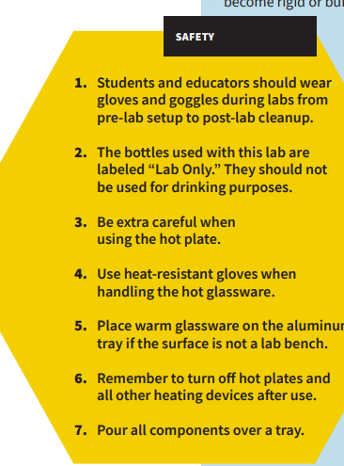
REMEMBER: Safety first!

Procedure:
- Have your Resource Manager gather the supplies for the lab.

- Put on your safety goggles. You may also request a safety apron to wear.

- Place wax paper over your loop tracing sheet and tape it to the tabletop.

- Set up your tray for pouring over.

- In a 250-mL beaker, use a digital scale to measure 5g of tapioca starch

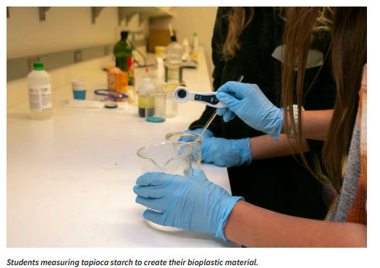

- Use a graduated cylinder to measure out 5mL of __________ (pure or dilute) white vinegar (an acid). Add it to the beaker with the starch. Mix with the stirring rod.

- Measure ______ mL of water and add to your beaker. Mix with the stirring rod.

- Measure 5mL of sorbitol (plasticizer) and add to your beaker. Mix with the stirring rod.

- Stir the solution until uniform.

- Turn on the hot plate and set to _____________ (High, medium, off or low). Using a timer, heat the solution for 6–10 minutes, stirring for 15 seconds every minute until the solution starts to thicken.
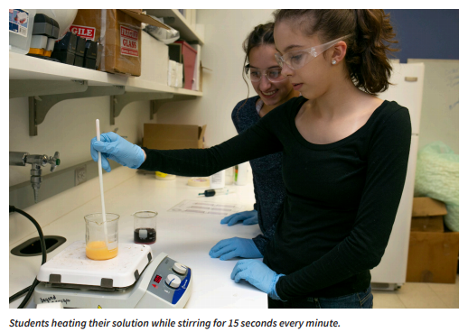
- When the solution reaches a gel-like consistency, put on your heat resistant safety gloves, turn off the hot plate, and remove the beaker from the heat.

- Using your stirring rod, transfer the material from the beaker into the syringe.
- Insert the plunger and flip the syringe upward. Push out excess air.

- Fill in the loop outlines on the tracing sheet using your syringe. Aim to make at least 3.
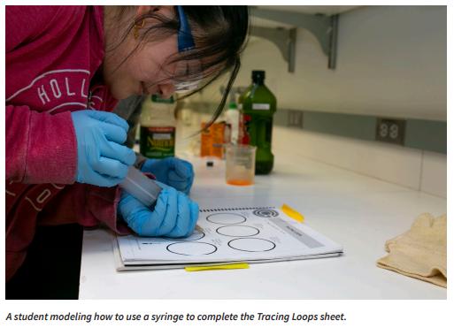
- Let your bioplastic material sit overnight to form.

Post-Lab Clean-Up
▶ All materials are safe to pour down the drain.
▶ Wipe any residue with a paper towel before washing the labware.
▶ Clean the beakers, teaspoons, and stirring rods in a warm, soapy water bath with 30 mL of vinegar.
▶ Dry the tools and lab equipment, then store them properly in the appropriate areas of the lab.
Ticket-Out
🎫
Describe the key step(s) your group will be changing in testing the impact of your variable on the flexibility of the loops. Include anything you’ll need to be particularly mindful to do with accuracy and precision.

