Lesson 1
Experimenting with Bioplastics

Activator/Bell Ringer/Starter
🔔
Match the term to its definition:
Term | Definition
- _____ Acid | - Used in bioplastics to create a solution
- _____ Water | B. Odorless, tasteless white substance naturally occurring in plant tissue
- _____ Plasticizer | C, A chemical that when added to a substance, promotes flexibility and elasticity
- _____ Starch | D. Substances that have a pH between 1 and 7.

Using the image, sequence the formulation to make a bioplastic, using numbers 1 - 5, with 1 being the first step.
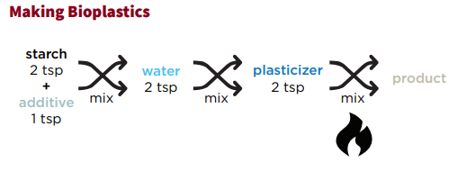
_____ Add heat to your mixture
_____ Mix starch with an additive
_____ Let your product cool off
_____ Add the alcohol to your mixture
_____ Add water to your mixture
Pre-Lab: Experimenting with Bioplastics

Pre-Lab Work
- Form into groups of 3-4 individuals and select your lab roles.
Project Coordinator and Lead  - Goes to the teacher to address a question.  - Keeps track of time and deadlines.  - Keeps the team on task.  - Monitors noise levels in groups, reminds group to be respectful of each other.  - Encourages Participation. | Project Architect  - Reads directions for tasks aloud to the group.  - Takes the lead on creating drawings, graphs, and diagrams needed by the group.  - Ensures work meets the assignment’s criteria.  - Helps develop other people’s ideas and to clarify points.
Project Resource Manager  - Collects supplies for the team.  - Sets up materials before beginning an activity.  - Cares for and returns supplies; Organizes clean-up.  - Finds out and gathers information, including ensuring that all data measured and recorded in labs/activities are accurate. | Project Documentation Specialist  - Makes sure each member of the team records work or data.  - Records all written information for the group, where needed.  - Makes and helps others make designs, tables, and/or graphs.  - Organizes and introduces a group report.
Project Coordinator/Lead is… Project Architect is…

Project Resource Manager is… Project Documentation Specialist is...

Background Info
Over the next few weeks, we are going to create a bioplastic product. In our last class, we discussed that bioplastics are plastics made from currently living, organic things, like potatoes, corn, tapioca, or even milk! They generally create less pollution and waste to manufacture than do petroleum/crude-oil based plastics.

- Read the following and respond to the questions that follow:

Bioplastics can have many different formulations (a means to make something, like a recipe). Today, your formulation will be made with starch, plasticizer, and an acid. These are the four components to making a starch-based bioplastic.
- A starch is an odorless, tasteless white substance naturally occurring in plant tissue; it stores carbohydrates - think of potatoes, rice, wheat, and tapioca - which are all starchy plants. Starch is the starting materials for bioplastics.
- Water is used in bioplastics to create a solution. Increase in water means a decrease in the concentration of starch. Often, this makes bioplastics more flexible (to a point, can be flooded with too much water.)
- Acids are substances that have a pH between 1-7. Varying on the strength of the acid, these help in crosslinking of bioplastics.
- A plasticizer is a substance added to a formulation to create a product that is more flexible. Plasticizers bind the bioplastics together to create a solid.

- Using the text and image above, revisit your bell ringer questions and check that you have matched the terms to their correct definitions:
Term | Definition
- _____ Acid | - Used in bioplastics to create a solution
- _____ Water | B. Odorless, tasteless white substance naturally occurring in plant tissue
- _____ Plasticizer | C. A chemical that when added to a substance, promotes flexibility and elasticity
- _____ Starch | D. Substances that have a pH between 1 and 7.

- Revisit your bell ringer questions again to make sure you have sequenced the formulation to make a bioplastic correctly. Use the numbers 1 - 5, with 1 being the first step.
_____ Add heat to your mixture
_____ Mix starch with an additive
_____ Let your product cool off
_____ Add the alcohol to your mixture
_____ Add water to your mixture

- Write down a “CC” next to the steps you just labeled in question 4 that you think are chemical changes.

- We will be making the industry standard “loop” shape for our initial experiments. Why would it be important to have a standard for trial shapes across an industry?
Lab: EXPERIMENTING WITH BIOPLASTICS

Materials:
- 250-mL beakers (3)
- Heat-resistant gloves
- Aluminum tray
- Hot plate
- Stirring rod
- Syringes
- Graduated cylinder
- Wax pencil
- Wax paper, 1 8x11 sheet
- Protective gloves, 1 pair per student
- Protective goggles, 1 per student
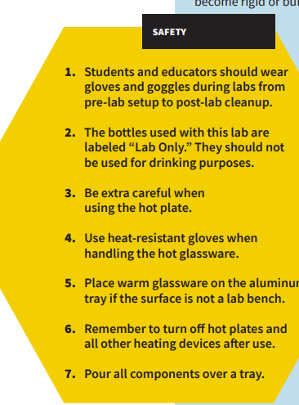
- Photocopies of Tracing Loops sheet, 1 per student
- Tapioca starch
- White vinegar
- Sorbitol
- Wax paper
- Tape
- pens/pencils
- Lab Safety Rules
- Cellphone timer

Procedure:
- Have your Resource Manager gather the supplies for the lab.

- Put on your safety goggles. You may also request a safety apron to wear.

- Place wax paper over your loop tracing sheet and tape it to the tabletop.

- Set up your tray for pouring over.

- In a 250-mL beaker, use a digital scale to measure 5g of tapioca starch.
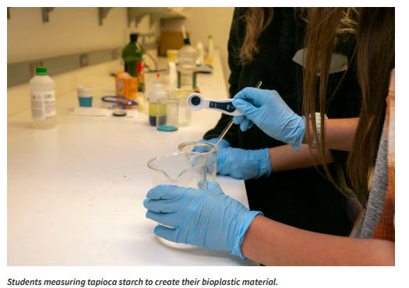
6. Use a graduated cylinder to measure out 5mL of white vinegar (an acid). Add it to the beaker with the starch. Mix with the stirring rod.

7. Measure 5mL of water and add to your beaker. Mix with the stirring rod.

8. Measure 5mL of sorbitol (plasticizer) and add to your beaker. Mix with the stirring rod.

9. Stir the solution until uniform. Teacher note: if you want to approve your students coloring the solution, add food coloring during this step.

10. Turn on the hot plate and set to medium (the middle of your hot plate settings). Using a timer, heat the solution for 6–10 minutes, stirring for 15 seconds every minute until the solution starts to thicken.
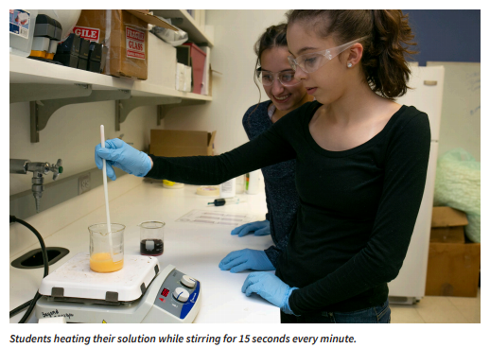
11. When the solution reaches a gel-like consistency, put on your heat resistant safety gloves, turn off the hot plate, and remove the beaker from the heat.

12. Scooping from the beaker, use your stirring rod to transfer the material from the beaker into the syringe.

13. Insert the plunger and flip the syringe upward. Push out excess air.

14. Fill in the loop outlines on the tracing sheet using your syringe. Aim to make at least 3.

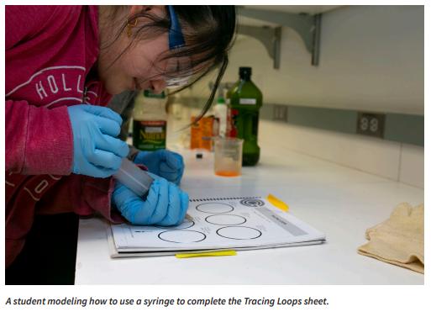
15. Let your bioplastic material sit overnight to form. Be careful to not knock or jolt the loops while they set.

Post-Lab Cleanup
- All materials are safe to pour down the drain.
- Wipe any residue with a paper towel before washing the labware.
- Clean all beakers, teaspoons, and stirring rod in a warm, soapy water bath with 30mL of vinegar in it.
- Dry the tools and lab equipment, then store them in the designated area.

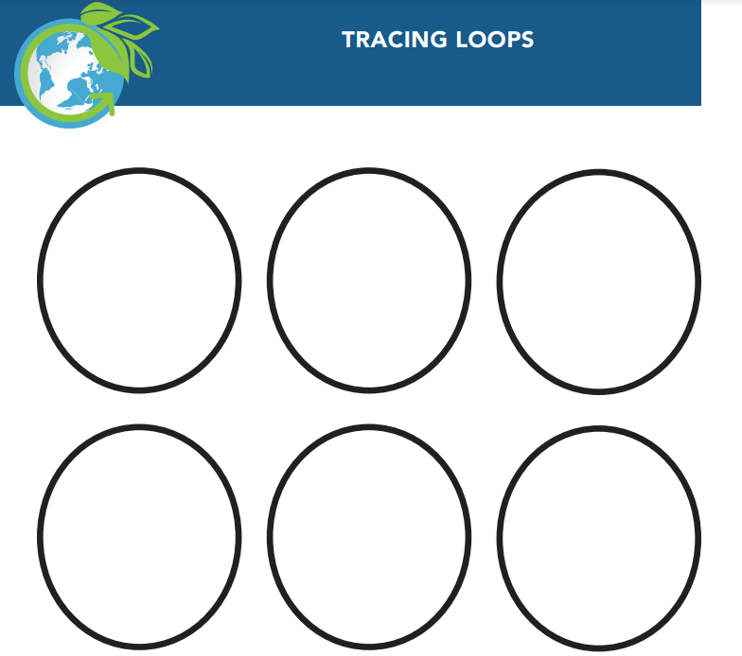

Ticket-Out
🎫
Conducting experiments can be challenging and there are lots of factors that can influence the outcomes. One reason we practice our procedure is so we can eliminate as many accidental deviations from the procedure as possible. Reflect on your first bioplastic making experiment today using complete sentences.
- Describe a step where you realized you will have to pay very close attention to what is happening.

- Identify a step that has a skill you will need to practice in order to do it accurately each time.

- Name any steps you were unable to follow the directions exactly. Include the reason why (Were you confused? Distracted? Unprepared with your materials?)
Step:
Reason why:

Step:
Reason why:

