Sustainable Invention: An Exploration of Bioplastics
Module 2

Table of Contents
- Teacher Resources
- Overview of Lesson 1: Experimenting with Bioplastics
- Overview of Lesson 2: Testing Flexibility
- Overview of Lesson 3: Variation: Causes and Analysis
- Overview of Lesson 4: Redesigning Your Procedure
- Overview of Lesson 5: Testing a Chosen Variable
- Overview of Lesson 6: Optimizing the Formula
- Lesson 1 Experimenting with Bioplastics
  - Bell Ringer
  - Pre-Lab: Experimenting with Bioplastics
  - Lab: Experimenting with Bioplastics
  - Ticket-Out
- Lesson 2 Testing Flexibility
  - Bell Ringer
  - Evaluating the Bioplastic Loops
  - Ticket-Out
- Lesson 3 Variation: Causes and Analysis
  - Bell Ringer
  - Loop Flexibility Variables
  - Ticket-Out
- Lesson 4 Redesigning Your Procedure
  - Bell Ringer
  - Variation Between Loops
  - Lab: Testing Variables with Bioplastics
  - Ticket-Out
- Lesson 5 Testing a Chosen Variable
  - Bell Ringer
  - Ticket-Out
- Lesson 6 Optimizing the Formula
  - Bell Ringer
  - Lab: Evaluating Impact of Variables
  - Ticket-Out

Desired Results
Enduring Understanding from Unit:
- Inventing a new technology involves coming up with an idea, developing that idea with the use of peer feedback, and re-designing based on testing.
- Bioplastics can be used to create novel products and/or better versions of already existing products.

Essential Question from Unit:
- How can we make a product that is good for people and the environment?

Standards Addressed (Content and ELP)
NGSS Science Standards:
- MS-PS1-2: Analyze and interpret data on the properties of substances before and after the substances interact to determine if a chemical reaction has occurred.
- MS-ETS2-2(MA): Given a design task, select appropriate materials based on the specific properties needed in the construction of a solution.

Science and Engineering Practices:
- 8. Obtaining, evaluating, and communicating information

Overview
Task overview: Students will engage in the work of green chemists who are tasked with creating a plastic that meets the needs of a specific client. In creating their plastic, they will test different variables to determine their impact on bioplastic characteristics. They will evaluate their plastic and their classmates’ plastics to determine if their client’s needs have been met and to assess whether the use of a bioplastic in this instance is better than the use of a petroleum-based plastic.

Language focus
Communicating through verbal and written language by all participants. Public speaking by some participants. Specific language focus is on:
- Listening to and discussing passages that discuss what is an additive, a starch, a plasticizer, an alcohol, and a formulation.
- Written analysis of the use of plastics versus bioplastics.
- Verbal and written evaluation of properties of loops.
- Reading about polymers, pH and its associated language, and cross-linking.
- Verbal and written evaluation of properties of loops created during these lessons.
- Written reflection of each day to demonstrate understanding of each lesson.

Learning Targets | Formative Assessment
- Content-focused:  - bioplastic  - Formulation  - Starch  - Plasticizer  - Additive  - Chemical change  - Physical change  - Flexible/Flexibility  - Elastic/Elasticity  - pH  - Acid  - Base  - Cross-Linking  - Polymer  - Language-focused:  - Listening to and discussion of passages  - Written analysis  - Verbal and written evaluations  - Content reading  - Written reflections | - See provided bell ringers and tickets out included  - Matching Activity of content-focused vocabulary  - Sequencing activity for steps of the lab utilizing the content-focused vocabulary  - Claim-Evidence-Reasoning statement about whether the lab will be evidence of a chemical or physical change  - Analysis questions of lab

Key Content Vocabulary | Cross-Disciplinary Vocabulary
- bioplastic  - Formulation  - Chemical change  - Physical change  - pH  - Acid  - Base  - Cross-Linking  - Polymer | - Starch  - Flexible/Flexibility  - Elastic/Elasticity

Materials or Apps
Teachers:  - 250-mL beakers, 3 per student group  - Heat-resistant gloves, 1 pair per student group  - Aluminum tray, 1 per group  - Hot plate, 1 per student group  - Stirring rod, 1 per student group  - Syringes, 1 per student group  - Graduated cylinder, 1 per student group  - Wax pencil, 1 per student group  - Wax paper, 1 8x11 sheet per group  - Protective gloves, 1 pair per student  - Protective goggles, 1 per student  - Photocopies of Tracing Loops sheet, 1 per student  - Tapioca starch  - White vinegar  - Sorbitol  - Wax paper  - Tape | Students:  - pens/pencils  - Lab Safety Rules  - Cellphone timer
Lesson Preparation
Instructor to provide photocopies of worksheets if not a one-to-one school or for students who require hard copies as an accommodation.

It is helpful for the instructor to run through the pre-lab and lab beforehand so they know about how long the lab takes and where students should be after a given amount of time. This will help them guide students with pacing during class. Videos of making bioplastics.

***As students collect data, it is important for the instructor to record the class data so it can be used to make adjustments in the next portion of the unit. This might look like a class table on the board or on a poster, snapping photos and uploading to a shared file, or on a shared google doc. ***

Clean all beakers, teaspoons, and stirring rod in a warm, soapy water bath with 30mL of vinegar in it.

Some storage considerations for the loops:
→ The loops will dry out if left out to sit exposed to the air and that may change some of their properties. Students may want to store them in an airtight container to see how that impacts the loop properties. Have students consider (in writing or in discussion) how else could they compensate for this shift if their client needed a longer lasting product.
→ Remind students they are in the prototyping stage. What would they do with more time? Would shelf-stability be a focus of their next stage of iteration?
→ It may also be worth exploring the downsides of and design flaws in “compostable” items that actually just are trash because we don’t have facilities to process them.

Estimated Time:
(6) 45-minute class periods with all resources used
Lesson Sequence
Lesson 1: Experimenting with Bioplastics
- Independent/Small Group (5 minutes): Students read the pre-lab and use it to answer the bell ringer question.

- Whole Class (5 minutes): Have students share their bell ringer answer with an elbow partner, then have a couple students share out.

- Whole Class/Small Group: (5 minutes): At this point, students can either choose their own lab groups or the instructor can pre-assign groups.
  - Have groups establish roles for the day (or the roles can stay the same over the course of the unit).

- Whole Class (5 minutes): The instructor reviews the lab safety expectations, reviews lab procedure, and confirms understanding of terms.
  - → Our main goal for today is two-fold: First off, we want to become familiar with the procedure for making bioplastics that we will be using multiple times as we make our final bioplastic product. Secondly, we are going to focus on observing the characteristics of bioplastics.

- Small Group (20-25 minutes): Students do the lab. During this time, the instructor functions as facilitator, engaging in frequent check-ins to ensure that everyone is progressing appropriately through the lab work. The instructor is also available to answer questions and assist groups that require more help than others.
  - Possible check in questions:
    - What are you noticing?
    - What step is next? How can you prepare for that step?
    - Are things going as expected? Can you pivot?
    - Sometimes questions aren’t needed, you can just watch and collect ideas for group questions at the end.
    - When students have questions, try to turn the question back to them, encouraging them to refer to their lab or their group mates.
  - **Provide time checks so students can know about how far they should be.
The students clean up the lab activity following the directions posted at the end of the lab.

- Ticket-out (5 minutes): Your ticket-out today is a reflection on lab process--parts that require extra paying attention, skills that were challenging, etc. Note specific places you deviated from the directions. This is not shaming, its information gathering so you have all the variables that might be impacting your bioplastic results.

Lesson 2: Testing Flexibility
- Independent (10 minutes): The students should return to their lab groups and select job roles for the day if they are changing. Together, groups brainstorm how to test for flexibility. Students can use the internet.
  - Video Resources:
    - Test for Flexibility: https://qualityinspection.org/flexibility-plastic-china/

- Whole Class (10 minutes): Establish a class method of testing flexibility. Have students add data collection tables to their Evaluating Bioplastic Loops Handout as applicable.

- Small Group (15-20 minutes): You are now going to test your loops, as well as the loops of two other groups. When you compare with another group, if there are differences EITHER between your loops OR in the results of how you each tested the loops, see if you can figure out what is causing the differences. Take notes in the space on your handout. This isn’t a “Our group is right, yours is wrong” scenario. We are exploring what causes the differences in certain characteristics and having all the information available will help us best understand those causes and impacts.
  - Test their loops for flexibility + elasticity, record results for their group + two other groups.

- Ticket-Out (5 min) is a reflection on their data collection. Have students share with an elbow partner and discuss as a class if time allows.

Lesson 3: Variation: Causes and Analysis
- Whole Class (10 minutes): Have all groups share their results and collect all the data for the class. Post the data for all the students to see and have them make two observations about the data on their own. Then have them share an observation with an elbow partner. Have a couple students share out what they notice about the data.

- Whole Class (15 minutes): As we look at the data and notice these differences and similarities, what do you think might have caused the variation? This is not “oh you made a mistake and we are going to shame you as a class”--we are human and this is the first time you’ve ever made a bioplastic! The goal of this is to see if there are any specific steps that have a significant impact on the elasticity or flexibility of the loops if not followed correctly. Look at how your group’s data is different from other data--could any of your inconsistencies with the procedure have been the culprit?
  - In their lab groups, have students hypothesize what caused the variations based on their reflections from the end of class the day before. Have the documentation specialist from each group share out their hypothesis.
  - As they share, make a list of variables that seem to impact the bioplastic results:
    - Concentration of solution (how much water)
    - Temperature
    - Ingredients used
    - pH
    - Specific errors?
  - For the above list, what seems to be the impact of each variable?
  - Provide time for students to record these notes in their worksheet.

- Whole Class (10 minutes): groups choose a variable to focus on (concentration of solution, temperature or pH). Ideally, there will be two groups testing each variable in each class. We will reserve testing the variable of ingredients further on in the unit.
  - As a class, discuss how we can alter concentration, temperature and pH.
  - Ideally, one group will test more/higher of the variable vs the original procedure and one group will test less/lower of the variable vs the original procedure (i.e. one group will add more heat, one will use less heat).

- Ticket-Out (10 min): Students consider the impact of variables on each other and how to mitigate those impacts.

Lesson 4: Redesigning Your Procedure
- Small Group (20 minutes): In small groups or partners, students match vocabulary using the Variation Between Loops reading.

- Whole Group (5 minutes): Referring to the reading, the list of variables from the previous day and their impact on flexibility fill out the chart at the bottom of the handout as a class.

- Small Group (5 minutes): Have groups make a hypothesis about how altering their group’s chosen variable will impact the loops’ final characteristics.

- Whole Group (5 minutes): As a class, go through the lab procedure. Identify each step where the three variables (temperature, concentration and pH) are involved. Have groups highlight/star the step(s) that apply to the variable they have chosen.

- Small Group (5 minutes): Groups plan and rewrite their lab procedure for testing their chosen variable. **Groups will turn in their lab procedure for the teacher to check over before the next day.**

- Ticket-Out (5 minutes): Students identify the key steps of the procedure they will be modifying and anything they might need to be extra careful with.

Lesson 5: Testing Chosen Variable
- Small Group (5-10 minutes): Students answer the bell ringer question while the teacher checks in with each group about feedback on their procedures. Groups make final adjustments to their procedure based on teacher feedback.

- Small Group (20-25 minutes): Students do the lab testing their chosen variable. During this time, the instructor functions as facilitator, engaging in frequent check-ins to ensure that everyone is progressing appropriately through the lab work. The instructor is also available to answer questions and assist groups that require more help than others. Make sure to check in with groups as the work on the step that specifically applies to the variable they are testing.
  - Possible check in questions:
    - What are you noticing?
    - What step is next? How can you prepare for that step?
    - Are things going as expected? Can you pivot?
    - Sometimes questions aren’t needed, you can just watch and collect ideas for group questions at the end.
    - When students have questions, try to turn the question back to them, encouraging them to refer to their lab or their group mates.
  - **Provide time checks so students can know about how far they should be.

- Small Group (10 minutes): The students clean up the lab activity following the directions posted at the end of the lab and complete the ticket-out.

Lesson 6: Optimizing the Formula
- Small Group/Whole Group (10 minutes): Students answer the bell ringer question. They can share with an elbow partner, then share out as a class what their initial observations are of similarities and differences between their modified loops and their original ones.

- Small Group (10 minutes): Groups repeat their tests for elasticity using the procedures from earlier in the week. Have groups that tested the same variable work together and compare their results, discussing any inconsistencies between their findings.

- Small Group (5 minutes): have the two same variable lab groups work together to make a recommendation to the class for an optimized formula based on their results.

- Whole Group (15 minutes): Have each variable group share out their recommendation, including reasons why. Discuss how there might be layers of interactions between the variables and how optimization of one variable might impact the others.

- Ticket-Out (5 minutes): Students complete an if/then statement.

Lesson 1
Experimenting with Bioplastics

Activator/Bell Ringer/Starter
🔔
Match the term to its definition:
Term | Definition
- _____ Acid | - Used in bioplastics to create a solution
- _____ Water | B. Odorless, tasteless white substance naturally occurring in plant tissue
- _____ Plasticizer | C, A chemical that when added to a substance, promotes flexibility and elasticity
- _____ Starch | D. Substances that have a pH between 1 and 7.

Using the image, sequence the formulation to make a bioplastic, using numbers 1 - 5, with 1 being the first step.
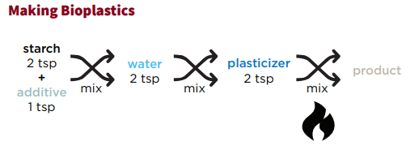
_____ Add heat to your mixture
_____ Mix starch with an additive
_____ Let your product cool off
_____ Add the alcohol to your mixture
_____ Add water to your mixture
Pre-Lab: Experimenting with Bioplastics

Pre-Lab Work
- Form into groups of 3-4 individuals and select your lab roles.
Project Coordinator and Lead  - Goes to the teacher to address a question.  - Keeps track of time and deadlines.  - Keeps the team on task.  - Monitors noise levels in groups, reminds group to be respectful of each other.  - Encourages Participation. | Project Architect  - Reads directions for tasks aloud to the group.  - Takes the lead on creating drawings, graphs, and diagrams needed by the group.  - Ensures work meets the assignment’s criteria.  - Helps develop other people’s ideas and to clarify points.
Project Resource Manager  - Collects supplies for the team.  - Sets up materials before beginning an activity.  - Cares for and returns supplies; Organizes clean-up.  - Finds out and gathers information, including ensuring that all data measured and recorded in labs/activities are accurate. | Project Documentation Specialist  - Makes sure each member of the team records work or data.  - Records all written information for the group, where needed.  - Makes and helps others make designs, tables, and/or graphs.  - Organizes and introduces a group report.
Project Coordinator/Lead is… Project Architect is…

Project Resource Manager is… Project Documentation Specialist is...

Background Info
Over the next few weeks, we are going to create a bioplastic product. In our last class, we discussed that bioplastics are a plastic made from currently living, organic things, like potatoes, corn, tapioca, or even milk! They generally create less pollution and waste to manufacture than do petroleum/crude-oil based plastics.

- Read the following and respond to the questions that follow:

Bioplastics can have many different formulations (a means to make something, like a recipe). Today, your formulation will be made with starch, plasticizer, and an acid. These are the four components to making a starch-based bioplastic.
- A starch is an odorless, tasteless white substance naturally occurring in plant tissue; it stores carbohydrates - think of potatoes, rice, wheat, and tapioca - which are all starchy plants. Starch is the starting materials for bioplastics
- Water is used in bioplastics to create a solution. Increase in water means a decrease in the concentration of starch. Often, this makes bioplastics more flexible (to a point, can be flooded with too much water.)
- Acids are substances that have a pH between 1-7. Varying on the strength of the acid, these help in crosslinking of bioplastics.
- A plasticizer is a substance added to a formulation to create a product that is more flexible. Plasticizers bind the bioplastics together to create a solid.

- Using the text and image above, revisit your bell ringer questions and check that you have matched the terms to their correct definitions:
Term | Definition
- _____ Acid | - Used in bioplastics to create a solution
- _____ Water | B. Odorless, tasteless white substance naturally occurring in plant tissue
- _____ Plasticizer | C. A chemical that when added to a substance, promotes flexibility and elasticity
- _____ Starch | D. Substances that have a pH between 1 and 7.

- Revisit your bell ringer questions again to make sure you have sequenced the formulation to make a bioplastic correctly. Use the numbers 1 - 5, with 1 being the first step.
_____ Add heat to your mixture
_____ Mix starch with an additive
_____ Let your product cool off
_____ Add the alcohol to your mixture
_____ Add water to your mixture

- Write down a “CC” next to the steps you just labeled in question 4 that you think are chemical changes.

- We will be making the industry standard “loop” shape for our initial experiments. Why would it be important to have a standard for trial shapes across an industry?
Lab: EXPERIMENTING WITH BIOPLASTICS

Materials:
- 250-mL beakers (3)
- Heat-resistant gloves
- Aluminum tray
- Hot plate
- Stirring rod
- Syringes
- Graduated cylinder
- Wax pencil
- Wax paper, 1 8x11 sheet
- Protective gloves, 1 pair per student
- Protective goggles, 1 per student
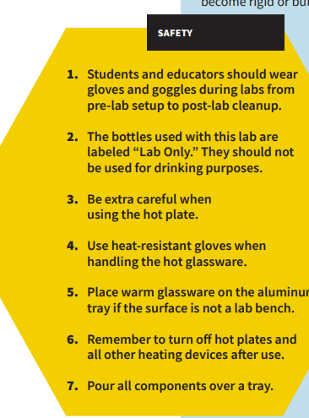
- Photocopies of Tracing Loops sheet, 1 per student
- Tapioca starch
- White vinegar
- Sorbitol
- Wax paper
- Tape
- pens/pencils
- Lab Safety Rules
- Cellphone timer

Procedure:
- Have your Resource Manager gather the supplies for the lab.

- Put on your safety goggles. You may also request a safety apron to wear.

- Place wax paper over your loop tracing sheet and tape it to the tabletop.

- Set up your tray for pouring over.

- In a 250-mL beaker, use a digital scale to measure 5g of tapioca starch.
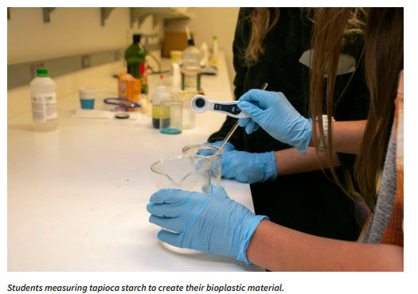
6. Use a graduated cylinder to measure out 5mL of white vinegar (an acid). Add it to the beaker with the starch. Mix with the stirring rod.

7. Measure 5mL of water and add to your beaker. Mix with the stirring rod.

8. Measure 5mL of sorbitol (plasticizer) and add to your beaker. Mix with the stirring rod.

9. Stir the solution until uniform. Teacher note: if you want to approve your students coloring the solution, add food coloring during this step.

10. Turn on the hot plate and set to medium (the middle of your hot plate settings). Using a timer, heat the solution for 6–10 minutes, stirring for 15 seconds every minute until the solution starts to thicken.
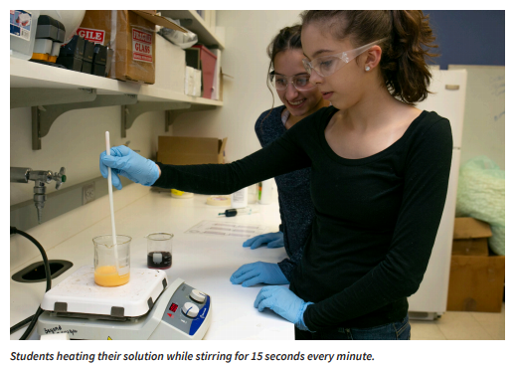
11. When the solution reaches a gel-like consistency, put on your heat resistant safety gloves, turn off the hot plate, and remove the beaker from the heat.

12. Scooping from the beaker, use your stirring rod to transfer the material from the beaker into the syringe.

13. Insert the plunger and flip the syringe upward. Push out excess air.

14. Fill in the loop outlines on the tracing sheet using your syringe. Aim to make at least 3.

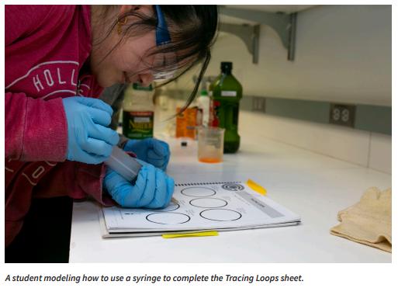
15. Let your bioplastic material sit overnight to form. Be careful to not knock or jolt the loops while they set.

Post-Lab Cleanup
- All materials are safe to pour down the drain.
- Wipe any residue with a paper towel before washing the labware.
- Clean all beakers, teaspoons, and stirring rod in a warm, soapy water bath with 30mL of vinegar in it.
- Dry the tools and lab equipment, then store them in the designated area.

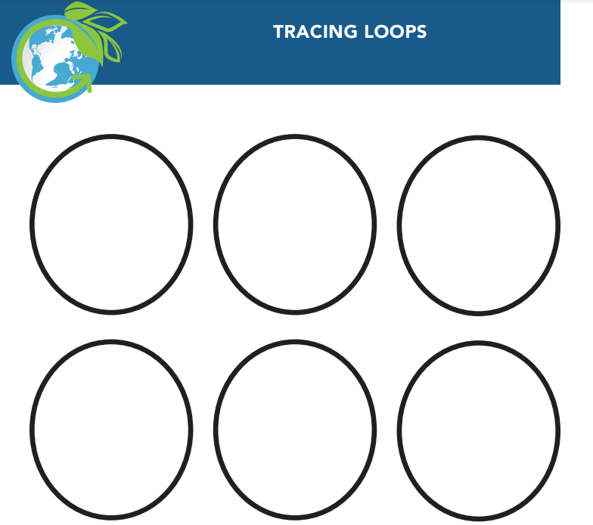

Ticket-Out
🎫
Conducting experiments can be challenging and there are lots of factors that can influence the outcomes. One reason we practice our procedure is so we can eliminate as many accidental deviations from the procedure as possible. Reflect on your first bioplastic making experiment today using complete sentences.
- Describe a step where you realized you will have to pay very close attention to what is happening.

- Identify a step that has a skill you will need to practice in order to do it accurately each time.

- Name any steps you were unable to follow the directions exactly. Include the reason why (were you confused? Distracted? Unprepared with your materials?)
Step:
Reason why:

Step:
Reason why:

Lesson 2
Testing Flexibility

Activator/Bell Ringer/Starter
🔔
- Return to your lab groups and select a job role for the day (look at descriptions from yesterday).

Project Coordinator/Lead is… Project Architect is…

Project Resource Manager is… Project Documentation Specialist is…

- Today we will be testing our bioplastics for flexibility . Work with your group to come up with a definition for what flexibility is and suggest a possible way to test the loops to measure their flexibility.
You want your tests to be:
- Consistent - can be repeated across several loops
- Provides data that can be easily documented, such as in the form of measurements, in the making of drawings, or the use of very descriptive language.
Characteristic | Definition | Possible way to test
Flexibility

Here is a link to check out: https://qualityinspection.org/flexibility-plastic-china/ Your group also can search testing options for flexibility.

Evaluating the Bioplastic Loops
Today, we are going to test the loops we created in our last class for flexibility (doesn’t break if bent). Your group will test the loops you made as well as ones made by two other groups.

Based on our class discussion, what method will you use to test the loops for flexibility?
Your answer:

Now, you are ready to make observations on one of your loops and on loops from two other groups in the class. Fill out the table below with your observations on:

- Loop flexibility
- Additional Observations or Notes
  - Here are some adjectives to use in your descriptive observations.
Additionally, have a conversation with the members of the other groups. Find out what they did to follow the procedure and take note of anything that is different from how your group did it.

 | Flexibility Observations  + Data | Notes to explain possible differences between loops | Other traits you notice (color, transparency, texture, structure)
Your Group
Group:

Group:

Ticket-Out
🎫
- Looking at the data you collected about flexibility, what factors seem to increase loop flexibility?
- What factors seem to decrease loop flexibility (make it more stiff/rigid)?
- Describe connections you notice between a flexible loop and other properties/characteristics (transparency, etc)?
Your answer:

Lesson 3
Variation: Causes and Analysis

Activator/Bell Ringer/Starter

🔔
Look at the class data and write down two observations.

Additional observations:

Loop Flexibility Variables

- Write down your group’s hypothesis for the main cause or causes of variation between the loops.
Example format: ______________ seems to make loops more flexible and _______________ seems to make loops less flexible (more stiff/rigid).

- Fill in the table below after the class discussion.

Variable | Impact on Loop

Ticket-Out
🎫
- Looking at our list of variables that impact our bioplastic’s flexibility, describe how temperature and solution concentration (the amount of water) might impact each other.
- Describe how a scientist might keep those two variables from impacting each other..
Lesson 4
Redesigning Your Procedure

Activator/Bell Ringer/Starter
🔔
After reading Variation Between Loops, match the following words and definitions.
Term | Definition
1. _____ Acid | A. A long, repeated chain of something, like a sugar
2. _____ Base | B. The interaction of polymers with other polymers through bonding.
3. _____ Concentration | C. Measure of how acidic or basic a solution is.
4. _____ Cross-Linking | D. A solution that has a pH that is below 7.
5. _____ Dilute | E. A solution that has a pH that is at or around 7.
6. _____ Neutral | F. A solution that has a pH that is above 7.
7. _____ pH | G. A solution that has a pH at around 1.
8. _____ Polymer | H. A solution that has a pH at around 14.
9. _____ Rigid | I. A solution that does not have a lot of water in it - so the main part of it is strong.
10. _____ Strong Acid | J. A solution that does have a lot of water in it - so the main part of it is weak.
11. _____ Strong Base | K. Not flexible, hard to bend or move.

Variation Between Loops

As we have seen, the loops did not perform exactly the same between the groups. Some loops may have been more flexible while others may have been more rigid. These loops may have varied because of human variation! You all did slightly different executions of the same procedure. The bioplastic properties are determined by three factors:

- Presence of heat? the temperature of the solution at the time of heating,
- the concentration of the solution, and
- the acidity or basicity of the solution.

Temperature
Often in the manufacturing of substances, heat/temperature plays a role in how quickly a chemical change will take place. The hotter something is, the faster its particles will move, and the more reactions or changes that can occur. However, too much heat may damage the bonds that form during the reactions. Monitoring temperature to ensure that it is consistent throughout the multiple trials is necessary to potentially avoid an “error”, or mistake, in loop manufacturing.

Concentration
The bioplastic properties are also determined in part by how much water is in the solution.
- If more water is added into the solution, the solution becomes more dilute, or less concentrated. The less concentrated the solution, the more flexible the final product.
- If you added less water to the solution, then the solution would become less dilute, or more concentrated. The more concentrated the solution, the less flexible the final product. Items that are not flexible are referred to as rigid.

More 💧 means less concentrated (dilute) which means flexible!

Less 💧 means more concentrated which means rigid!

Acids and Bases
Plastics come in many shapes and forms, and their properties change based on the chemical reactions that occur when they are created. Our starting material, starch, is a polymer, or long chain, of molecules.

MONOMER
(A SUGAR)

POLYMER
LOOSE MONOMERS
The polymer chains of sugars interact with each other through bonding, or cross-linking. Lots of bonds between the chains create a rigid structure, while less bonds between the chains create a loose and flexible structure. If there is no cross-linking, there won’t be a solid plastic.

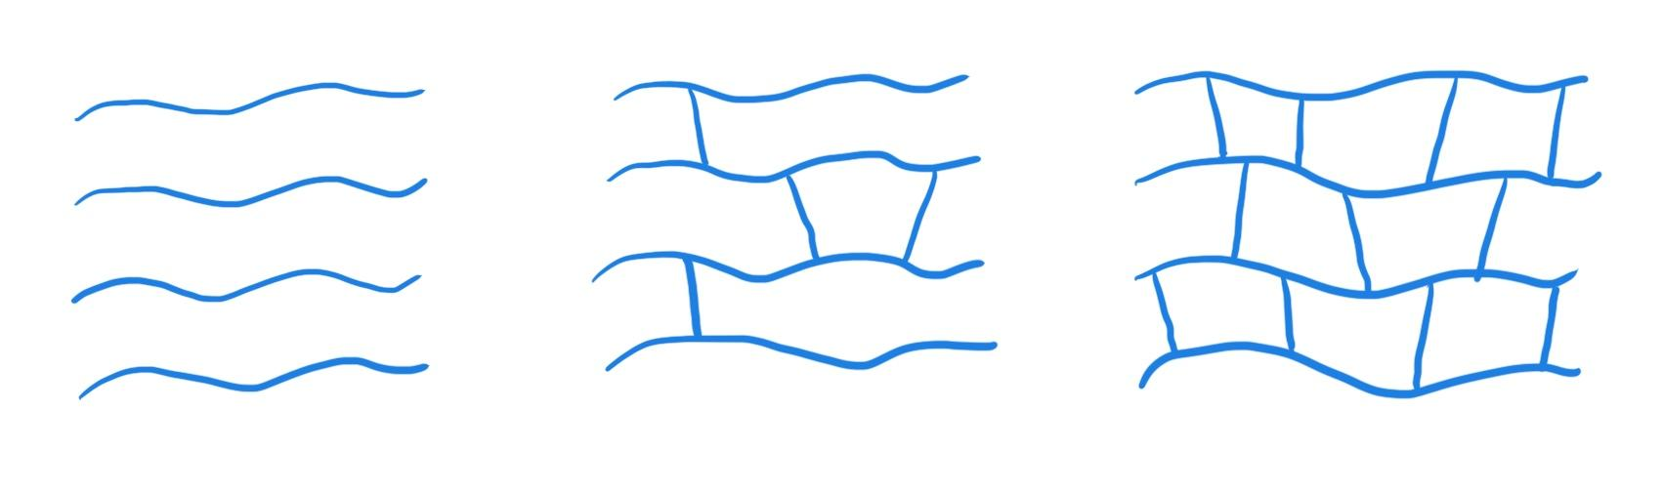

Polymers with NO cross-linking

Polymers WITH cross-linking

We measure how acidic or basic an environment is using pH. The pH scale ranges from 1 (strong acid) to 7 (neutral) to 14 (strong base). The further a pH is from 7, the stronger the acid/base is, while a pH closer to 7 indicates a weaker or more neutral acid/base. The pH impacts how much bonding (cross-linking) occurs. A strong acid or base blocks some cross-linking when creating your bioplastic, which would create a more flexible product. Putting your starch polymer in a weak acid or base environment will keep more of the cross-linking bonds intact, and create a more rigid product.. Stronger acids or bases create smaller pieces, or smaller polymers.
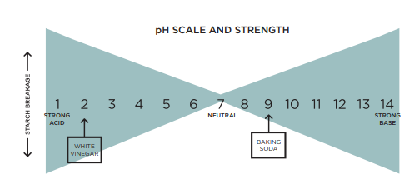

More Flexible | Less Flexible (Rigid)
___low____Concentration of starch (___high___) water | ___high___Concentration of starch (___low___) water
_______ temperature | _______ temperature
______ pH | ______ pH

My group’s variable:
Hypothesis:

Lab: Testing Variables With Bioplastics:
Temperature, Concentration, pH

My group’s variable:

Materials:
- 250-mL beakers (3)
- Heat-resistant gloves
- Aluminum tray
- Hot plate
- Stirring rod
- Syringes
- Graduated cylinder
- Wax pencil
- Wax paper, 1 8x11 sheet
- Protective gloves, 1 pair per student
- Protective goggles, 1 per student
- Photocopies of Tracing Loops sheet, 1 per student
- Tapioca starch
- White vinegar (pure)
- Diluted white vinegar (50% water, 50% vinegar)
- Sorbitol
- Wax paper
- Tape
- Lab Safety Rules
- Cellphone timer

List below the formula components you will be using:
Starch: _________________
Acid:________________
Heat:_______________
Water:_______________
Alcohol: _________________
Plasticizer: _______________
REMEMBER: Safety first!

Procedure:
- Have your Resource Manager gather the supplies for the lab.

- Put on your safety goggles. You may also request a safety apron to wear.

- Place wax paper over your loop tracing sheet and tape it to the tabletop.

- Set up your tray for pouring over.

- In a 250-mL beaker, use a digital scale to measure 5g of tapioca starch

- Use a graduated cylinder to measure out 5mL of __________ (pure or dilute) white vinegar (an acid). Add it to the beaker with the starch. Mix with the stirring rod.

- Measure ______ mL of water and add to your beaker. Mix with the stirring rod.

- Measure 5mL of sorbitol (plasticizer) and add to your beaker. Mix with the stirring rod.

- Stir the solution until uniform.

- Turn on the hot plate and set to _____________ (High, medium, off or low). Using a timer, heat the solution for 6–10 minutes, stirring for 15 seconds every minute until the solution starts to thicken.
- When the solution reaches a gel-like consistency, put on your heat resistant safety gloves, turn off the hot plate, and remove the beaker from the heat.

- Using your stirring rod, transfer the material from the beaker into the syringe.
- Insert the plunger and flip the syringe upward. Push out excess air.

- Fill in the loop outlines on the tracing sheet using your syringe. Aim to make at least 3.
- Let your bioplastic material sit overnight to form.

Post-Lab Clean-Up
▶ All materials are safe to pour down the drain.
▶ Wipe any residue with a paper towel before washing the labware.
▶ Clean the beakers, teaspoons, and stirring rods in a warm, soapy water bath with 30 mL of vinegar.
▶ Dry the tools and lab equipment, then store them properly in the appropriate areas of the lab.
Ticket-Out
🎫
Describe the key step(s) your group will be changing in testing the impact of your variable on the flexibility of the loops. Include anything you’ll need to be particularly mindful to do with accuracy and precision.

Lesson 5
Testing Chosen Variable

Activator/Bell Ringer/Starter
🔔
Based on your experience testing the loops, describe the advantages of using machines for quality control instead of humans.

Ticket-Out
🎫
This was our second time conducting this specific bioplastic experiment, although with a modified procedure. Reflect on your second bioplastic making experiment today using complete sentences.
- Describe a step you did with more in line with the directions today than the first time.

- Your group modified some specific steps of the procedure in order to test your chosen variable. Were you able to follow the modified steps exactly? If not, record how you actually did the step. **Include any non-modified steps you were unable to carry out exactly as directed as well.**
Step:
What actually happened:

Step:
What actually happened:

Lesson 6
Optimizing the Formula

Activator/Bell Ringer/Starter
🔔
Record 2 initial observations regarding how this second bioplastic is similar and different from your original bioplastic.

Similarities:

Differences:

Lab: Evaluating Impact of pH, Temperature
and Concentration on Flexibility
Fill in your data in the box that corresponds to the variable you tested. Add the data from other groups as well.
 | Flexibility Observations + Data: | Notes to explain possible differences between loops | Other traits you notice (color, transparency, texture, structure)
Lower Concentration Group
Higher Concentration Group

More Acidic pH Group:
Less Acidic pH Group :
Higher Temperature Group :
Lower Temperature Group :

Make a recommendation for optimization for your variable:

Justification #1:

Justification #2:
Ticket-Out
🎫
Write an “if / then” statement based on your observations of today's activity.

For example:
If (pH, temperature, etc) is (increased / decreased) then the flexibility of the loop will _________________.

