Lesson 5
Applying the Orb-It Analysis

Activator/Bell Ringer/Starter
🔔
Get into your work groups. Review each of your tickets-out from yesterday and read through the feedback you left about the work. Considering what you know so far, what steps will you take to complete the assignment today?

Your response:

Orb-It
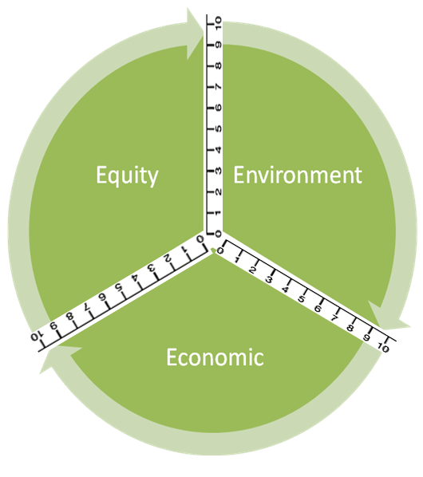
Orb-It Tool
Directions:
- Research your product as group.

- Use personal experience and information from your research to fill in the second column (Info from research or personal experience to support the rating).

- Refer to the rating scale below to rate each criteria:
10 – Perfect (it couldn’t be better!)
9 – Excellent (impressive, but could still improve slightly)
8 – Great (better than expected, but could improve a little)
7 – Good (average performance)
6 – Pretty good (good, significant improvements could be made)
5 – Adequate (it’s just okay)
4 - Partially proficient (needs much improvement)
3 – Falls short
2 – Tries, but still does not succeed
1 – Barely (it’s unsatisfactory)
0 – Doesn’t (it failed miserably!)

Social Impact (Equity) | Info from research or personal experience to support the rating | Ratings
Ingredients
Use of Renewable Feedstocks
Health
Designing Safer Chemicals
Environmental Impact | Info from GoodGuide or personal experience to support the rating | Ratings
Air pollution
Waste Prevention & Design for Degradation
Energy Use
Design for Energy Efficiency
Toxic Waste
Waste Prevention & Design for Degradation
Water Quality
Waste Prevention & Design for Degradation
Climate Change
Waste Prevention
Economic Impact | Info from GoodGuide or personal experience to support the rating | Ratings
Cost
Quality
Designing Safer Chemicals
Philanthropy
Gives back to the community

- Now, label the Orb-It Orb by following the steps below:
STEP 1: Place your rating for Equity on both the number lines bordering “Equity”.
STEP 2: Use a compass to make an arc connecting those two points.
STEP 3: Shade the area you created within the arc.
STEP 4: Repeat steps 1 – 3 for both Environment and Economic.
Ticket-Out
🎫
Please fill in the chart below about your experiences with the lessons so far:
What were some new things you learned during these lessons? | What activity or lesson was easiest for you?
What was something that surprised you from the lessons? | What activity or lesson was the most challenging?

