Lesson 4
Why Invent with Green Chemistry?

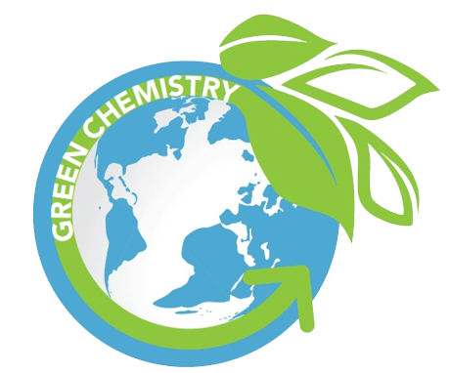

Activator/Bell Ringer/Starter
🔔
Fill in the organizer below based on any background knowledge you have on this topic. If you do not know anything about this topic, use your best judgment at filling this out.
I think Green Chemistry…
Use in a descriptive sentence.
Characteristics/Examples of Green Chemistry are...
Provide a drawing of your sentence.
GREEN CHEMISTRY

Why Invent with Green Chemistry?

We are now going to watch a video featuring John Warner, co-founder of the field of green chemistry. John, in particular, believes in inventing with intention. After the video, answer the 3 questions posed below. We will then share our answers with one another as a class. Afterwards, revise your own answers, as needed.
1  What is the relationship between how the world uses things and invention? | 2  How does this connect unlikely things to one another? For example, the creation of less hazardous road pavements leading to new cell phone technology? | 3  Why is Green Chemistry important for developing a new way to make things ?
Your Answer: | Your Answer: | Your Answer:
Answers from the Class: | Answers from the Class: | Answers from the Class:
Revised Explanation: | Revised Explanation: | Revised Explanation:

Inventing with a Goal in Mind

Directions: Read the text below. You will use the information provided in the next activity.

Green chemistry is the science of designing chemical products or processes to reduce and/or eliminate the use or creation of hazardous substances. Different from other sciences that study what something does, green chemistry focuses on the building blocks of a product to make it more environmentally friendly. For example, as we know from our work with packing peanuts and yesterday’s work, creating products from a petroleum source is hazardous to the environment, so green chemistry would look at methods to create products with the same overall properties that produce fewer pollutants or even none at all!

Inventing for a sustainable future involves thinking about the environment at the earliest stage of design. The inventive mindset taps into the creativity and curiosity of inventors, artists, and scientists. Designing with the environment in mind also involves thinking about the interaction of matter, known as chemistry. Chemistry is the science behind all of the products we use and consume. It is usually defined as how matter interacts with other matter. Matter is basically the “stuff” that makes up things.

Though chemistry is the foundation of life and critical to invention, it sometimes has a negative reputation when it comes to the environment. There are a lot of products that have been created in a way that is hazardous, wasteful, and damaging to the environment. These items create poisonous conditions to our land or water supply, they fill our garbage dumps with materials that will not biodegrade for hundreds or thousands of years, and they contaminate our air. However, green chemistry is the opposite of this.

Green chemistry is an approach that puts chemists in the role of the inventor. It helps them intentionally design chemical products that are safer for humans and for the environment. Green chemistry is often described as the science of creating solutions and sustainable products. It focuses on reducing or eliminating pollution at the earliest design stage of a material, as well as in its use. So, green chemists keep in mind their invention’s impact on both human and environmental health. Green chemists often get their inspiration for product design from nature since nature is able to “invent” without causing harm. This process of copying nature to invent is called biomimicry. An example of this is how green chemists are developing a glue to be used in the field of medicine, such as in place of stitches in surgical procedures, modeled after the “glue” that mussels use to stick to rocks.

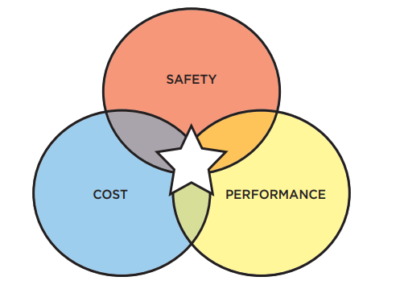

Green chemists think not just about how a product will be used, but who the user will be, what costs they are willing to spend, and what makes a product viable to that person. A great invention is at the intersection of those considerations, having a high performance (meaning that it does exactly what it is designed for at the same level of a less green alternative), a low financial cost, and being very safe for humans and their environment.

One example in need of a green chemistry product redesign is the . Check out the video below of what a lava lamp is and what it is made from:

Video Link: https://www.businessinsider.com/adidas-sneakers-plastic-bottles-ocean-waste-recycle-pollution-2019-8

Lava lamps cause damage to humans, contaminate the environment, and fill our landfills with non-recyclable plastics. They require a sustainable solution. This means that they would become nontoxic to humans, recycle in environmental ways, and do not fill our landfills. As we have seen, there is now a sustainable solution to packing peanuts, in the form of the slightly more expensive ones made of corn or potato starch that decompose when exposed to water.

In conclusion, behind every invention is a person or team of people who recognize a problem or see an opportunity and invent a solution. Their goal is to follow the main tenets of Green Chemistry - make production more efficient and cause less harm. Inventing is a balance between discovery and creativity. The intentional invention of materials that are “benign by design” is at the core of green chemistry.

Understanding Green Chemistry
and Invention with Intent

Directions:
- You will be randomly assigned to groups. Choose a job role once in your group. The roles are:
  - Artist - In charge of the artwork and encourages use of color to express ideas.
  - Recorder - documents the group’s ideas.
  - Sentence creator - Takes the group’s idea and turns them into sentences.
  - Team organizer - Keeps the team on task, manages the time.

- You will use the information you learned today and yesterday to complete a chart paper-sized version of the graphic organizer below.
We think Green Chemistry…
Use in a descriptive sentence.
Characteristics/Examples of Green Chemistry are...
Provide a drawing of your sentence.
GREEN CHEMISTRY
- If we have enough time left to class, then I will ask each team to hang up their organizer around the classroom, and for you all to take a tour of the classroom. Observe each other’s organizers and write down the definitions, characteristics, sentences, and drawings that stood out to you on the mini organizer below.

Define Green Chemistry
Use in a descriptive sentence.
Characteristics/Examples of Green Chemistry
Provide a drawing of your sentence.
GREEN CHEMISTRY

Ticket-Out
🎫
What are 3 things that you have learned about Green Chemistry?

1 | 2 | 3

