Lesson 2
Plastics in our World

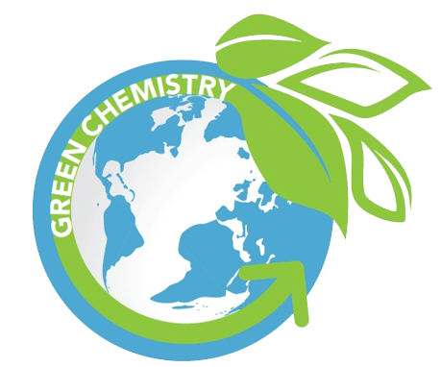

Activator/Bell Ringer/Starter
🔔
- You will be given some tokens. Get up and walk around the room, making observations on the objects in our classroom. Each time you see an object made of plastic, either entirely or partially, please add a token to the plastic container. If you see an item entirely or partially made of wood, please add a token to the wood container. Please do the same for the categories of paper and stone/mineral. For example, if I were in a home and that home has granite counter-tops in the kitchen, I would put a token in the stone container. If the kitchen floor was a plastic laminate, I would put a token in the plastic container. If a spatula was made of plastic and wood, I would put a token in each container. If instead, that spatula was made of metal, I would put a token in the metal container.

- Now, we will tally the results of step 1. What observations can you make about the objects in the classroom? Some sentence starters to help you:
I notice the ________ container has the most tokens.
I notice the ________ container has the least tokens.
I noticed many combinations of ________ and ________ materials in the room.
I saw very little of ___________ in the room.
Your answer:

- With a nearest neighbor, pair-up and discuss the questions in the table below. Then, form a square (pair up with another pair) and share your answers with one another.
Question | Paired Answer | Squared Answer
Why do you think staplers are made of plastic and metal?
Why do you think beakers are made of glass?
Why do you think the cabinets are made of wood?

Plastics In Our World

Directions: We are going to do a Pair-Square activity.
- First, you will work with your nearest neighbor, to read through the document below. As you read, please highlight and underline key concepts, make notes in the margin, and look up any word that you do not know.
- Afterwards, you and your partner should then answer the questions in the graphic organizer about the reading.
- Next, you and your partner will work together with another duo and discuss your answers with them.

READING
What is plastic? Polystyrene is the plastic located in the traditional packing peanuts. Plastic is a petroleum-based product. It is made of polymers, which are just lots of repetitions of the same subunit (poly means many and -mer means part). Crude oil and the plastics made from it create a lot of pollution.

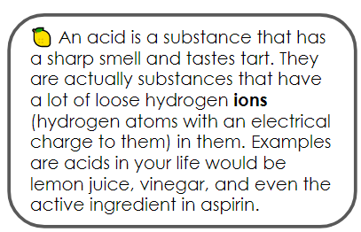
Where do we get plastic from? Plastic is made from crude oil, a type of nonrenewable resource - so we will eventually run out of it. It is made from crude oil which itself is made from a specific decay process of organisms over a very long period of time. We access it by drilling into vast underground reservoirs. To extract the crude oil, a large amount of clean water is used, generating unusable wastewater. A large infrastructure is built to get the oil to ground level. Once there, the oil is pumped through a pipeline; these pipelines are sometimes thousands of miles long. The production and transportation of oil through these pipelines have two major risks—pipeline leaks and oil spills—which cause immediate and long-term environmental damage. The crude oil then goes to a refinery to be processed into different types of fuel, chemicals, and plastics.

The oil for plastic gets processed into small pellets. Additives are mixed in, more water is used, and strong acids are added to break down the pellets; these processes all contribute to additional risks in the production of plastic. Finally, the pellets are heated at extremely high temperatures in a furnace. Once melted, the material is poured into a mold and left to harden into its final plastic form. While many petroleum-based plastics are recyclable, a vast majority of them end up in landfills. These plastics last in the environment for approximately 400 years, on average. An overwhelming 93% of all plastics consumed in the United States are not recycled.

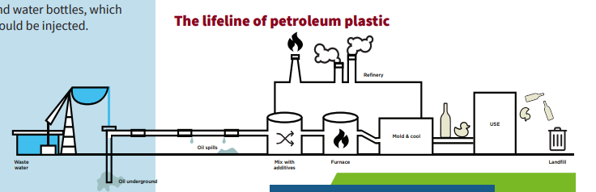

WHAT IS A BIOPLASTIC?
Looking at the life cycle above, you can see that petroleum oil is extracted from the ground and you may think, “If it comes from nature, shouldn’t that make it sustainable?”

Petroleum oil comes from deep in the ground and takes tens of millions of years to create, but humans consume oil at a much faster rate than it is made. The process of extracting oil from the ground also involves generating a lot of wastewater, and digging into the earth to extract the petroleum oil can disrupt the natural ecosystems. Biological material, or living materials, can be grown and harvested above ground. This makes biological material more accessible, and they have a smaller environmental impact like the corn starch packing peanuts. Many companies have used biological material sources to make plastics to be more cost effective and sustainable than traditional petroleum oil-based plastics. When we use a biological material to make a plastic, we refer to that plastic as a bioplastic.
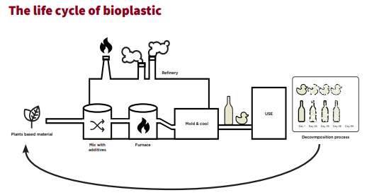

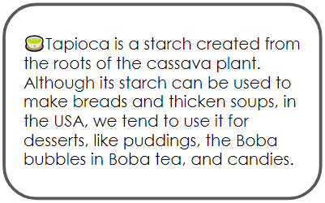
Depending on where you are in the world, different starches (the white powdery stuff that is naturally occurring in potatoes, rice, wheat, etc…) are used as the biological material in bioplastics. In the packing peanuts, corn starch was used. However, there are a lot of different starches that can be used to create a bioplastic. Generally, scientists use whichever starch is the most abundant in their area. The following image shows which types of starches are most abundantly used in each region:

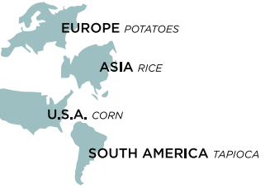
Pros and Cons of Using Biodegradable Packing Peanuts

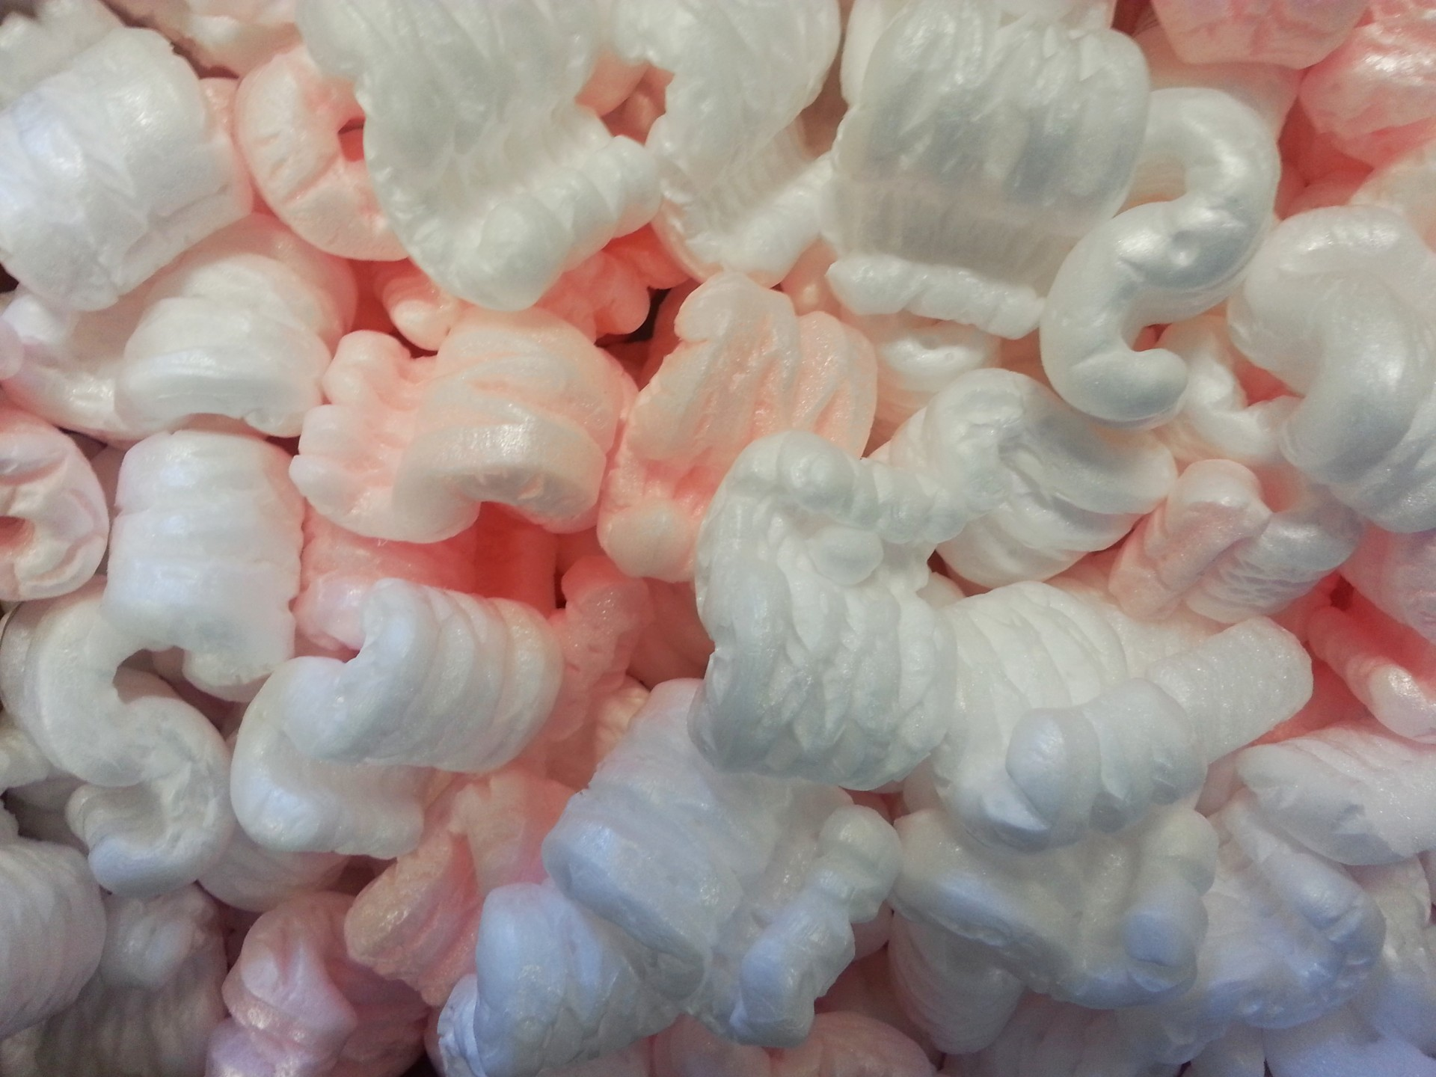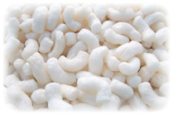
Traditional Packing Peanut
Biodegradable Packing Peanut

Pair-Square Chart
Question | Pair  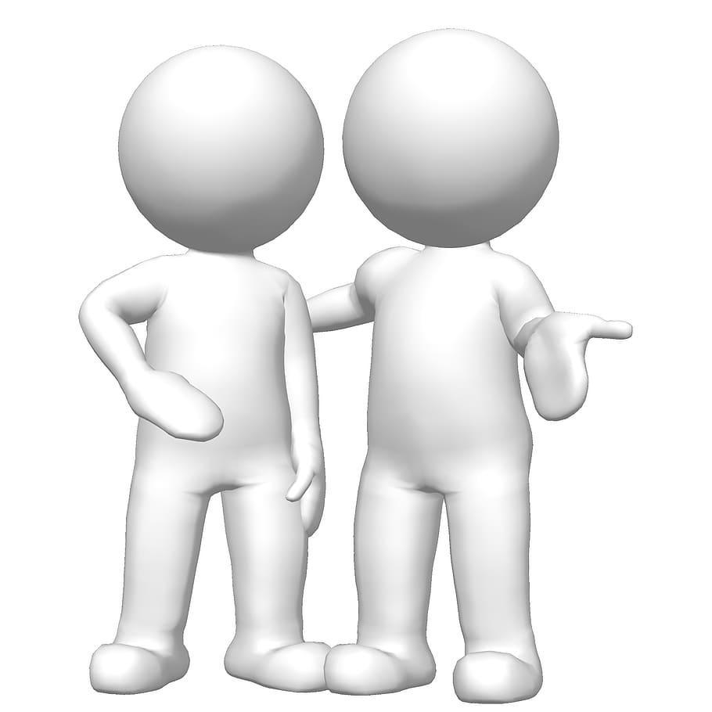 | Square  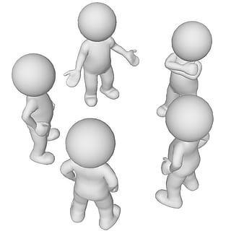
Identify two problems with using crude oil to make plastics.
If you were moving and needed the packing peanuts for the items in your home, which peanut would be best for you and why?
If corn starch packing peanuts can be used to replace polystyrene peanuts, what else could we do to reduce the crude oil waste in our landfills?
What is the relative cost of corn starch peanuts compared to polystyrene peanuts?

Ticket-Out
🎫
Please answer the questions below completely:
List 3 important points from this lesson:

