Lesson 1
Creating a Better World

Activator/Bell Ringer/Starter
🔔
That’s Me!
Directions
- I will show you a slideshow presentation on the classroom screen. Each slide will contain a statement. Every time the statement applies to you, stand up and state “That’s Me!” If it does not apply to you, stay seated.
- Fill in the table below with checks for each statement and sum up your table in the end.
Question | That’s Me! | That’s NOT Me!
1
2
3
4
5
6
7
8
9
10
11
SUM | /11 | /11

That’s Me! Slides
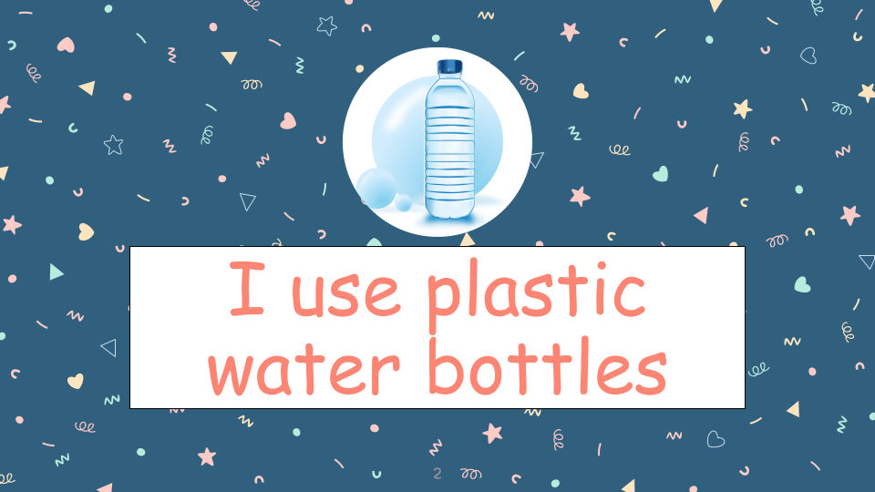
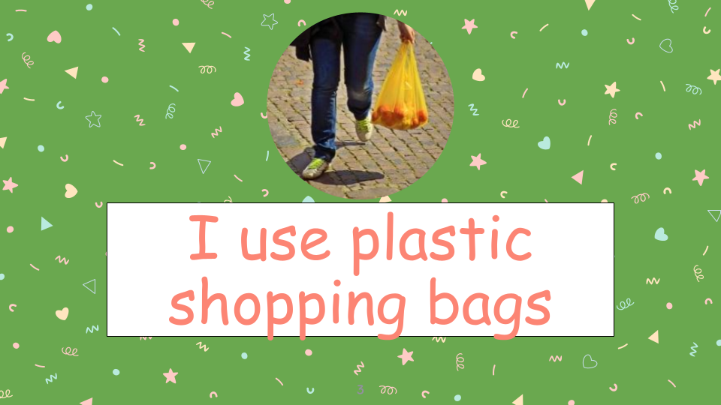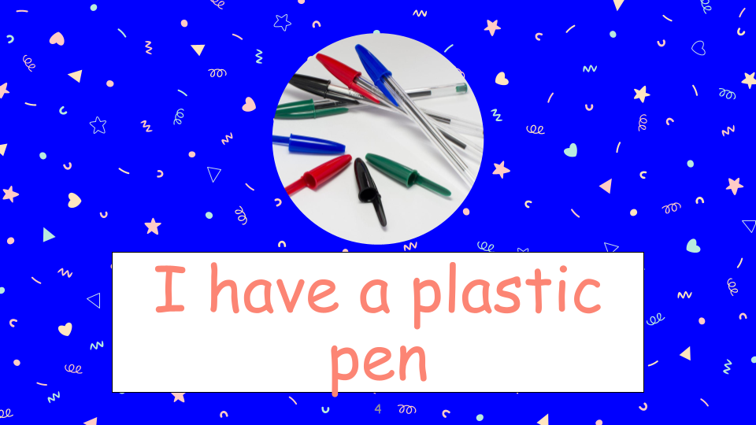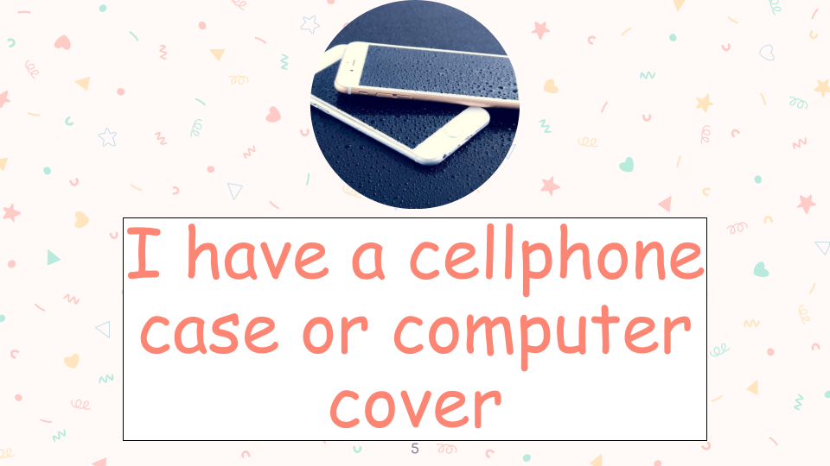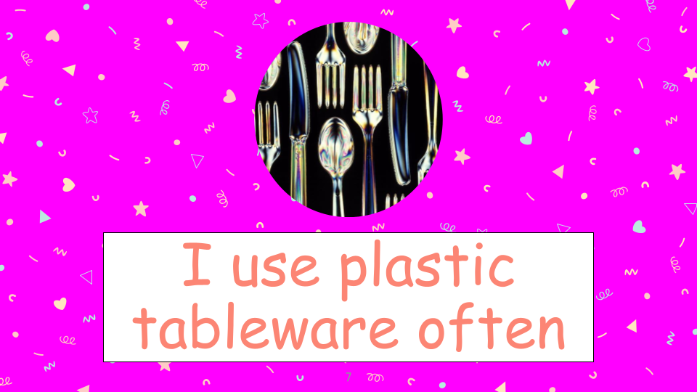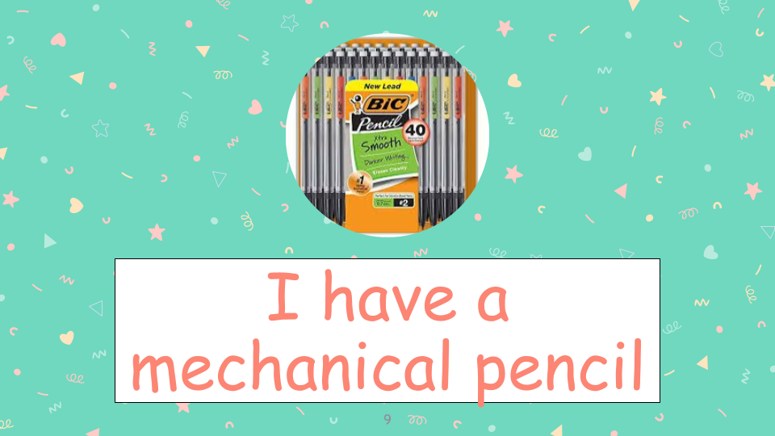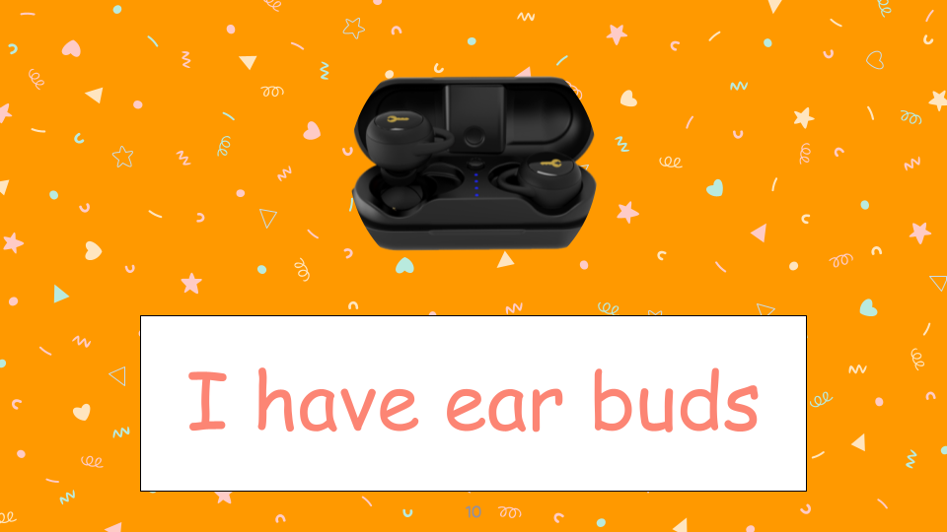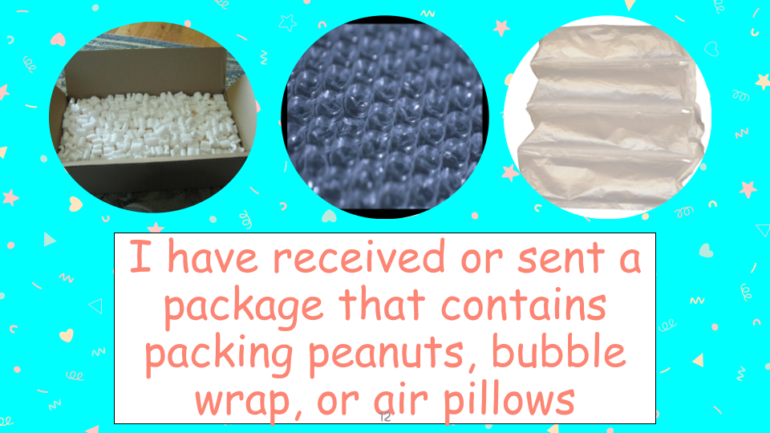
Packing Problems

Directions: I am going to show you a demonstration that involves packing peanuts. These are the little foam items that sometimes come in boxes that are shipped to homes. The peanuts we will observe today are both the traditional kind made from styrofoam, and a newer variety made from corn starch. Both types of packing peanuts will be placed into water and acetone. As I do the demonstration, I would like you to answer the questions below.

Demo 1
- Fill in the table below.
 | Traditional Packing Peanut (Water) | Traditional Packing Peanut (Acetone)
Observations When Placed in Liquid | I notice…  I wonder…. | I notice….  I wonder….

Demo 2
- Fill in the table below.
 | Newer Variety Packing Peanut (Water) | Newer Variety Peanut (Acetone)
Observations When Placed in Liquid | I notice…  I wonder…. | I notice….  I wonder.

- Which situation involved a chemical reaction? List or draw evidence of a chemical reaction in this demonstration.

Ticket-Out
🎫
Text Me!

Respond to one of the 4 questions below as a “text message.”

  - Thinking back on the “That’s Me!” activity and the packing peanuts activity, where do you think you could replace a plastic in your life with an environmentally friendlier alternative? Explain.

  - How did the packing peanut demo change your perspective on plastic use? Explain.

  - From your “That’s me!” activity, do you think you use a lot of plastics? Why or Why not?

  - Sometimes we DO need non-biodegradable plastics for certain objects. What is an example of an object you feel needs to be made of a non-biodegradable plastic and why?

