Sustainable Invention: An Exploration of Bioplastics
Module 1

Table of Contents
- Teacher Resources
- Overview of Lesson 1: Creating a Better World
- Overview of Lesson 2: Plastics in Our World
- Overview of Lesson 3: Client Pitch Challenge
- Overview of Lesson 4: Why Invent with Green Chemistry
- Overview of Lesson 5: Applying the Orb-It Analysis
- Lesson 1 Creating a Better World
  - Bell Ringer
  - That’s Me! Slides
  - Packing Problems
  - Ticket-Out
- Lesson 2 Plastics in Our World
  - Bell Ringer
  - Plastics in Our World
  - Pair-Share Chart
  - Ticket-Out
- Lesson 3 Client Pitch Challenge
  - Bell Ringer
  - Client Pitch Challenge
  - Criteria for Success for the Project
  - Grading Rubric for the Project
  - Ticket-Out
- Lesson 4 Why Invent with Green Chemistry
  - Bell Ringer
  - Why Invent with Green Chemistry? Continued
  - Inventing with a Goal in Mind
  - Understanding Green Chemistry and Inventing with Intent
  - Ticket-Out
- Lesson 5 Applying the Orb-It Analysis
  - Bell Ringer
  - Orb-It Orb
  - Orb-It Tool
  - Ticket Out
- Extend the Learning: What are the 12 Principles of Green Chemistry Activity

Desired Results
Enduring Understanding from Unit:
- Green Chemistry allows us to create products that are safer for us and the environment, contributing to a sustainable future.
- Bioplastics can be used to create novel products and/or better versions of already existing products.

Essential Question from Unit:
- How can we make a product that is good for people and the environment?

Standards Addressed (Content and ELP)
NGSS Science Standards:
- MS-PS1-2: Analyze and interpret data on the properties of substances before and after the substances interact to determine if a chemical reaction has occurred.

Science and Engineering Practices:
- 1. Asking questions (for science) and defining problems (for engineering)

Overview
Task overview: Students will be introduced to bioplastics and key concepts of Green Chemistry. They will be expected to be able to identify the benefits of utilizing bioplastics in place of traditional plastics and how green chemistry assists with their creation.

Language focus
Communicating through verbal and written language by all participants. Public speaking by some participants. Specific language focus is on:
- Listening to passages that discuss what is a plastic, a bioplastic, and green chemistry.
- Written analysis of the use of plastics versus bioplastics.
- Written expression of what is Green Chemistry
- Written reflections to demonstrate understanding of lessons

Learning Targets | Formative Assessment
- Content-focused:  - Bioplastic  - Green Chemistry  - Language-focused:  - Listening to passages  - Written analysis  - Written expression  - Written reflections | - See provided closures below  - Categorization activity  - Pair-Share-Square  - Four-Square Graphic Organizer (AKA Frayer Model) - Green Chemistry modified organizer

Key Content Vocabulary | Cross-Disciplinary Vocabulary
- Plastic  - Bioplastic  - Green Chemistry  - Chemistry  - Matter | - Sustainable  - Sustainability  - Sustainable Solution  - Hazardous

Materials or Apps
Teachers:  - Chart Paper, 1 per student group on most days  - Markers for chart paper, 1 mixed color box per student group or crayola or similar markers | Students:  - pens/pencils  - Lab Safety Rules
Lesson Preparation
Instructor needs to pre-print photocopies of worksheets if not a one-to-one school or for students who require hard copies as an accommodation to the curriculum for each day.

For each lesson, the instructor will want to have available chart paper and colored markers or several boxes of mixed colors chart-paper markers.

For Activity 2: Buckets/Containers are placed in the center of the classroom. They need to be labeled plastic, wood, metal, paper, stone. The instructor should also have something that can be used as a countable token to pass out in large amounts to each student. It could be bingo chips, strips of paper, marbles, etc….

Estimated Time:
(5) 45-minute class periods with all resources used
Lesson Sequence
Lesson 1: Creating a Better World
- Whole Class (5 minutes): The instructor shows slides from the “That’s Me! Slides”. The slides can be shown from this file, or a slidedeck can be created with one image on each slide. The students either stand up and state, “That’s Me!” if the statement applies to them. If this activity is being done remotely or in a hybrid classroom, the instructor could still ask the students to stand and sit or could have the students use a hand-raise icon in their remote environment and/or fill out a poll per question instead. A “That’s Me!” tally sheet is provided to record responses if that is desired.

- Pairs (5 minutes): Students pair up to conduct a short peer interview. Each student takes turns asking the other two questions:
* Why are plastics so useful to you?
* What is a downside of using plastic?

- Whole Class (15 minutes): The teacher introduces the essential question – How can we make a product that is good for people and the environment? Break students into groups to conduct a Tea Party conversation on this question (http://rbcomprehensionstrategies.weebly.com/tea-party.html).
  - Call on a few students to share a key point or reflection from their conversation. Then transition to the next activity: “Let's look at an example!”

- Whole Class (15 minutes): Instructor directs the attention of the class to where they have set up a demonstration. The demo will consist of 4 beakers, 2 filled with water and 2 filled with acetone, as well as 8 cups minimum of packing peanuts, 4 traditional polystyrene and 4 made from a bioplastic (the corn starch variety would work best). Video support resources:
  - https://thediscoveryden.weebly.com/2017-2018-blog/packing-peanut-lab
  - https://www.youtube.com/watch?v=wdWRx05P4I0
  - The instructor will go over the instructions to the worksheet called “Packing Problems”. The instructor will first demonstrate what happens to the polystyrene peanuts if they are placed in acetone and water, specifically in that order. This should be done fairly slowly to get that “Wow” factor. The students will be asked to write down their observations and questions. The instructor will follow-up with the same demonstration, but with the biodegradable peanuts.
  - Students will then be asked to draw or write down why they think the packing peanuts behaved as they did in the different liquids. Each student should identify evidence of a reaction where appropriate.

- Independent Work (5 minutes): Ticket-Out The students will do the “Text Me!” activity. Student pick one of four questions to respond to:
  - Thinking back on the “That’s Me!” activity and the packing peanuts activity, where do you think you could replace a plastic in your life with an environmentally friendlier alternative? Explain.
  - How did the packing peanut demo change your perspective on plastic use? Explain.
  - From your “That’s me!” activity, do you think you use a lot of plastics? Why or Why not?
  - Sometimes we DO need non-biodegradable plastics for certain objects. What is an example of an object you feel needs to be made of a non-biodegradable plastic and why?

Lesson 2: Plastics in Our World
- Teacher Set-Up Before Class: Buckets/Containers of equal size are placed in the center of the classroom. If possible, clear beakers would be best and visually fun! The containers need to be labeled plastic, wood, metal, paper, stone/mineral. The instructor should also have something that can be used as a countable token to pass out in large amounts to each student. It could be bingo chips, strips of paper, marbles, etc….

- Whole Class (10 minutes): All the students will do the bell ringer activity, which asks them to look around the room and make observations as to what the items of the room are constructed from. Each time they notice something made in full or partially of plastic, they add their token to the plastic container, such as a classroom chair. If they notice an object is made of wood, they add a token to the wood container, such as a cabinet door, and so on. If they noticed something made of metal, like a file cabinet, they would add a token to the metal container. If they notice something made of stone/mineral, such as the graphite in their pencils. It should be noted that these examples may also be provided to the students to help them understand how to do the activity.
  - Afterwards, the instructor should tally the amount of tokens in each container with the students, representing the amounts on their classroom board. If the containers are clear, such as beakers, the instructor can use the containers as a form of 3-D bar graph. The instructor should then ask the students to write down their observations from the tally. The instructor may want to provide sentence starters, such as “I observe that the plastic bucket has ______ tokens in it”.

- Pair-Square (10 minutes): The instructor asks the students to answer three questions in the bell ringer table. They answer 3 questions about why content within the classroom is made of either plastic, metal, glass and stone/minerals. If the examples provided here do not match the contents of the instructor’s classroom, they can substitute with other items around their room. The students will engage in this process as part of a pair-square activity. For the “pair” part, the students are to locate someone sitting nearest them and work with them. If the instructor notices students having trouble, they can assign the nearest neighbor for the students. If the class is odd numbered, it would be best to have a group of 3 rather than an individual working alone. For the “square” part, two groups combine to form a group of 4. They share their answers with one another and discuss them.
OR
If the instructor would like to finish this activity a little more quickly, they can switch to this version of this activity. The instructor asks the students to answer 1 question using sticky notes to stick to the classroom whiteboard or this can be created digitally using a jamboard or other white board app. The question that should be posted in either type of location is: What might be a deciding factor in the choice of material used for a product? The students will be asked to post between 1 and 3 sticky notes.

- Small Group (15-20 minutes): For students to learn about the specific manufacture of plastics, the students will engage in a short reading, called “Plastics in Our World,” about plastics, bioplastics, and traditional polystyrene and bioplastic-based packing peanuts, and the pros and cons of their use. The students are asked to underline or highlight the text for key understanding and to look up words that they do not know. It would be best if the instructor could briefly model this for the students. If there is too much reading for the time available, this can be set up as a jigsaw to both reduce reading time and encourage sharing among the students.
  - The students will then be asked to complete a pair-square chart about the reading, the video, as well as the previous day’s activities. The students should work with the same pair and square groups that they formed in step 3. If the shorter version of step 3 was chosen, the instructor should assign groups at this time. If the instructor is concerned about the students being able to make conversation, they can include discussion starters, such as “Why did you pick ... as your answer”, “How is … an example of…?”, “Do you agree with…?”, “What do you think about…”, “Why do you think… about…?” As the students work, the instructor should act as facilitator, walking around the room and doing quick check-ins and also to make sure that the students are overall getting the key ideas. If the instructor would like to, this activity can also be collected for a quick formative assessment.

- Ticket-Out (5 minutes): Students will list 3 important points they took away from today’s lesson.

Lesson 3: Client Pitch Challenge
- Independent Work (5 minutes): Students will receive a Bell Ringer, which asks them to reflect on yesterday’s reading and respond to the question: What factors should be considered when choosing materials used to produce a product?

- Whole Class (10 minutes): Introduce Client Pitch Challenge. A bioplastics manufacturer needs our help. They have been developing a bioplastic that they can manufacture with a range of different properties that can be used in different applications. They need help, however, pitching the value of bioplastics to different clients.

- Small Group (15 minutes): Students choose which plastic item they would like to redesign using bioplastic. Small group activity to brainstorm possibilities. Choices have to make use of properties the manufacturer can manipulate (e.g., flexibility, texture). Students ask classmates for feedback on which items they would like to have and why. Students record different items and their application, and what material properties are important for those items.

- Whole Class (10 minutes): Introduce the project criteria for success, review qualities of a good pitch and expectations for highlighting green chemistry concepts/benefits. The Teacher can also share the grading rubric now, or later in module 4.

- Individual (5 minutes): Students complete Ticket-Out .

Lesson 4: Why Invent with Green Chemistry?
- Independent Work (5 minutes): Students will receive the Bell Ringer, which asks them to fill in a graphic organizer about green chemistry. The students should be told to use their background knowledge or best judgment to fill it out. The students will be reflecting on this later in the class, so when they have completed the task, they can put it aside.

- Whole Class (10-15 minutes): The students will receive a worksheet called “Why Invent with Green Chemistry?”. The instructor will show the video (around 3 minutes long) designed to be watched with it and then the student’s will answer the questions posted on the chart in their worksheet. The instructor has the students share-out their answers with the class. They are to write down any answers that differ from theirs (struggling learners and EL students can be encouraged to focus on listening for the different answers versus writing answers done on this document). The instructor can also choose to have the students work in pairs on this activity, in which case the task of listening for answers that vary from theirs can be split, making it a little easier to listen while working. The instructor can also choose to document all of the comments on the classroom board or on a google slide or jamboard and the students can grab information from that as needed. Afterwards, the students are to update/revise their own answers.

- Whole class (5-10 minutes): The students next engage in the activity, Inventing with a Goal in Mind. First, they read the provided text. It is strongly recommended that this be read aloud to the students. Since the text is lengthy, the teacher can randomly pick student names (via a random name generator from online or labeled popsicle sticks in a cup) and have the students read roughly a paragraph at a time out-loud.

- Small Group (10 minutes): Note: The instructor should randomly create work groups in advance and have chart paper available for the students to use. It would be best if the chart paper were pre-labelled so that the students can go to work immediately. The students will move onto the document called “Understanding Green Chemistry and Invention with Intent.” Note that there are two organizers that look exactly the same. The first one is a model. The students are to work in their groups of 4 to fill out a larger version on chart paper. This can also be made in a jamboard instead.

- Optional: The second organizer is used for a gallery walk, where the students walk around the room and document the answers the other groups provided, but focusing specifically on those answers they found interesting. The gallery walk can be skipped if the instructor is short on time. It can also be extended and the instructor can ask the students to instead write down at least 2 pieces of information from everyone’s chart-paper organizers if class runs short.

- Ticket-Out (5 minutes): The students will fill out a reflection of the day that focuses on their 3 things they learned from this day’s learning.

Lesson 5: Applying the Orb-It Analysis
- Individual (5 minutes): Bell Ringer

- Whole Class (10 minutes): Short activity to introduce Orb-It Orb and the Orb-It calculation tool. The teacher presents a case to model the use of the tool, using the packing peanuts as the example. Additional information for the teacher about the Orb-It tool in this document may be a useful resource.

- Small Group (15 minutes): Students use the Orb-It Orb and calculation rubric on their own pitch product. This is a planning exercise to identify the desired qualities of their product; this is not a final analysis (that will happen in module 4).

- Small Group (10 minutes): Students pair up (two to four students) and share their desired qualities using the Orb-It categories. Each student gets feedback from others on what they might consider as additional possible qualities.

- Individual (5 minutes): Ticket out.

Extended Learning Activity: If the instructor would like to spend a little more time on Green Chemistry, they can have their students work together in small groups and read through an abridged version of the 12 Principles of Green Chemistry. As the students read, they can look up the scientific words that are unfamiliar to them, and then discuss and answer 5 post-reading questions. It would be a good idea for the instructor to review the post-reading questions with the students to help direct how they should engage in the reading assignment. Additionally, it would be best to also model how to engage in the modified 3As practice provided at the end of the reading since students may be unfamiliar with it, especially in a science classroom.

Additional possible reading extension: Are plastics a social problem or a scientific one? https://particle.scitech.org.au/earth/green-chemistry-and-its-mission-to-eat-plastic-waste/

Lesson 1
Creating a Better World

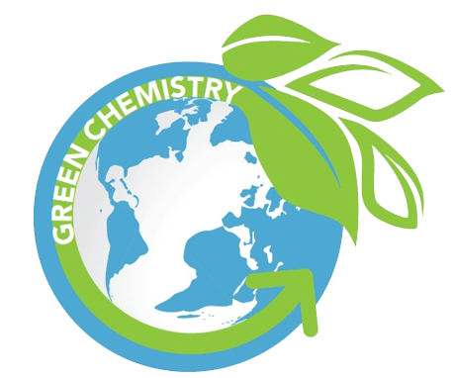

Activator/Bell Ringer/Starter
🔔
That’s Me!
Directions
- I will show you a slideshow presentation on the classroom screen. Each slide will contain a statement. Every time the statement applies to you, stand up and state “That’s Me!” If it does not apply to you, stay seated.
- Fill in the table below with checks for each statement and sum up your table in the end.
Question | That’s Me! | That’s NOT Me!
1
2
3
4
5
6
7
8
9
10
11
SUM | /11 | /11

That’s Me! Slides
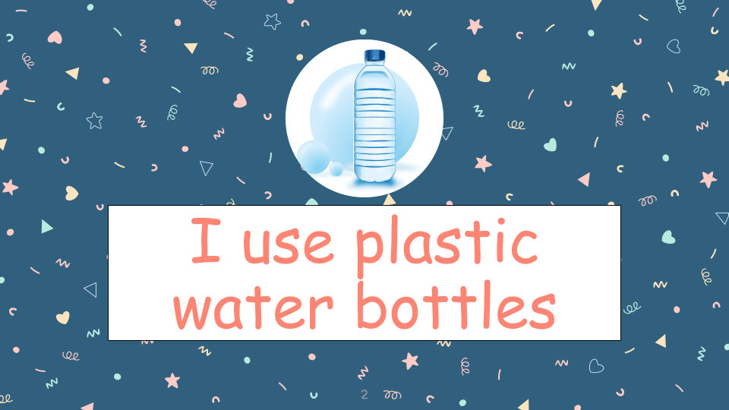
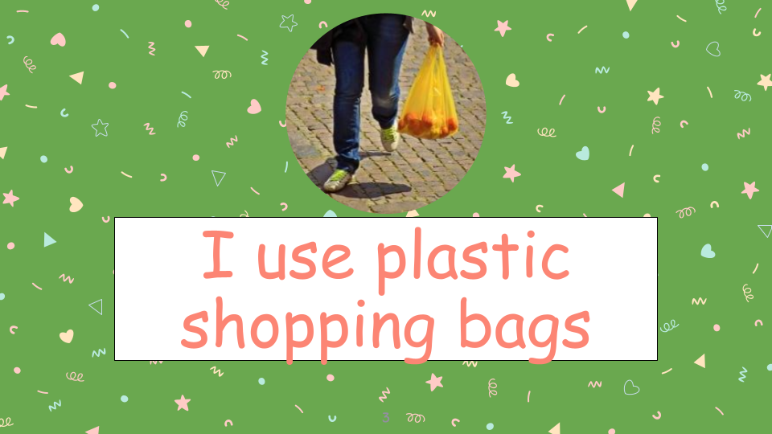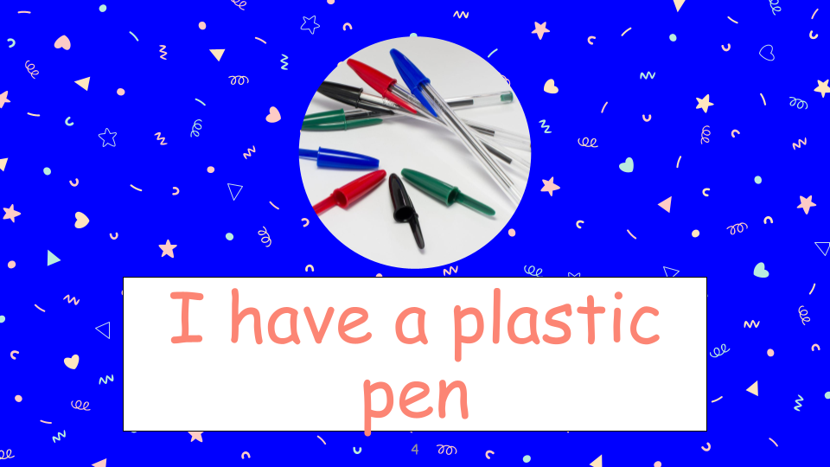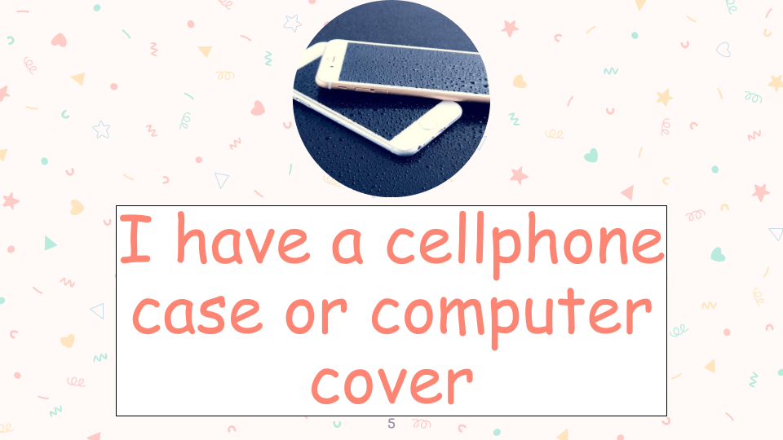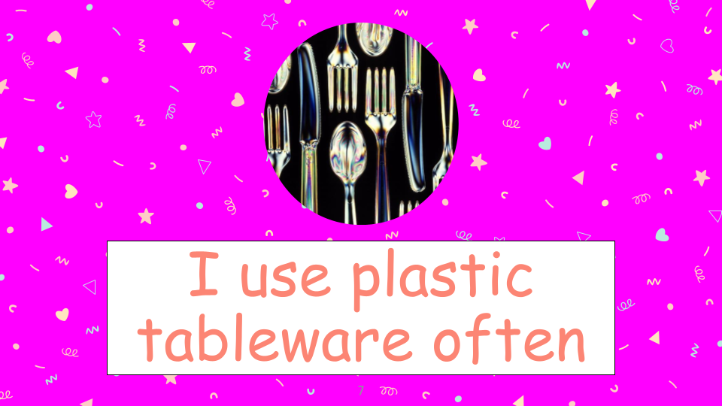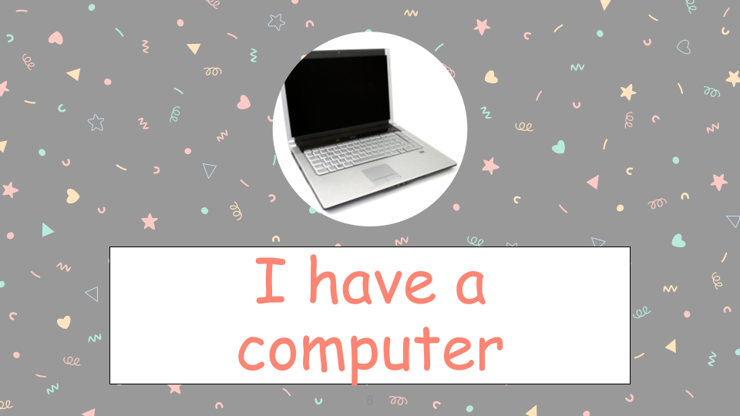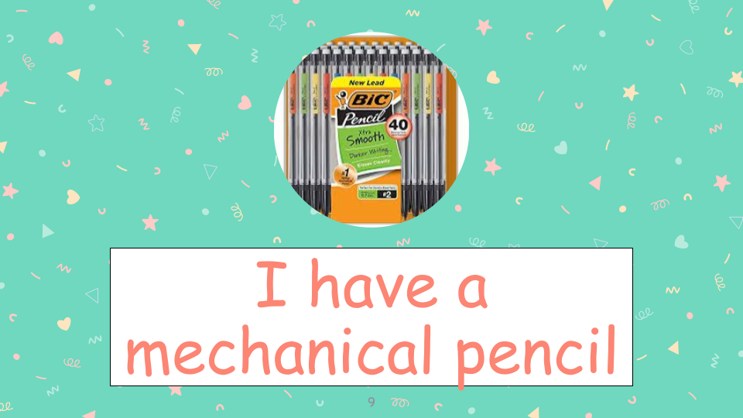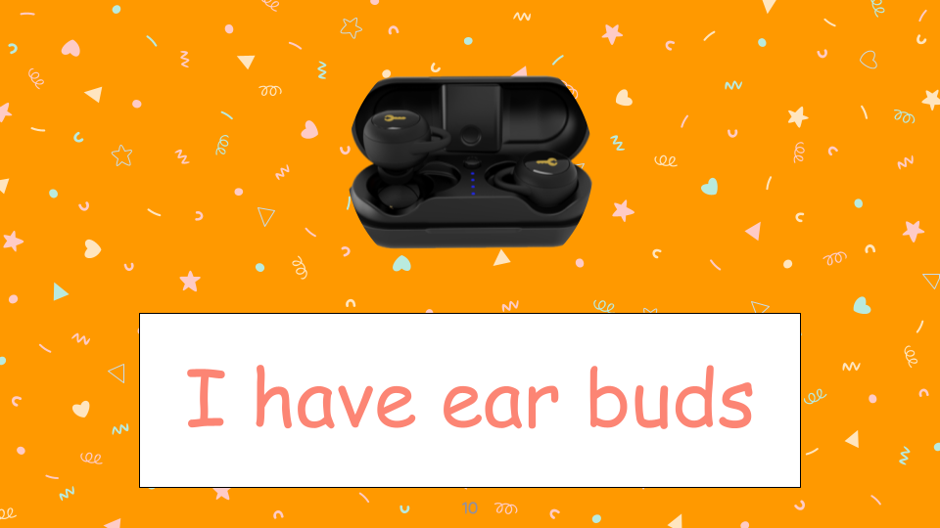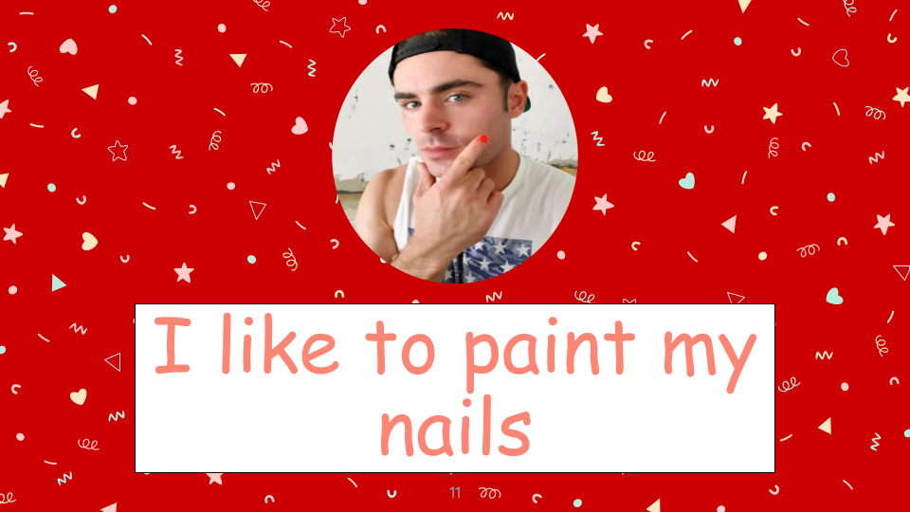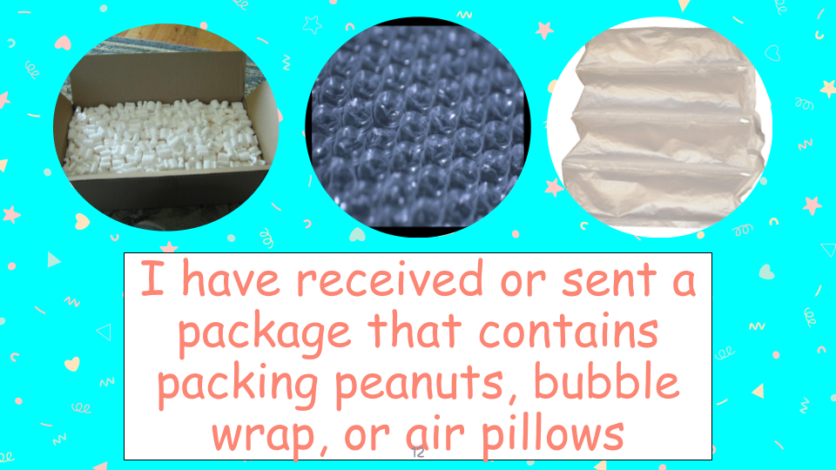
Packing Problems

Directions: I am going to show you a demonstration that involves packing peanuts. These are the little foam items that sometimes come in boxes that are shipped to homes. The peanuts we will observe today are both the traditional kind made from styrofoam, and a newer variety made from corn starch. Both types of packing peanuts will be placed into water and acetone. As I do the demonstration, I would like you to answer the questions below.

Demo 1
- Fill in the table below.
 | Traditional Packing Peanut (Water) | Traditional Packing Peanut (Acetone)
Observations When Placed in Liquid | I notice…  I wonder…. | I notice….  I wonder….

Demo 2
- Fill in the table below.
 | Newer Variety Packing Peanut (Water) | Newer Variety Peanut (Acetone)
Observations When Placed in Liquid | I notice…  I wonder…. | I notice….  I wonder.

- Which situation involved a chemical reaction? List or draw evidence of a chemical reaction in this demonstration.

Ticket-Out
🎫
Text Me!

Respond to one of the 4 questions below as a “text message.”

  - Thinking back on the “That’s Me!” activity and the packing peanuts activity, where do you think you could replace a plastic in your life with an environmentally friendlier alternative? Explain.

  - How did the packing peanut demo change your perspective on plastic use? Explain.

  - From your “That’s me!” activity, do you think you use a lot of plastics? Why or Why not?

  - Sometimes we DO need non-biodegradable plastics for certain objects. What is an example of an object you feel needs to be made of a non-biodegradable plastic and why?

Lesson 2
Plastics in our World

Activator/Bell Ringer/Starter
🔔
- You will be given some tokens. Get up and walk around the room, making observations on the objects in our classroom. Each time you see an object made of plastic, either entirely or partially, please add a token to the plastic container. If you see an item entirely or partially made of wood, please add a token to the wood container. Please do the same for the categories of paper and stone/mineral. For example, if I were in a home and that home has granite counter-tops in the kitchen, I would put a token in the stone container. If the kitchen floor was a plastic laminate, I would put a token in the plastic container. If a spatula was made of plastic and wood, I would put a token in each container. If instead, that spatula was made of metal, I would put a token in the metal container.

- Now, we will tally the results of step 1. What observations can you make about the objects in the classroom? Some sentence starters to help you:
I notice the ________ container has the most tokens.
I notice the ________ container has the least tokens.
I noticed many combinations of ________ and ________ materials in the room.
I saw very little of ___________ in the room.
Your answer:

- With a nearest neighbor, pair-up and discuss the questions in the table below. Then, form a square (pair up with another pair) and share your answers with one another.
Question | Paired Answer | Squared Answer
Why do you think staplers are made of plastic and metal?
Why do you think beakers are made of glass?
Why do you think the cabinets are made of wood?

Plastics In Our World

Directions: We are going to do a Pair-Square activity.
- First, you will work with your nearest neighbor, to read through the document below. As you read, please highlight and underline key concepts, make notes in the margin, and look up any word that you do not know.
- Afterwards, you and your partner should then answer the questions in the graphic organizer about the reading.
- Next, you and your partner will work together with another duo and discuss your answers with them.

READING
What is plastic? Polystyrene is the plastic located in the traditional packing peanuts. Plastic is a petroleum-based product. It is made of polymers, which are just lots of repetitions of the same subunit (poly means many and -mer means part). Crude oil and the plastics made from it create a lot of pollution.

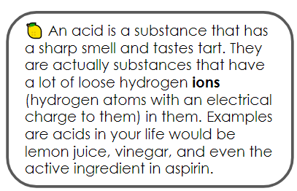
Where do we get plastic from? Plastic is made from crude oil, a type of nonrenewable resource - so we will eventually run out of it. It is made from crude oil which itself is made from a specific decay process of organisms over a very long period of time. We access it by drilling into vast underground reservoirs. To extract the crude oil, a large amount of clean water is used, generating unusable wastewater. A large infrastructure is built to get the oil to ground level. Once there, the oil is pumped through a pipeline; these pipelines are sometimes thousands of miles long. The production and transportation of oil through these pipelines have two major risks—pipeline leaks and oil spills—which cause immediate and long-term environmental damage. The crude oil then goes to a refinery to be processed into different types of fuel, chemicals, and plastics.

The oil for plastic gets processed into small pellets. Additives are mixed in, more water is used, and strong acids are added to break down the pellets; these processes all contribute to additional risks in the production of plastic. Finally, the pellets are heated at extremely high temperatures in a furnace. Once melted, the material is poured into a mold and left to harden into its final plastic form. While many petroleum-based plastics are recyclable, a vast majority of them end up in landfills. These plastics last in the environment for approximately 400 years, on average. An overwhelming 93% of all plastics consumed in the United States are not recycled.

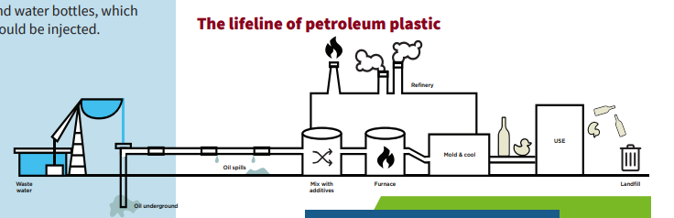

WHAT IS A BIOPLASTIC?
Looking at the life cycle above, you can see that petroleum oil is extracted from the ground and you may think, “If it comes from nature, shouldn’t that make it sustainable?”

Petroleum oil comes from deep in the ground and takes tens of millions of years to create, but humans consume oil at a much faster rate than it is made. The process of extracting oil from the ground also involves generating a lot of wastewater, and digging into the earth to extract the petroleum oil can disrupt the natural ecosystems. Biological material, or living materials, can be grown and harvested above ground. This makes biological material more accessible, and they have a smaller environmental impact like the corn starch packing peanuts. Many companies have used biological material sources to make plastics to be more cost effective and sustainable than traditional petroleum oil-based plastics. When we use a biological material to make a plastic, we refer to that plastic as a bioplastic.
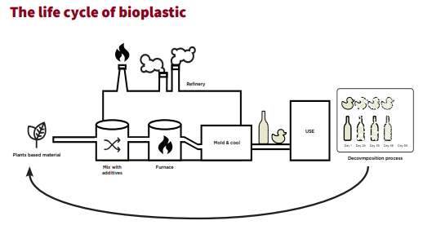

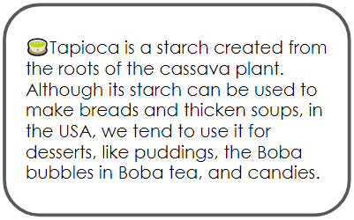
Depending on where you are in the world, different starches (the white powdery stuff that is naturally occurring in potatoes, rice, wheat, etc…) are used as the biological material in bioplastics. In the packing peanuts, corn starch was used. However, there are a lot of different starches that can be used to create a bioplastic. Generally, scientists use whichever starch is the most abundant in their area. The following image shows which types of starches are most abundantly used in each region:

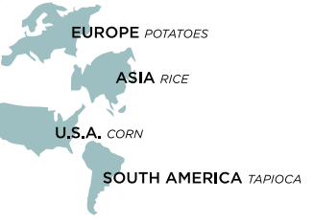
Pros and Cons of Using Biodegradable Packing Peanuts

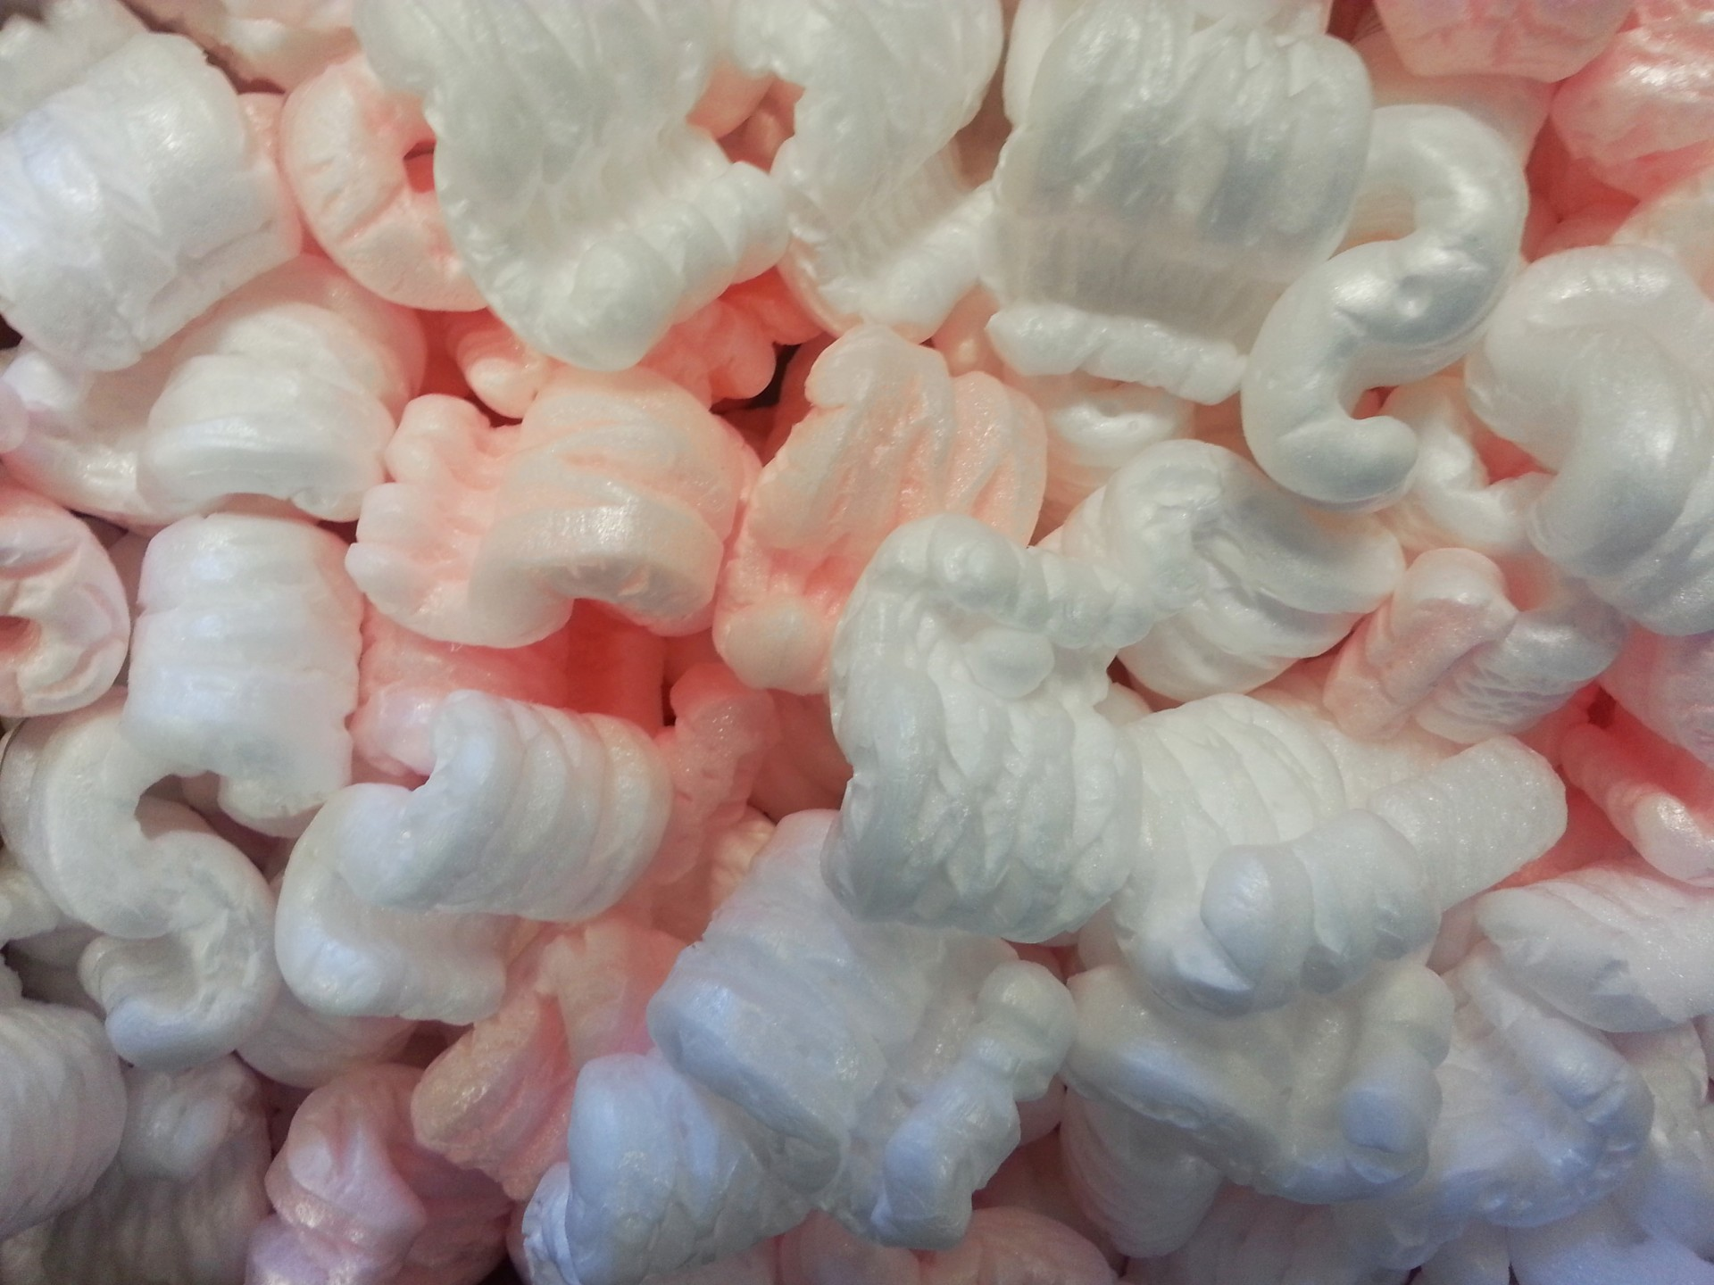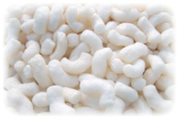
Traditional Packing Peanut
Biodegradable Packing Peanut

Pair-Square Chart
Question | Pair | Square  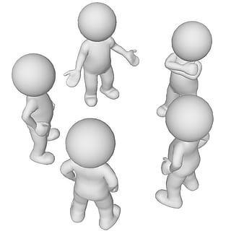
Identify two problems with using crude oil to make plastics.
If you were moving and needed the packing peanuts for the items in your home, which peanut would be best for you and why?
If corn starch packing peanuts can be used to replace polystyrene peanuts, what else could we do to reduce the crude oil waste in our landfills?
What is the relative cost of corn starch peanuts compared to polystyrene peanuts?

Ticket-Out
🎫
Please answer the questions below completely:
List 3 important points from this lesson:

Lesson 3
Client Pitch Challenge

Activator/Bell Ringer/Starter
🔔
Reflect on yesterday’s reading to respond to this question.

What factors should be considered when choosing materials used to produce a product?

Client Pitch Challenge

Directions
- The Scenario: A bioplastics manufacturer needs our help. They have been developing a bioplastic that they can manufacture with a range of different properties that can be used in different applications. They need help, however, pitching the value of bioplastics to different clients.

- Your task: Choose which plastic item you would like to redesign using bioplastic. Complete a small group activity to brainstorm possibilities. Choices have to make use of properties the manufacturer can manipulate (e.g., flexibility, texture).

Example objects could include:
- Water Bottles
- Reusable Shopping Bags
- Biodegradable Trash Bags
- Or, a green alternative to a traditionally plastic product of your choice (check with me for permission!)

- Once you have brainstormed some items, ask classmates for feedback on which items they would like to have and why. Record different items and their application, and what material properties are important for those items.

- You will create a pitch for your product in the form of several Google or Jamboard slides. The pitch should be colorful, interesting, contain pictures and must include:
  - A comparison and a contrast of your Green Chemistry product with the traditional version of your product. There should be at least 5 points of comparison. You may discuss their effects on the environment, their costs, additional benefits/deficits to humans, how human needs for the purpose of this product came into play, etc…
  - What makes this a “green” product? This should include an assessment of the product using the Orb-It Orb and Tool to assist you (Discussed further in lesson 5).
  - How is Green chemistry used in its production. This should include a brief description of the manufacturing process.

- You may use Google to find information about your product. Suggested websites are also provided below. Please make sure to include a second slide or second board with a list of the references you used for this assignment.

- Possible resources:
  - For Water Bottles
    - Here’s a Water Bottle You Can Actually Eat
    - Edible Water Bottles and the Strange Science of Spherification
    - London Marathon Replaces Water Bottles With Biodegradable And Edible Water Pouches
    - Notpla - We Make Packaging Disappear

  - For Reusable Shopping Bags
    - 6 Best Reusable Shopping Bags For Smarter Shopping
    - Sustainable Shopping - Which Bag is Best?
    - Plastic, Paper or Cotton: Which Shopping Bag is Best?
    - Here's how many times you actually need to reuse your shopping bags

  - For Biodegradable Trash Bags
    - Top 5 Best Biodegradable Trash Bags of 2020
    - Are biodegradable bags better than plastic? It’s complicated.
    - How biodegradable plastic bags don’t live up to their name
    - Why Waste It? Let’s Sort it!

Criteria for Success

Pitch contains…
Criterion | Available Points | Student Self-Score | Earned Score
Name of your product | 5
Provide a comparison and a contrast of your Green Chemistry product with the traditional version of your product. There should be at least 5 points. You may discuss their effects on the environment, their costs, additional benefits/deficits to humans, how human needs for the purpose of this product came into play, etc… | 15
What makes this a “green” product. Use the Orb-It Orb to assess. | 15
How is Green chemistry used in its production? This should include a brief description of the manufacturing process. | 15
Graphic organizer providing information about the product | 15
Presentation:  - Is colorful, interesting, and contains pictures.  - Uses appropriate grammar, punctuation, and spelling | 20
Contains a Works Cites/Reference Slide/Board | 15
TOTAL | 100 | /100 | /100

Grading Rubric

Content Grade
Criterion | Available Points and Description
Name of your product | 5  Present |  |  | 0  Missing
Provide a comparison and a contrast of your Green Chemistry product with the traditional version of your product. There should be at least 5 points. You may discuss their effects on the environment, their costs, additional benefits/deficits to humans, how human needs for the purpose of this product came into play, etc… | 15  The comparison and contrast contains at least 5 points. It is written in complete sentences or displayed extremely clearly in a graphical format. | 10  The comparison and contrast contains only 3-4 points. It is written in mostly complete sentences or displayed fairly well in a graphical format. | 5  The comparison and contrast contains only 1-2 points. It is not written in complete sentences or displayed in a comprehensible graphical format. | 0  Missing
What makes this a “green” product. Use the Orb-It Orb to assess. | 15  Student clearly describes in complete sentences what makes the product green and includes a complete evaluation of the product using the Orb-It Orb. The description is accurate to the product. | 10  Student clearly describes in mostly complete sentences what makes the product green and includes a mostly mostly complete evaluation of the product using the Orb-It Orb. The description is fairly accurate to the product. | 5  Students description is difficult to understand. They do not necessarily use the Orb-It Orb to evaluate the product. | 0  Missing
How is Green chemistry used in its production. This should include a brief description of the manufacturing process. | 15  The student correctly explains how this product utilizes green chemistry, specifically designing the manufacturing process. The description is written clearly using easy to understand language and/or uses graphics to explain it well. | 10  The student explains how this product utilizes green chemistry, specifically designing the manufacturing process. The description is written mostly clearly, but may use high-level language and/or uses not very descriptive graphics to explain it. | 5  The student explains how this product utilizes green chemistry incorrectly. Using descriptive written language and/or graphics. | 0  Missing
Graphic organizer providing information about the product. | 15  The student provides a graphic organizer, which is complete and demonstrates that the student has information about the product by providing a well developed description of the product, a thorough list of the characteristics of the product, and an extremely descriptive and well thought out sentence with a drawing. | 10  The student provides a graphic organizer, which is complete and mostly demonstrates that the student has information about the product by providing a well developed description of the product, a list of the characteristics of the product, and a somewhat descriptive sentence. There may or may not be a drawing. | 5  The student provides a graphic organizer, which is only partially complete and somewhat demonstrates that the student has information about the product. There is a description of the product, a list of the characteristics of the product, and a somewhat descriptive sentence. There is no drawing. | 0  Missing
CONTENT TOTAL | /65

Style and Works Cited Grade
Criterion | Available Points and Description
Presentation:  - Is colorful, interesting, and contains pictures.  - Uses appropriate grammar, punctuation, and spelling | 20  Is colorful, interesting, and contains pictures.  Uses appropriate grammar, punctuation, and spelling at all times. | 15  Is colorful, interesting, and/or contains pictures.  Uses appropriate grammar, punctuation, most of the time. | 10  Is colorful, interesting, or contains pictures.  Uses appropriate grammar, punctuation, some of the time. | 5  Is neither colorful, interesting, nor contains pictures.  Uses appropriate grammar, punctuation rarely. | 0  Missing
Contains a Works Cited/Reference Slide/Board | 15  Contains a works cited/reference slide/board using an appropriate reference method, such as APA/MLA or other method suggested by the instructor. | n/a | n/a | n/a | 0  Missing
STYLE AND WORK CITED TOTAL | /35

PROJECT GRADE TOTAL… /100

Ticket-Out
🎫
- Provide cool feedback (areas that could use improvement) about how today went. You can discuss how the group work went, how the research went, how you feel the creation process is going, etc...

Your response:

- Similarly, provide warm feedback (positive feedback) about how today went. You can discuss how the group work went, how the research went, how you feel the creation process is going, etc...

Your response:

Lesson 4
Why Invent with Green Chemistry?

Activator/Bell Ringer/Starter
🔔
Fill in the organizer below based on any background knowledge you have on this topic. If you do not know anything about this topic, use your best judgment at filling this out.
I think Green Chemistry…
Use in a descriptive sentence.
Characteristics/Examples of Green Chemistry are...
Provide a drawing of your sentence.
GREEN CHEMISTRY

Why Invent with Green Chemistry?

We are now going to watch a video featuring John Warner, co-founder of the field of green chemistry. John, in particular, believes in inventing with intention. After the video, answer the 3 questions posed below. We will then share our answers with one another as a class. Afterwards, revise your own answers, as needed.
1  What is the relationship between how the world uses things and invention? | 2  How does this connect unlikely things to one another? For example, the creation of less hazardous road pavements leading to new cell phone technology? | 3  Why is Green Chemistry important for developing a new way to make things ?
Your Answer: | Your Answer: | Your Answer:
Answers from the Class: | Answers from the Class: | Answers from the Class:
Revised Explanation: | Revised Explanation: | Revised Explanation:

Inventing with a Goal in Mind

Directions: Read the text below. You will use the information provided in the next activity.

Green chemistry is the science of designing chemical products or processes to reduce and/or eliminate the use or creation of hazardous substances. Different from other sciences that study what something does, green chemistry focuses on the building blocks of a product to make it more environmentally friendly. For example, as we know from our work with packing peanuts and yesterday’s work, creating products from a petroleum source is hazardous to the environment, so green chemistry would look at methods to create products with the same overall properties that produce fewer pollutants or even none at all!

Inventing for a sustainable future involves thinking about the environment at the earliest stage of design. The inventive mindset taps into the creativity and curiosity of inventors, artists, and scientists. Designing with the environment in mind also involves thinking about the interaction of matter, known as chemistry. Chemistry is the science behind all of the products we use and consume. It is usually defined as how matter interacts with other matter. Matter is basically the “stuff” that makes up things.

Though chemistry is the foundation of life and critical to invention, it sometimes has a negative reputation when it comes to the environment. There are a lot of products that have been created in a way that is hazardous, wasteful, and damaging to the environment. These items create poisonous conditions to our land or water supply, they fill our garbage dumps with materials that will not biodegrade for hundreds or thousands of years, and they contaminate our air. However, green chemistry is the opposite of this.

Green chemistry is an approach that puts chemists in the role of the inventor. It helps them intentionally design chemical products that are safer for humans and for the environment. Green chemistry is often described as the science of creating solutions and sustainable products. It focuses on reducing or eliminating pollution at the earliest design stage of a material, as well as in its use. So, green chemists keep in mind their invention’s impact on both human and environmental health. Green chemists often get their inspiration for product design from nature since nature is able to “invent” without causing harm. This process of copying nature to invent is called biomimicry. An example of this is how green chemists are developing a glue to be used in the field of medicine, such as in place of stitches in surgical procedures, modeled after the “glue” that mussels use to stick to rocks.

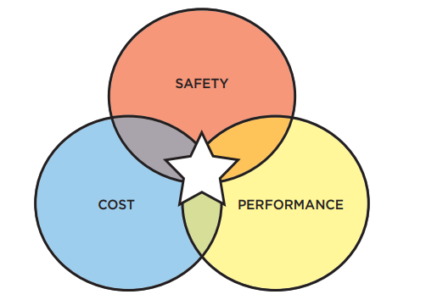

Green chemists think not just about how a product will be used, but who the user will be, what costs they are willing to spend, and what makes a product viable to that person. A great invention is at the intersection of those considerations, having a high performance (meaning that it does exactly what it is designed for at the same level of a less green alternative), a low financial cost, and being very safe for humans and their environment.

One example in need of a green chemistry product redesign is the . Check out the video below of what a lava lamp is and what it is made from:

Video Link: https://www.businessinsider.com/adidas-sneakers-plastic-bottles-ocean-waste-recycle-pollution-2019-8

Lava lamps cause damage to humans, contaminate the environment, and fill our landfills with non-recyclable plastics. They require a sustainable solution. This means that they would become nontoxic to humans, recycle in environmental ways, and do not fill our landfills. As we have seen, there is now a sustainable solution to packing peanuts, in the form of the slightly more expensive ones made of corn or potato starch that decompose when exposed to water.

In conclusion, behind every invention is a person or team of people who recognize a problem or see an opportunity and invent a solution. Their goal is to follow the main tenets of Green Chemistry - make production more efficient and cause less harm. Inventing is a balance between discovery and creativity. The intentional invention of materials that are “benign by design” is at the core of green chemistry.

Understanding Green Chemistry
and Invention with Intent

Directions:
- You will be randomly assigned to groups. Choose a job role once in your group. The roles are:
  - Artist - In charge of the artwork and encourages use of color to express ideas.
  - Recorder - documents the group’s ideas.
  - Sentence creator - Takes the group’s idea and turns them into sentences.
  - Team organizer - Keeps the team on task, manages the time.

- You will use the information you learned today and yesterday to complete a chart paper-sized version of the graphic organizer below.
We think Green Chemistry…
Use in a descriptive sentence.
Characteristics/Examples of Green Chemistry are...
Provide a drawing of your sentence.
GREEN CHEMISTRY
- If we have enough time left to class, then I will ask each team to hang up their organizer around the classroom, and for you all to take a tour of the classroom. Observe each other’s organizers and write down the definitions, characteristics, sentences, and drawings that stood out to you on the mini organizer below.

Define Green Chemistry
Use in a descriptive sentence.
Characteristics/Examples of Green Chemistry
Provide a drawing of your sentence.
GREEN CHEMISTRY

Ticket-Out
🎫
What are 3 things that you have learned about Green Chemistry?

1 | 2 | 3

Lesson 5
Applying the Orb-It Analysis

Activator/Bell Ringer/Starter
🔔
Get into your work groups. Review each of your tickets-out from yesterday and read through the feedback you left about the work. Considering what you know so far, what steps will you take to complete the assignment today?

Your response:

Orb-It
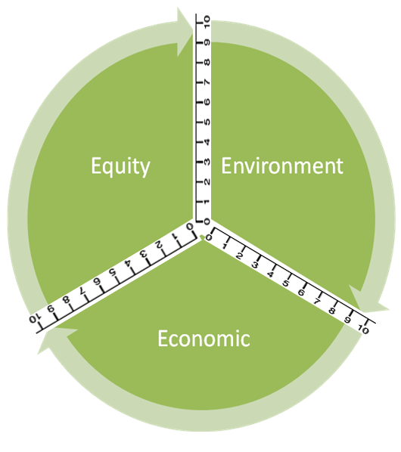
Orb-It Tool
Directions:
- Research your product as group.

- Use personal experience and information from your research to fill in the second column (Info from research or personal experience to support the rating).

- Refer to the rating scale below to rate each criteria:
10 – Perfect (it couldn’t be better!)
9 – Excellent (impressive, but could still improve slightly)
8 – Great (better than expected, but could improve a little)
7 – Good (average performance)
6 – Pretty good (good, significant improvements could be made)
5 – Adequate (it’s just okay)
4 - Partially proficient (needs much improvement)
3 – Falls short
2 – Tries, but still does not succeed
1 – Barely (it’s unsatisfactory)
0 – Doesn’t (it failed miserably!)

Social Impact (Equity) | Info from research or personal experience to support the rating | Ratings
Ingredients
Use of Renewable Feedstocks
Health
Designing Safer Chemicals
Environmental Impact | Info from GoodGuide or personal experience to support the rating | Ratings
Air pollution
Waste Prevention & Design for Degradation
Energy Use
Design for Energy Efficiency
Toxic Waste
Waste Prevention & Design for Degradation
Water Quality
Waste Prevention & Design for Degradation
Climate Change
Waste Prevention
Economic Impact | Info from GoodGuide or personal experience to support the rating | Ratings
Cost
Quality
Designing Safer Chemicals
Philanthropy
Gives back to the community

- Now, label the Orb-It Orb by following the steps below:
STEP 1: Place your rating for Equity on both the number lines bordering “Equity”.
STEP 2: Use a compass to make an arc connecting those two points.
STEP 3: Shade the area you created within the arc.
STEP 4: Repeat steps 1 – 3 for both Environment and Economic.
Ticket-Out
🎫
Please fill in the chart below about your experiences with the lessons so far:
What were some new things you learned during these lessons? | What activity or lesson was easiest for you?
What was something that surprised you from the lessons? | What activity or lesson was the most challenging?

Extend the Learning:
What are the Principles of Green Chemistry

Green Chemistry has 12 specific rules, or principles, it follows. These principles ensure that scientists will follow the core tenets of creating products that are efficient for the environment, made of inexpensive materials, and provide a valuable use to the consumer.

To do this activity, you will form into groups of 3-4 individuals. Each of you should choose one of the following job roles and then you will read the 12 Principles provided below and research any words you are unfamiliar with.

Job Roles

  - Facilitator - Makes sure the team starts quickly and remains focused; manages time; makes sure all voices are heard during discussion.

  - Reader - Reads the article out-loud to their group mates. Makes brief checks for understanding with the assistance of the Strategy Analyst.

  - Strategy Analyst - Assists with check-ins for understanding of the text read. Engages in research of words requested by the group.

  - Recorder - records names and roles of group members; records group’s thoughts on the post-reading questions.

The 12 Principles of Green Chemistry
(taken and edited from Beyond Benign)

1. Pollution Prevention: It is better to prevent waste than clean it up after-the-fact, so the goal is to create less waste from an experiment.

2. Atom Economy: This principle gets more into the actual chemistry of how products are made. As chemists, atoms are assembled to make molecules which are then used to make materials. This principle says that it is best to use all the atoms in a process to prevent atomic waste.

3. Less Hazardous Chemical Synthesis: This principle is aimed at reducing the hazards in a chemical process, so that it is safer to make a product. This also often makes a chemical process more efficient too!

4. Designing Safer Chemicals: Whereas principle 3 focuses on the process of chemical manufacture, this one focuses on the chemical itself. The goal is to design chemicals that are less toxic or not toxic at all.

5. Safer Solvents and Auxiliaries: Many chemical reactions are done in a solvent. Traditionally, organic solvents have been used that pose hazards and/or are highly toxic (such as nail polish remover). A specific type, called volatile organic compounds (VOC’s), add to pollution and can be highly hazardous to humans. This principle focuses on creating products that use less hazardous solvents (such as water).

6. Design for Energy Efficiency: Today, there is a focus on renewable energy and energy conservation. This principle focuses on creating energy efficient reactions to make a product.

7. Use of Renewable Feedstocks: 90-95% of the products we use in our everyday lives are made from petroleum. Our society not only depends on petroleum for transportation and energy, but also for making products. This principle seeks to shift our dependence on petroleum and to make products from renewable materials that can be gathered or harvested locally, such as biofuels.

8. Reduce Derivatives: In chemistry, we regularly engage in the manipulation of molecules in order to shape the molecules into what we want them to look like. This often produces unwanted extra products (derivatives). This principle looks at these processes and aims to reduce the manufacture of those derivatives.

9. Catalysis: In a chemical process catalysts are used in order to reduce energy requirements and to make reactions happen more efficiently (and many times quicker). Very little of a catalyst is required to have an effect and sometimes, a can be truly “green” and will have little to no toxicity, perhaps even being able to be used over-and-over again.

10. Design for Degradation: Not only do we want our materials to come from renewable resources, but we would also like them to decompose quickly. This principle seeks to design products to perform their intended function and then, when appropriate, degrade into safe, innocuous by-products.

11. Real-time Analysis for Pollution Prevention: Chemists, like bakers, need to be able to answer the following questions: How long do I allow the reaction/baking to run? When do I know it will be “done”? Knowing exactly when it would be “done”, would reduce waste in the manufacturing process and ensure that your product is the one that you intended to make.

12. Inherently Safer Chemistry for Accident Prevention: This principle focuses on safety for the worker. It is better to use materials and chemicals that will not explode, catch fire, ignite in air, etc. when making a product. So, these kinds of chemicals should be avoided whenever possible.

Post-Reading Questions

- What were 3 words that you needed to look up as a group to understand the reading better? What did they mean in the context of the reading?
Word | Meaning in Context of the Reading

- What would you like to Ask the author about within the text?
Your answer:

- What Aspect would you want to engage in further research about? Why?
Your answer:

- What parts of the text do you want to Aspire to?
Your answer:

- How do you see the 12 principles applying to some aspect of your everyday life? Try to answer this question by specifically identifying at least 3 of them. For example, many coffee houses have switched from using plastic stirrers to wooden stirrers, which follows principle 10 (design for degradation).
Your answer:

