

**MIDDLE SCHOOL**

**Biotechnology**

**Mapping the Males**

**Goal**: Students will narrow down possible fathers using observation skills and accessing background knowledge. Students will also be introduced to gel electrophoresis.

**Learning Objectives**: Students will…

* Make observations about potential fathers based on map and biological information
* Hypothesize top biological father candidates
* Watch video about gel electrophoresis

**Materials:**

* Mapping the Males Regional Map
* Mapping the Males Daddy Data Sheet
* Projection system
* Access to the video weblink <http://learn.genetics.utah.edu/content/labs/gel/>
* Gel Electrophoresis Sequencing cards

**Time Required**: 45 - 60 minute class period

**Standards Met**:

* Science as inquiry: Abilities necessary to do scientific inquiry
* Life science: Reproduction and heredity
* Science and technology: Abilities of technological design

**Procedure**:

* Explain to students that Furry Friends was able to obtain a DNA gel electrophoresis fingerprint that belongs to the father of the kittens.
  + Furry Friends needs to determine which cat is the father. (Sparky is type AB blood so Furry Friends needs to make sure that the father is not B type because the combination can be harmful to kittens)
  + They have provided us with a map and would like your recommendations for potential fathers.
  + Once they have this information, they will collect samples and run DNA gel electrophoresis on those cats.
* Give each group a Mapping the Males Regional Map and Daddy Data Sheet
* Students should complete the sheet and recommend 1 cat who they believe is the strongest candidate for fatherhood.
* Once students have finished, explain that Furry Friends will complete a gel electrophoresis for each cat recommended.
* Tell students that they will complete a simulation in class tomorrow so they can experience the gel electrophoresis process.
* Today, they will watch a short video demonstrating the process
  + <http://learn.genetics.utah.edu/content/labs/gel/>
  + Stop the video when the picture of the man in glasses suggests that you do your own!
* If there is time, give students the cut out gel electrophoresis sequencing cards and have them put the steps in the correct order

**Assessment:**

* Completed Daddy Data Sheet
* Gel Electrophoresis Sequencing cards

**Mapping the Males: Regional Map**

MCj02972830000[1][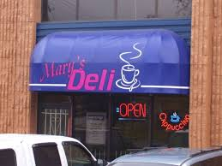](http://images.google.com/imgres?imgurl=http://www3.telus.net/oldstyledeli/deli2t.jpg&imgrefurl=http://www3.telus.net/oldstyledeli/&usg=__cNvr9EXw7vtVovt2giprOqoXnAA=&h=450&w=600&sz=51&hl=en&start=71&um=1&tbnid=3HlqO5NDbYxJjM:&tbnh=101&tbnw=135&prev=/images?q%3Ddeli%26ndsp%3D20%26hl%3Den%26rls%3Dcom.microsoft:en-US%26rlz%3D1I7GGIE_en%26sa%3DN%26start%3D60%26um%3D1) 

**Mary’s Deli Old Lady Smith’s House Café Perk**

Billie XX Bowser XY Tuga XY

Spayed Age 3 Neutered Age 6 Age 17

Smoke Black & Brown Black & White Himalayan Maine Coon Abyssinian

Found

6 of the cats that were in Sparky’s shed the day of her capture

(2 were not found)

[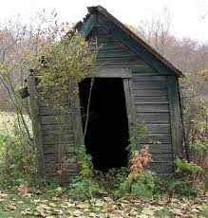](http://images.google.com/imgres?imgurl=http://www.shedplans-101.com/shed.jpg&imgrefurl=http://www.shedplans-101.com/resources.php&usg=__eg9Ydv7_2FFtCOIOBsBGMVITbL8=&h=325&w=310&sz=29&hl=en&start=88&um=1&tbnid=r5N6sGNZ9fJCiM:&tbnh=118&tbnw=113&prev=/images?q%3Dold%2Bshed%26ndsp%3D20%26hl%3Den%26rls%3Dcom.microsoft:en-US%26rlz%3D1I7GGIE_en%26sa%3DN%26start%3D80%26um%3D1)

**Sparky’s Shed**

[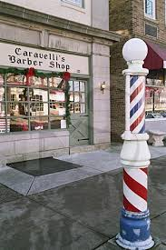](http://images.google.com/imgres?imgurl=http://www.ronsaari.com/stockImages/barberShops/CaravellisBarberShop.jpg&imgrefurl=http://www.ronsaari.com/stockImages/barberShops/CaravellisBarberShop.php&usg=__y77j95HnICzsbj7tW4I4NDwnpLM=&h=600&w=400&sz=55&hl=en&start=15&um=1&tbnid=7jvQXs81RbK14M:&tbnh=135&tbnw=90&prev=/images?q%3Dbarber%2Bshop%26hl%3Den%26rls%3Dcom.microsoft:en-US%26rlz%3D1I7GGIE_en%26um%3D1)[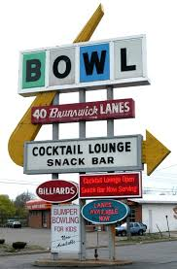](http://images.google.com/imgres?imgurl=http://www.waterwinterwonderland.com/images/signs/Bowling_Alley_Lansing.jpg&imgrefurl=http://www.waterwinterwonderland.com/signs.asp&usg=__D6GupwCOdzaNnDS2ZnyQ_gIDGik=&h=684&w=450&sz=71&hl=en&start=27&um=1&tbnid=Dsv6I4StzNi9nM:&tbnh=139&tbnw=91&prev=/images?q%3Dbowling%2Balley%26ndsp%3D20%26hl%3Den%26rls%3Dcom.microsoft:en-US%26rlz%3D1I7GGIE_en%26sa%3DN%26start%3D20%26um%3D1) 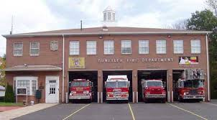

**Bowl-a-Rama Pleasantville Carmen’s Firehouse Barber Shop**

Carson XY Lucky XY Eloise XX

Age 9 Age 4 Age 7

Brown & White Mixed Cinnamon Orange & White American Shorthair Persian Manx

**Mapping the Males: Daddy Data Sheet**

Billie

* Yes
* No

2 reasons for your conclusion:

1. ______________________________

2. ______________________________

Carson

* Yes
* No

2 reasons for your conclusion:

1. ______________________________

2. ______________________________

Lucky

* Yes
* No

2 reasons for your conclusion:

1. ______________________________

2. ______________________________

Our top 3 recommendations for the father of Sparky’s kittens are:

1. ___________________________
2. ___________________________
3. ___________________________

*Place a star by your first choice!

Bowser

* Yes
* No

2 reasons for your conclusion:

1. ______________________________

2. ______________________________

Tuga

* Yes
* No

2 reasons for your conclusion:

1. ______________________________

2. ______________________________

Eloise

* Yes
* No

2 reasons for your conclusion:

1. ______________________________

2. ______________________________

**Mapping the Males: Daddy Data Sheet-Teacher Key**

**Billie:**

Sex: XX

Spayed

Age: 3

Breed: Himalayan

Color: Smoke

**Carson:**

Sex: XY

Age: 9

Breed: Mixed

Color: Brown and White

**Lucky:**

Sex: XY

Age: 4

Breed: Persian

Color: Cinnamon

**Bowser:**

Sex: XY

Neutered

Age: 6

Breed: Maine Coon Cat

Color: Black and Brown

**Tuga:**

Sex: XY

Age: 17

Breed: Abyssinian

Color: Black and White

**Eloise:**

Sex: XX

Age: 7

Breed: American Short-hair

Color: Orange and White Calico

**Mapping the Males: Gel Electrophoresis Sequence Cards**

|  |  |
| --- | --- |
| Add electrical current to make DNA strands move (electrophoresis) | Place DNA samples in the holes at the end of the gel using a pipette |
| Procure the gel, the jello-like filter | Stain the gel to see the DNA strands |
| Short strands move more quickly than long strands | Obtain a vial of a DNA sample |
| View the results | Dance a jig to celebrate your biotechnology skills |

**Mapping the Males: Gel Electrophoresis Sequence Cards Teacher Key**

1. Obtain a vial of a DNA sample

2. Procure the gel, the jello-like filter

3. Place DNA samples in the holes at the end of the gel using a pipette

4. Add electrical current to make DNA strands move (electrophoresis)

5. Short strands move more quickly than long strands

6. Stain the gel to see the DNA strands

7. View the results

8. Dance a jig to celebrate your biotechnology skills