 

**MIDDLE SCHOOL**

**Math & Engineering**

**House Overview**

**Goals:** To introduce students to the house project and review assessment & expectations

**Objectives:** Students will…..

* Interpret project requirements
* Evaluate house specifications and design
* Understand the grading criteria by reviewing the rubric
* Determine applications for math skills

**Standards met:**

* Connections: Recognize & apply mathematics in context outside of class
* Representation: Use representations to organize, record, & communicate mathematical ideas

**Time required:** 45 minutes

**Materials:** (for 30)

* 30 copies Specification Sheet
* 30 copies of concept map rubrics
* 30 copies of house components concept map
* 30 copies of math skills concept map

**Prep:**

* Make 30 copies of Specification and rubrics
* Make 30 copies of the House Components Concept Map

**Procedure:**

* Explain to students that the next step is to understand the requirements of the unit
* Give each student the Specification Sheet
* Review the sheet with the students, defining and explaining terms they may not understand
* Review the unit goals and skills students will be expected to master
* Give each student a copy of the rubric and review the expectations
* Create a concept map of elements students would like to include in a dream home. THEY MUST INCLUDE ALL ELEMENTS ON THE SPECIFICATION SHEET
* Option 1 - Give each student a copy of the House Components Concept Map
* Option 2 – Allow students to complete their own concept map including elements they’d like to include in a home
* Using the lists from “Whose House Is It?” and the Specification Sheet, students should complete the concept map of elements to include in a dream home
* Create a concept map explaining how they will use the math listed for the unit.
* Option 1 - Give each student a copy of the Math Skills Concept Map
* Option 2 – Allow students to complete their own concept map describing how they will use the various math skills listed on the specification sheet

**Assessment:**

* Completion of Concept Maps**House Overview - House Specifications**

**The list below includes all of the specifications that your house must include to meet the basic requirements for this project.**

* 1200 square feet maximum
* 2 bedrooms
  1. Each bedroom should contain 1 closet
* 1 Kitchen
* 1 Dining space
* 1 Bathroom
* Only 1 floor

**House Overview - Grading Rubric**

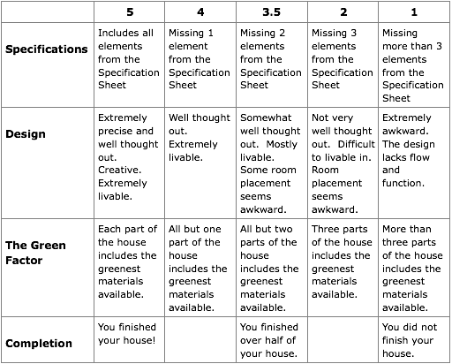

**House Overview - Math Skills Grading Rubric**

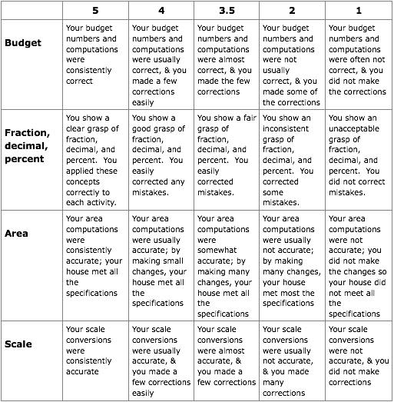

**House Overview - Components Concept Map Teacher Key**

*Student answers will vary significantly, but may resemble the concept map below.*

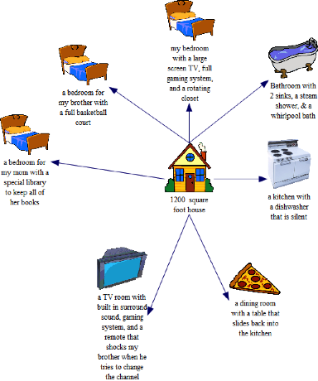

**House Overview - Components Concept Map**

Use the concept map below to outline the rooms you would have in your house. You made add boxes and pictures. Each picture should have an explanation that would peak the interest of a potential buyer.

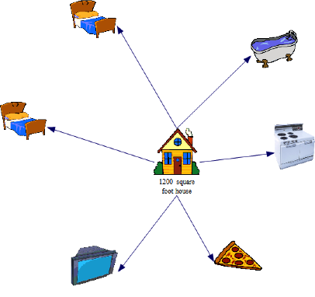

**House Overview - Math Skills Concept Map**

Using the concept map below, brainstorm at least one way in which you will use each math concept listed to complete your house.

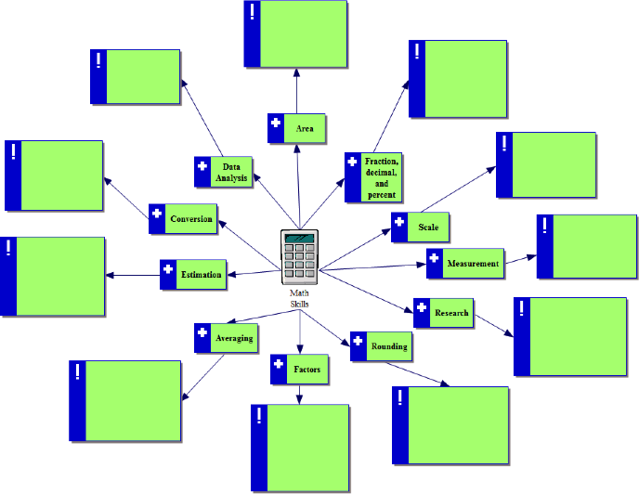

**House Overview - Math Skills Concept Map Teacher Key**

***Answers will vary, but may include the following:***

