 

**MIDDLE SCHOOL**

**Math & Engineering**

**Final Budget**

**Goals:** To apply math skills to a real life budgeting situation

**Objectives:** Students will…..

* Determine actual costs of materials using ***Construction Estimating List*** ***for House Building*** from Part I
* Calculate 7% sales tax on each item to be purchased (windows, doors, foundation, etc.) and round to the nearest cent
* Calculate amount of loan spent using a transaction register

**Standards met:**

Connections:

* Recognize and apply mathematics in contexts outside of mathematics

Numbers & Operations:

* Work flexibly with fractions, decimals, and percents to solve problems
* Select appropriate methods and tools for computing with fractions and decimals, and apply the selected methods

**Time required:** 2 class periods

**Materials: (for 30)**

* 30 copies of ***Transaction Register***
* 30 copies of ***Vendor List***
* 2 sets of front-to-back checks per student
* Overhead transparency of the transaction register
* Overhead transparency of checks
* Individual copies of student completed “***Construction Estimating List for House Building”***
* 30 copies of vendor’s list

**Prep:**

* Make copies of the transaction register and checks
* Optional: ask a local bank to donate check books to the school so students have the opportunity to use actual checkbooks

**Procedure:**

* Give each student a copy of the transaction register
* Using overhead, have a student place the loan amount in the correct place on the balance sheet
* Students should add the loan amount to his or her transaction register
* Review methods of rounding, finding percents and decimal computation
* Ask students to use their “***Construction Estimating List for House Building”***  from Part I to calculate the cost of materials plus 7% for every purchase on the list and round to the nearest cent
* Using the **vendor list, transaction register**  and the **checks**, student will write a check to each companyfor materials and balance the amount on the balance sheet using decimal computation until all vendors are paid
* Model the first transaction using the overhead transparency of the balance sheet and check

**Assessment:**

* Transaction Register

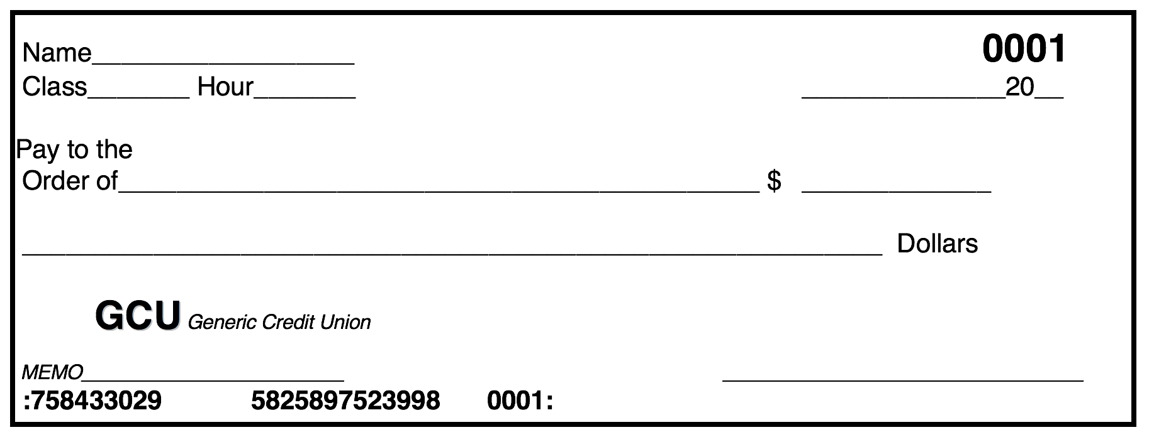

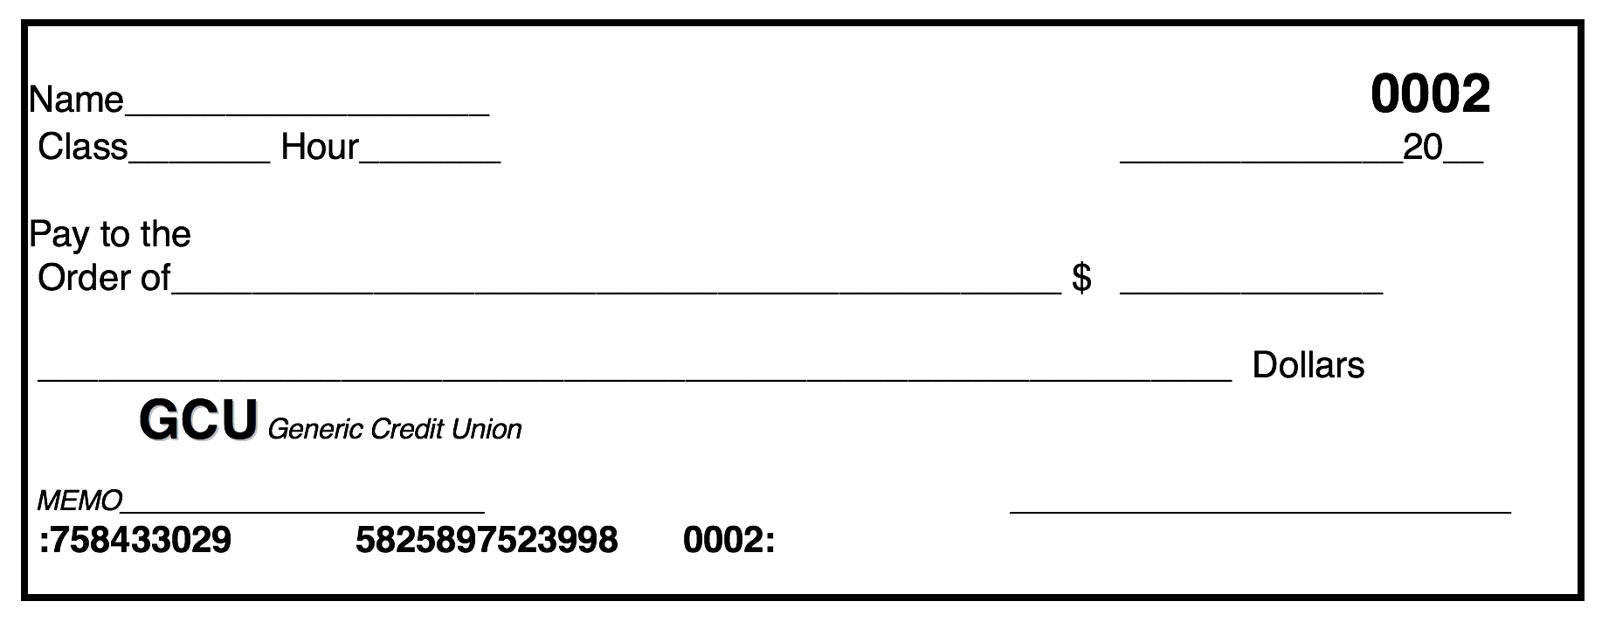

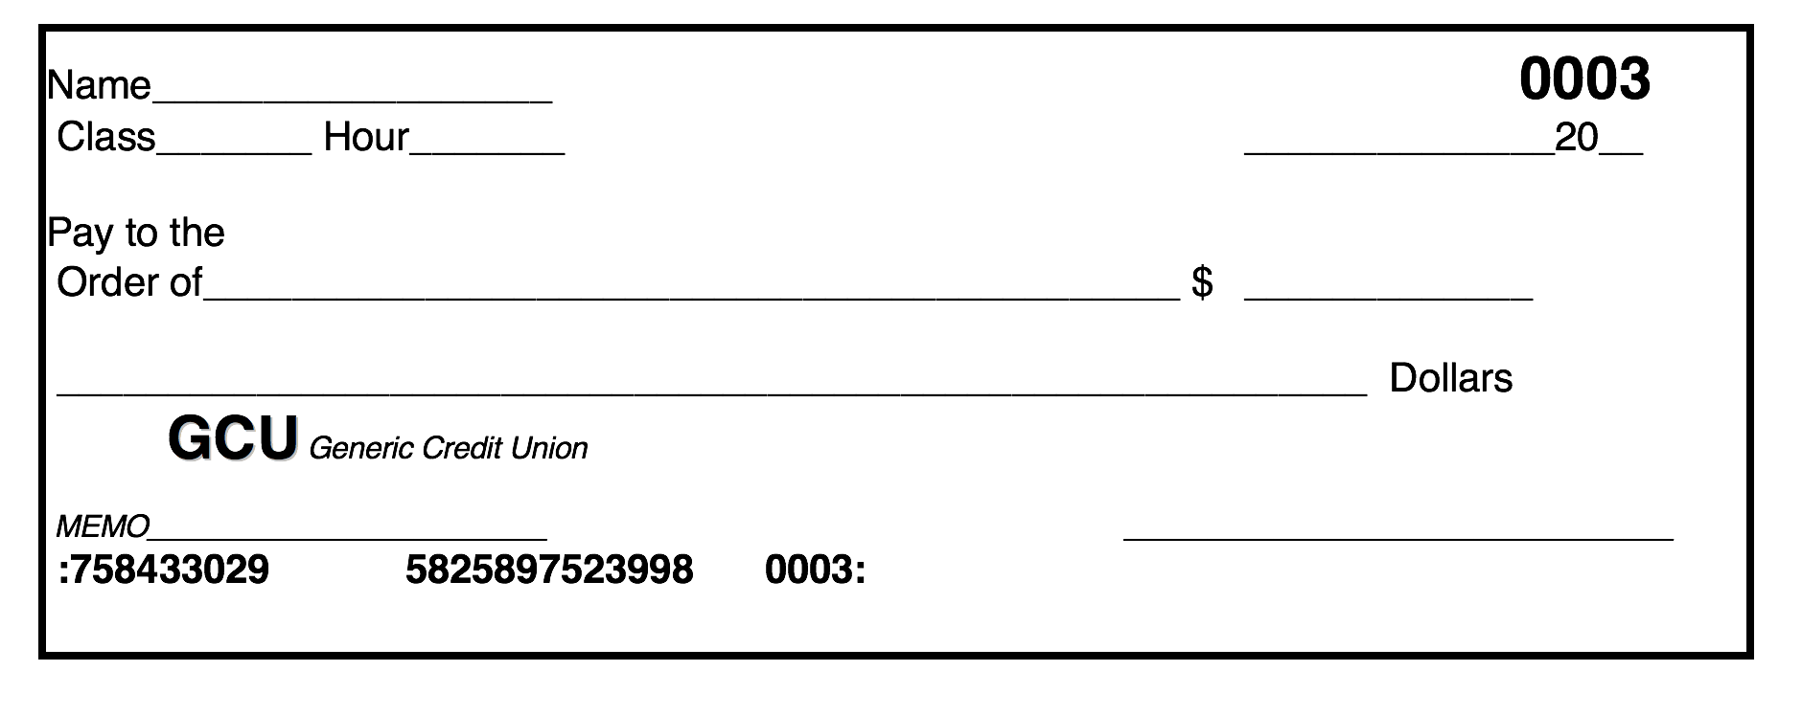

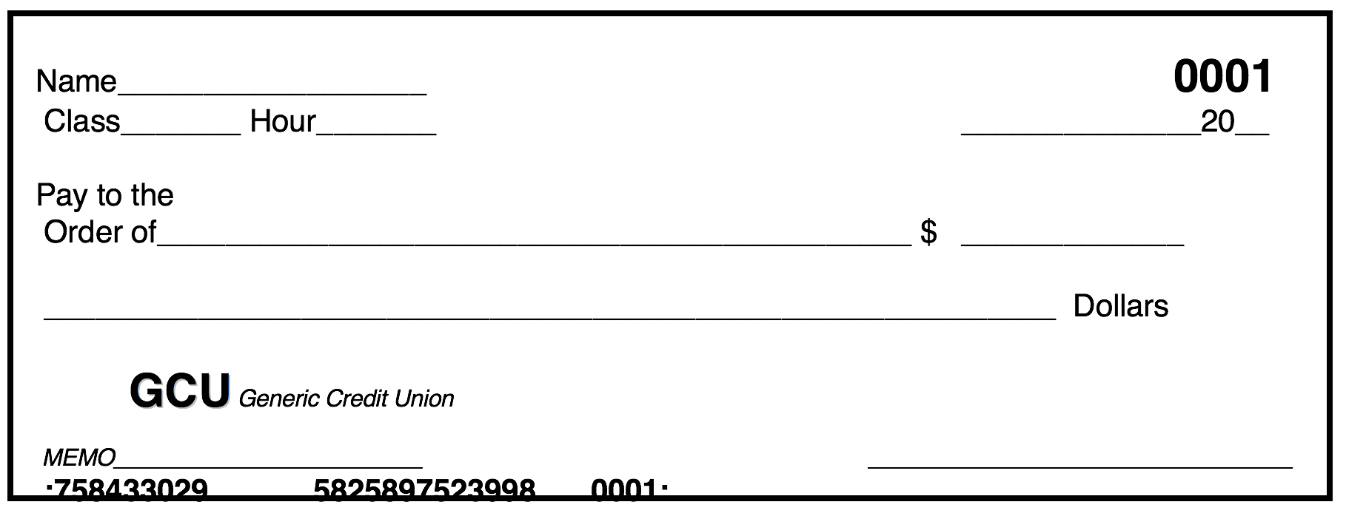

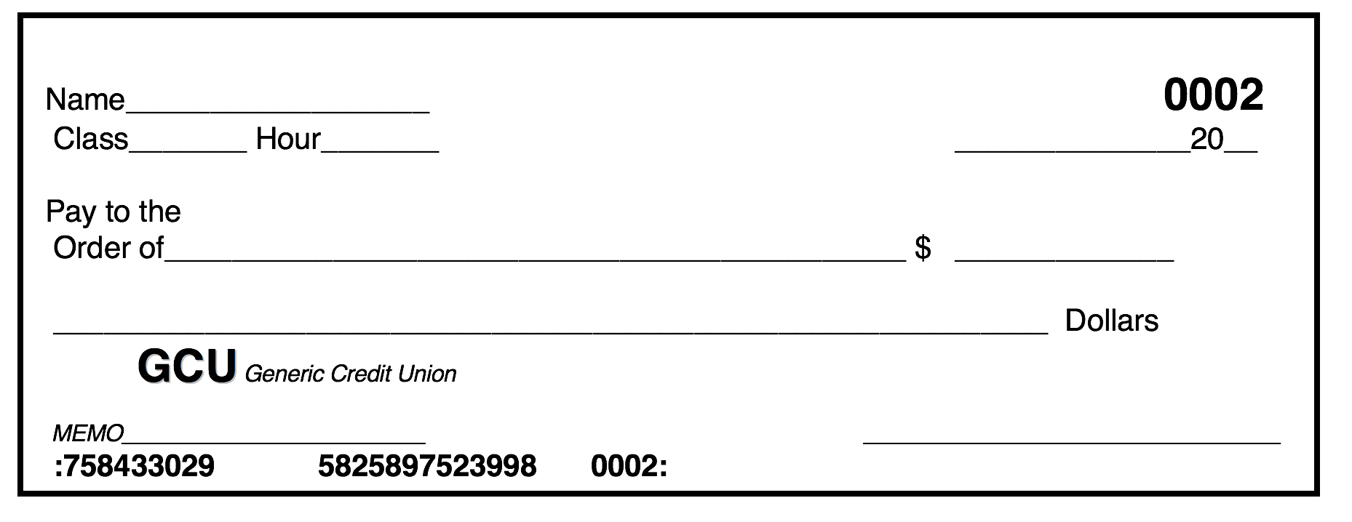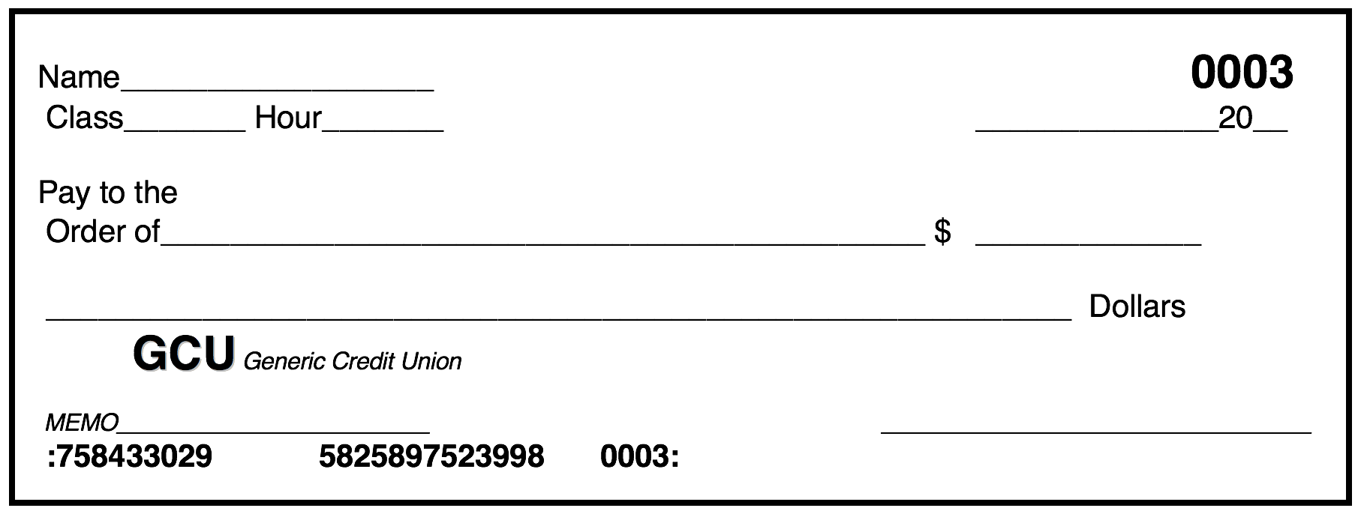**Final Budget: Transaction Register**

|  |  |  |  |  |  |  |  |
| --- | --- | --- | --- | --- | --- | --- | --- |
| CHECK # | DATE |  | TRANSACTION DESCRIPTION |  | Subtractions (-) | Additions (+) | Balance (=) |
|  |  |  |  |  |  |  |  |
|  |  |  |  |  |  |  |  |
|  |  |  |  |  |  |  |  |
|  |  |  |  |  |  |  |  |
|  |  |  |  |  |  |  |  |
|  |  |  |  |  |  |  |  |
|  |  |  |  |  |  |  |  |
|  |  |  |  |  |  |  |  |
|  |  |  |  |  |  |  |  |
|  |  |  |  |  |  |  |  |
|  |  |  |  |  |  |  |  |

**Final Budget: Vendor List**

**Foundation: Zippy’s Foundations, LLC**

**Water, electric**

**& gas: City Utilities**



**Walls: Humpty**

**Dumpty**

**Construction Co.**



**Roof: Reindeer Roofing**

**Interior Doors: Slammin’  Doors**

**Exterior Doors: No Draft Doors Inc. **



**Windows: Ike & Cee Glass**

**Heating & Cooling: Fire and Ice Plumbing**