 

**MIDDLE SCHOOL**

**Math & Engineering**

**Decision Graphic Introduction**

**Teacher Background:** The goal is for students to make informed and quantifiable decisions. One way to do this is to employ the concepts of sustainability; defined as: “Meeting the needs of current generations without compromising the needs of future generations.” In order to determine if something is sustainable, three elements must be considered: economics, environment, and social equity. These are known as the “three Es”. For the purposes of this activity, we are going to use 2 of those factors:

* Economic – factors or criteria might be, but are not limited to, jobs, cost, human hours, etc.
* Environment – factors or criteria might include: air quality, water quality, open space, safety, etc.

**Goal:** Students use a quantifiable decision-making graphic to weigh the pros and cons of two houses; they must quantify the house’s environmental and economic impacts.

**Objectives:** Students will…..

* Analyze information about three different houses
* Compare and contrast the houses
* Use criteria to assign a number from a scale rating the product’s environmental and economic status
* Justify their ratings using data
* Graph their results
* Weigh the pros and cons of each item based on the ratings and information
* Determine which house they would purchase

**Standards met:**

Data Analysis

* Select and use appropriate statistical methods to analyze data
* Develop and evaluate inferences and predictions that are based on data

Problem Solving

* solve problems that arise in mathematics and in other contexts
* apply and adapt a variety of appropriate strategies to solve problems

Number Operations

* develop meaning for integers and represent and compare quantities with them

**Time required:**

* 45 minutes

**Materials: (for class of 30)**

* 1 can of Cola
* 22 copies of a 1 liter jug
* Overhead transparency of graph
* Transparency of 2 houses
* 30 rulers
* 30 sheets of graph paper
* 10 copies of Information for Straw Bale
* 10 copies of Information for Timber Frame House
* 10 copies of Information for Concrete Built House
* 30 copies of Student Directions
* Optional: Masking tape or Sidewalk Chalk

**Procedure:**

* Warm-up: Place 1 can of Coke on a table in the front of the room. Ask students to guess how many liters of water it takes to create the 330ml can of cola.
  + Tallying the water footprints of manufactured goods can be tenuous since there are no clear standards for what a water footprint should measure. Some companies measure just water used in factory operations; others count the liters used to grow ingredients in their supply chains, and still others take stock of water that consumers use to wash clothes or dishes with their products. Coca-Cola Co.'s bottling factories use approximately 4 liters of water to make a 2-liter bottle of soda. But that figure surges to as high as 500 liters of water per 2-liter bottle of soda if you add the water used to grow ingredients such as sugar cane, according to an estimate provided to the company by the World Wildlife Fund. **This means it takes approximately 83 liters to make a single 330 ml can of coke.** A Coca-Cola spokeswoman said the water-footprint figure is preliminary and may change as the methodology improves. <http://www.waterefficiency.net/the-latest/carbon-water-footprints.aspx>
* Begin taping pictures of 5 liter jugs to the board. Tell students to inform you when to stop. Keep going until you have 16 or 17 pictures on the board. Discuss rounding and estimation and rationale behind the number of picture on the board.
* Explain to students that as consumers it is important to make informed decisions, but it is difficult to get all of the information. This is true for home builders as well.
* Use an overhead to project Decision Graphic
* To introduce the idea, tell the class that they will be helping you shop for a new house. You are considering 3 options; one is a straw bale house, one is concrete built, and the last is a traditional house made from wood.
* Split class into two groups.
* Assign half of the class the responsibility of analyzing the environmental and economic information on a straw bale house and the other half on a timber frame house.
* Split each half into two groups and assign the groups either economics or environment.
* Pass out information charts comparing the houses.
* Allow students to read over the information.
  + You may want to employ a partner reading technique
* Give students the Student Directions and review.
  + Optional: you may want to ask students if they agree with the ratings. If they do not, allow students to change the ratings on the sheet and find the mean score using their numbers.
* Give students the graphic options sheet. Review the different types of graphs.
* Tell students they will have to choose one type of graph to represent their data.
* Give each student a sheet of graph paper and allow them time to graph the data
* Share and compare.
* Show graphs on the overhead.
* Give students time to answer the questions on the bottom of the Student Directions sheet.
* OPTIONAL KINESTHETIC ACTIVITY – create a human graph:
  + Tape a graphic pattern on the floor or use chalk to draw it outside
  + Tell students that one representative from the group should stand on the large graph line that represents the mean score for their criteria.
  + Have each person standing on the graph explain why he or she is standing that point (criteria, information, personal experience…).
  + Once all explanations have been given for both houses, have the rest of the group members fill in the space between their number and the “0”.
    - Create the graphic on an overhead transparency
* Determine which house is the most sustainable
* Have the students discuss the problems that arise if each group uses different criteria and why it would be important for both groups to agree on common criteria.
* Refer back to the criteria and explain that their final houses will be evaluated on these criteria.

**Assessment:**

* Participation in Decision Graphic activity
* Completion of Decision Graphic

**Decision Graphic Introduction - Houses**

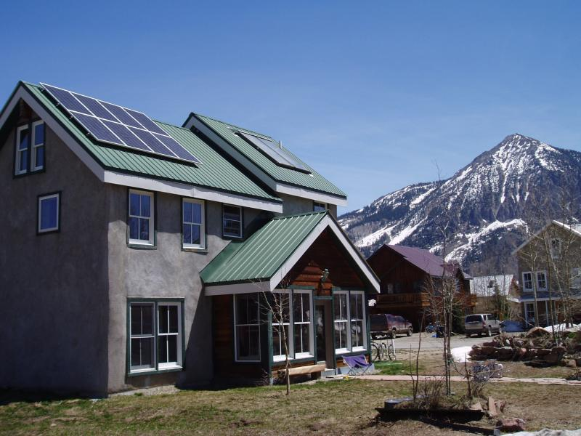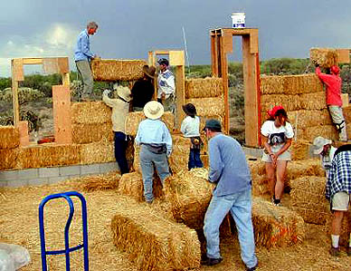

House in Crested Butte, Colorado made from Straw Bale construction.

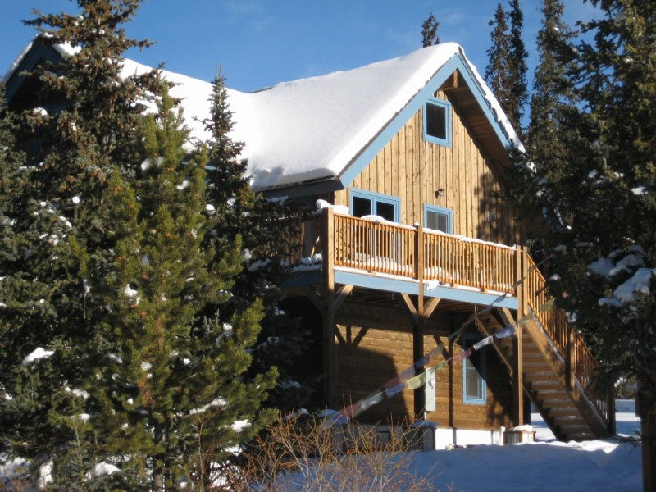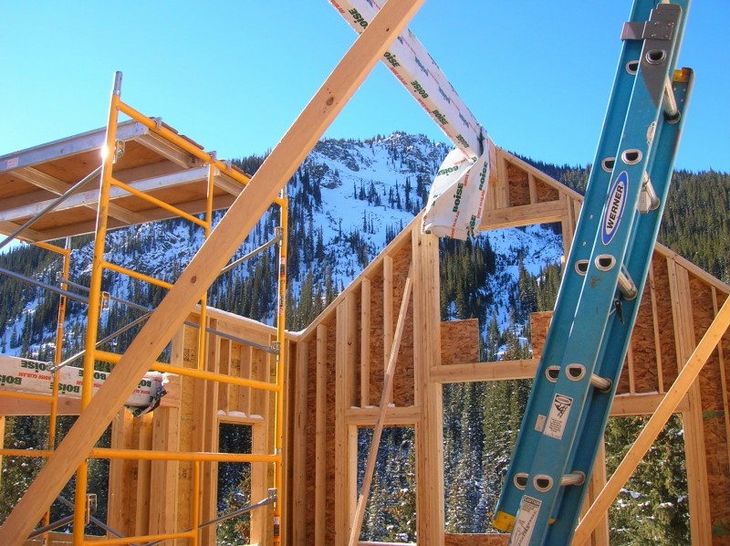

House in Montezuma, Colorado made from timber frame construction.

**Decision Graphic Intro**

**Information Table for Straw Bale**

**Rating Scale: Meets the criteria in the following manner:**

10 – Perfect (it couldn’t be better!)

9 – Excellent (impressive, but could still improve slightly)

8 – Great (better than expected, but could improve a little)

7 – Good (average performance)

6 – Pretty good (proficient, but considerable improvements could be made)

5 – Adequate (it’s just okay)

4 - Partially proficient (needs much improvement)

3 – Falls short

2 – Tries, but still does not succeed

1 – Barely (it’s unsatisfactory)

0 – Doesn’t (it failed miserably!)

|  |  |  |
| --- | --- | --- |
| **Environmental Criteria** | **Supporting Data** | **Rating** |
| **Prevents the production of wastes** | Straw is often considered an agricultural waste product so less waste goes to the landfill | 10 |
| **Promotes the use of readily available, local, renewable resources** | Straw is available wherever grain crops are grown, and is annually renewable. | 9 |
| **Durability, not immortality (strong, but biodegradable)** | Care must be taken to assure that the straw is kept dry, or it will eventually rot. For this reason it is generally best to allow a straw bale wall to remain breathable; any moisture barrier will invite condensation to collect and undermine the structure. Other possible concerns with straw bale walls are infestation of rodents or insects, so the skin on the straw should resist these critters. | 2 |
| **Mean** |  |  |
| **Economic Criteria** | **Supporting Data** | **Rating** |
| **Cost** | One California study indicated that such a "super-insulated" straw bale home could save as much as 75% of heating and cooling costs.  Construction cost of the average straw bale home is approximately $95 per square foot; cost depends upon where you live | 7 |
| **Very time efficient installation** | Easy to build. A wood, steel, or concrete framework is erected and bales are placed in the walls as insulation. The bales are stacked like huge bricks, and pinned with stakes. For added strength, chicken wire is commonly wrapped inside and out, and sewn tight to the bales. Then an earth plaster or cement stucco is applied as a finish. However, most builders do not commonly work with straw. | 6 |
| **Reduces energy consumption** | Straw bales offer excellent insulation.  An eighteen-inch wide bale equals R-48. The average house has an R-value of approximately 10 - 16. | 9 |
| **Mean** | Taken from www.greenbuilding.com |  |

*R-value = The bigger the number, the better the [building insulation](http://en.wikipedia.org/wiki/Building_insulation)'s effectiveness

**Decision Graphic Intro**

**Information Table for Timber Frame**

**Rating Scale: Meets the criteria in the following manner:**

10 – Perfect (it couldn’t be better!)

9 – Excellent (impressive, but could still improve slightly)

8 – Great (better than expected, but could improve a little)

7 – Good (average performance)

6 – Pretty good (proficient, but considerable improvements could be made)

5 – Adequate (it’s just okay)

4 - Partially proficient (needs much improvement)

3 – Falls short

2 – Tries, but still does not succeed

1 – Barely (it’s unsatisfactory)

0 – Doesn’t (it failed miserably!)

|  |  |  |
| --- | --- | --- |
| **Environment** | **Supporting Data** | **Ratings** |
| **Prevents the production of wastes** | 1 tree is used to make multiple boards; however, the entire tree cannot be used to make boards so there is waste | 6 |
| **Promotes the use of readily available, local, renewable resources** | Wood is available wherever trees grow and is a renewable resource | 9 |
| **Durability, not immortality (strong, but biodegradable)** | Wood is biodegradable, but some woods are treated with products that will not biodegrade quickly | 6 |
| **Mean** |  |  |
| **Economic** | **Supporting Data** | **Ratings** |
| **Cost** | Average cost is approximately $100 per square foot; cost depends upon where you live | 6 |
| **Very time efficient installation** | Wood is easy to work with. Walls are assembled on the floor using wood and nails. Then they are raised into place. A wall is framed in [lumber](http://home.howstuffworks.com/lumber.htm) and, once standing, covered on the outside with plywood to give the wall rigidity | 9 |
| **Reduces energy consumption** | A wall made from wood has an approximate R-value of 9–16. This is the same as the US average home. | 3 |
| **Mean** |  |  |

*R-value = The bigger the number, the better the [building insulation](http://en.wikipedia.org/wiki/Building_insulation)'s effectiveness

**Decision Graphic Intro – Graphic Options**

**All graphs have:**

* A concise title
* Clear labels

**Bar Graph –** a chart with bars whose lengths represent quantities. Bar graphs are effective for looking at differences amongst similar items. They are useful because you can line up different types of objects right next to each other and compare them instantly.

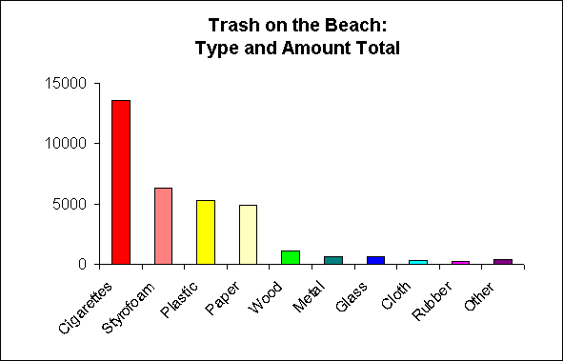

**Line Graph -** A bar graph is used to represent change over time.

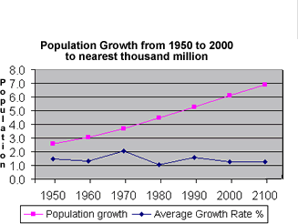

**Pictogram –** A pictogram uses pictures and colors to visually represent a set of data. It is used in the same way as a bar chart.

|  |  |  |  |  |  |  |  |  |  |  |  |  |  |  |  |  |  |  |  |  |  |  |  |  |  |  |  |  |  |  |  |  |  |  |  |  |  |  |  |  |  |  |  |  |  |  |  |  |  |  |  |  |  |  |  |  |  |  |  |  |  |  |  |  |  |  |  |  |  |  |  |  |  |  |  |  |  |  |  |  |  |  |  |  |  |  |  |  |  |  |  |  |  |  |  |  |  |  |
| --- | --- | --- | --- | --- | --- | --- | --- | --- | --- | --- | --- | --- | --- | --- | --- | --- | --- | --- | --- | --- | --- | --- | --- | --- | --- | --- | --- | --- | --- | --- | --- | --- | --- | --- | --- | --- | --- | --- | --- | --- | --- | --- | --- | --- | --- | --- | --- | --- | --- | --- | --- | --- | --- | --- | --- | --- | --- | --- | --- | --- | --- | --- | --- | --- | --- | --- | --- | --- | --- | --- | --- | --- | --- | --- | --- | --- | --- | --- | --- | --- | --- | --- | --- | --- | --- | --- | --- | --- | --- | --- | --- | --- | --- | --- | --- | --- | --- | --- |
| Top of Form     |  |  |  |  |  |  |  |  |  |  |  |  |  |  | | --- | --- | --- | --- | --- | --- | --- | --- | --- | --- | --- | --- | --- | --- | | Description | 1 | 2 | 3 | 4 | 5 | 6 | 7 | 8 | 9 | 10 |  |  | Value | |  | pic43 | pic43 | pic43 | pic43 | pic43 | pic43 | blank | blank | blank | blank |  |  |  | |  | pic40 | pic40 | pic40 | pic40 | pic40 | pic40 | pic40 | blank | blank | blank |  |  |  | |  | pic83 | pic83 | pic83 | blank | blank | blank | blank | blank | blank | blank |  |  |  | |  | pic50 | pic50 | pic50 | pic50 | pic50 | pic50 | pic50 | pic50 | blank | blank |  |  |  | |  | pic53 | pic53 | pic53 | pic53 | blank | blank | blank | blank | blank | blank |  |  |  | |  | pic50 | pic50 | pic50 | pic50 | blank | blank | blank | blank | blank | blank |  |  |  |   邐秜ㄻ䢌ㄫ눭ㄴ쮉㄰欍ㄥ谻ㆫ鴠ㆫ  Bottom of Form |

**Pie Chart –** a circular chart divided into sections. Each section represents the size of each value.

**Decision Graphic Intro – Student Directions**

1. Review the information on the table and the rating scale.
2. Determine the mean average for each category, environment and economics.
3. Determine which type of graph best displays this information.
4. On a sheet of graph paper, create a graph displaying the mean scores for each category. Be sure to include:
   * Labels
   * Color coding
   * Clear and relevant scale
5. Use the data to support your answers the questions below:
   1. Which building material would you choose to use? Why?
   2. Which criteria impacted your decision the most? Why?