

**MIDDLE SCHOOL**

**Green Chemistry**

**Breaking the Tension**

**Background:** Surface tension is the pulling of particles in a liquid towards each other. Soaps and detergents reduce the surface tension of water. Water has a high [surface tension](http://en.wikipedia.org/wiki/Surface_tension) of 72.8 mN/m at [room temperature](http://en.wikipedia.org/wiki/Room_temperature), caused by the strong cohesion between water molecules, the highest of the non-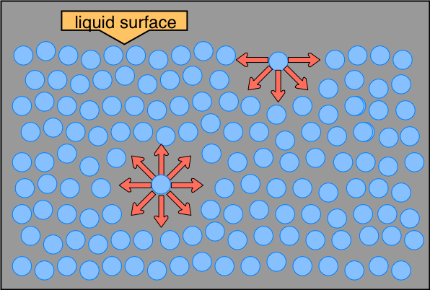metallic liquids.

This drawing highlights two H2O molecules, one at the surface, and the other in the bulk of the liquid. The surface molecule is attracted to its neighbors below and to either side, but there are no attractions pointing in the 180° solid angle above the surface. As a consequence, a molecule at the surface will tend to be drawn into the bulk of the liquid. But since there must always be some surface, the overall effect is to minimize the surface area of a liquid.

*taken from <http://www.chem1.com/acad/sci/aboutwater.html#STW>

**Goal:** Students will observe the effect of surface tension in water, and the dispersive force of detergents. They will understand how shampoos work.

**Objectives:** Students will…

* Observe examples of surface tension
* Develop a hypothesis
* Conduct a test on the surface tension of water
* Collect data and record results
* Make suggestions as to reasons for result
* Observe dispersal of a substance through reduced surface tension

**Materials:**

* coin
* Dropper
* Small beaker
* Petri dishes
* pepper
* Sodium Lauryl Sulfate solution
* 3 – 5 ft. section of rope

**Time Required:** 45–60 minute class period

**Standards Met:**

* Science as inquiry: Abilities necessary to do scientific inquiry
* Physical science: Properties and changes of properties in matter

**Green Chemistry Principles Addressed:**

* Avoid using solvents, separation agents, or other auxiliary chemicals. If these chemicals are necessary, use innocuous chemicals.

**Procedure:**

IN CLASS

* Explain to students that liquids have a special property that keeps water particles sticking together.
* Ask students how many drops of water can be held on the coin before it runs off.
* Explain the small experiment for the coin dropper test
* Students conduct the dropper test and record results
* Repeat test with few drops of Sodium Lauryl Sulfate solution added to beaker water
* Write up results on board and make comparisons between groups’ results
* Discuss variations of results
* Explain surface tension as a result of the ways that the water molecules are attracted to each other
  + Have students stand in front of the room, holding the ends of a rope and leaning back slightly to support each other’s weight.
  + Explain that these students are representative of two water molecules attracting each other. This attraction is called surface tension.
  + Ask students what would happen if the attraction (rope) between these water molecules (students) were broken.
* Outline procedure for dispersal of pepper
* Students conduct experiment and observe result.
* Explain that substances used to break the surface tension of water are called surfactants.

**Assessment:**

* Completed data table that accurately depicts the results of surface tension
* Participation
* Completed lab questions
* Adhering to proper lab safety procedures

**Breaking the Tension – Lab Procedures**

* 1. **Safety glasses MUST be worn during this lab**
  2. One member of your group should obtain your lab materials:
     + coin
     + Dropper
     + Small beaker of water
     + Large petri dish
     + Pepper shaker
     + Small beaker of SLS solution
  3. Using a dropper, carefully add water drop by drop to the coin until water overflows. Count each drop as you go!
  4. Record the number of water droplets in the data table.
  5. Repeat test using water from beaker with the SLS solution added to it.
  6. Observe outcome.
  7. Add water to petri dish.
  8. Sprinkle pepper to cover the surface of the water
  9. Add 1 drop of SLS solution to the water and record observations.
  10. Clean up equipment according to teachers instructions

**Breaking the Tension - Results**

|  |  |  |
| --- | --- | --- |
| Group number | No of water drops held (plain water) | No of water drops held (water with SLS solution added) |
|  |  |  |
|  |  |  |
|  |  |  |
|  |  |  |
|  |  |  |
|  |  |  |
| Average |  |  |

**Breaking the tension – Lab Questions**

1. How many drops of plain water could be held by the coins?
2. How many drops of water with SLS solution were held by the coins?
3. What was the effect of adding SLS solution to the pepper water?
4. One of the principles of green chemistry states:

*Avoid using solvents, separation agents, or other auxiliary chemicals. If these chemicals are necessary, use innocuous chemicals.*

* + In this lab, what role does the SLS solution play?
  + List other ways to reduce surface tension in water?

**Breaking the Tension – Lab Questions Teacher Key**

1. How many drops of plain water could be held by the coins?

*Approximately 30-35 drops. Numbers will vary!*

1. How many drops of water with SLS solution were held by the coins?
2. What was the effect of adding SLS solution to the pepper water?

|  |  |
| --- | --- |
| **Temp. (°C)** | **Surface tension (mN/m)** |
| 0 | 75.83 |
| 20 | 72.88 |
| 30 | 71.4 |
| 50 | 68.45 |
| 70 | 65.49 |
| 90 | 62.54 |
| 95 | 61.8 |

*The SLS broke the surface tension, allowing the pepper to disperse. That’s way the pepper shot out of the sides of the petri dish.*

1. One of the principles of green chemistry states:

*Avoid using solvents, separation agents, or other auxiliary chemicals. If these chemicals are necessary, use innocuous chemicals.*

* + In this lab, what role does the SLS solution play?

*The SLS solution is a surfactant, an auxillary chemical. It serves to break the surface tension of the water. As a cleansing agent, it is believed that this allows the dirt or grease to be swept away. However, it may not be a necessary chemical.*

* + List other ways to reduce surface tension in water?

*~ Heat reduces water tension (think of boiling water!) See chart above for specifics.*

*~ Gravity breaks water tension*

*~ Air breaks surface tension (often used for divers and ski jump training in a pool)*