 **Lesson One: Beginning an Investigation by Gathering Evidence**

**MIDDLE SCHOOL**

**Green Chemistry**

**Background:** It’s hard to imagine a world without the convenience of plastics. However, large-scale plastics production is a new phenomenon in human history. The manufacture and use of plastics for purposes other than those of the military only became common in 1950. Since then, the amount of plastics made annually has doubled about every 15 years, making plastics the most widely produced type of man-made material. Most commonly made plastics are derived from non-renewable fossil fuels, with renewable bio-based plastics making up just a little more than 1% of the plastics currently made each year. With our disposable culture and widespread use of plastic packaging, about half of the plastics made each year become trash within the same year.

What happens when we dispose of these plastics? In the United States, only about 9% of our plastics are recycled, following Europe and China at 30% and 25%, respectively. About 12% of plastics are incinerated and the rest are sent to landfills or end up in the natural environment, where they will take more than 400 years to break down.

This lesson introduces the global problem of plastics and sets the stage for designing a biodegradable cell phone case made from renewable materials. Students will consider their own impact on the environment through their personal choices while exploring the scale of effect that one product can have.

**Additional Resources:**

*National Geographic: Planet or Plastic?* <https://www.nationalgeographic.com/environment/planetorplastic/?beta=true>

*A Whopping 91% of Plastic Isn’t Recycled*

<https://news.nationalgeographic.com/2017/07/plastic-produced-recycling-waste-ocean-trash-debris-environment/>

*NEW Global study shows the production, use, and fate of all plastics ever made* <http://www.plasticpollutioncoalition.org/pft/2017/7/20/new-global-study-shows-the-production-use-and-fate-of-all-plastics-ever-made>

*Production, use, and fate of all plastics ever made* (peer-reviewed article) <http://advances.sciencemag.org/content/3/7/e1700782.full>

*Infographic: Global Cell Phone Statistics*

<https://longren.io/infographic-global-cell-phone-statistics/>

*22 Facts About Plastic Pollution (And 10 Things We Can Do About It)*

<https://www.ecowatch.com/22-facts-about-plastic-pollution-and-10-things-we-can-do-about-it-1881885971.html>

**Objectives:** Students will…

* Complete an ecosystem graphic organizer based on evidence from readings
* Perform calculations to determine the approximate mass of cell phone cases that are disposed of each year
* Work collaboratively to define problems associated with cell phone case use and disposal

**Key terms:** Sustainability, ecosystem, nonrenewable resources

**Materials:**

* Online interactive class quiz platform (Kahoot!, Poll Everywhere, etc.)
* Electronic devices (smartphones, iPads, or computers; 1 per student)
* Calculators (1 per student)
* Copies of *Lesson 1 Student Sheet: Ecosystem Graphic Organizer*
* Copies of *Lesson 1 Student Sheet: Mass Calculation*
* Copies of *More plastic than fish in the sea by 2050* <https://www.theguardian.com/business/2016/jan/19/more-plastic-than-fish-in-the-sea-by-2050-warns-ellen-macarthur>
* Digital balance
* Sticky notes (3 per student group)

**Time Required:** One or two 45- to 60-minute class periods

**Standards Met:**

**MS-PS1-3.** Gather and make sense of information to describe that synthetic materials come from natural resources and impact society.

**Keys to Success:**

* A Kahoot! quiz has been made to accompany this lesson. If you prefer, you may use the PowerPoint provided to create a quiz on a platform more familiar to your students. The quiz can be accessed here: “Beyond Benign Plastics Quiz”<https://play.kahoot.it/#/k/63354ec1-345b-4929-b1a6-9994f8a68591>.
* Kahoot! and Poll Everywhere allow students to report—in real time—their answers to questions with the rest of the class. This allows the teacher to gauge student understanding in a low-pressure, interactive way. If devices are not available for all students, a similar result can be achieved using the provided PowerPoint to go through the questions as a class.
* In place of the provided graphic organizer, students may also create their own graphic organizers.

**Teacher Preparation:**

* Set up online quiz accounts for students.
* Set up the online quiz for your class if you’re using a quiz platform other than Kahoot!

**Procedure:**

5E Procedure:

*Engage:* Students begin to develop an understanding of a global real-world problem: the challenges of making more plastics and the issue of ocean plastic debris.

1. Hand out the Lesson 1 Student Sheet: Ecosystem Graphic Organizerand instruct students to add to it as they participate in the online quiz and read through the article.
2. Begin discussing the problems of plastics in the environment by going through the online quiz or the PowerPoint with your students:
   1. Beyond Benign Plastics Quiz:<https://play.kahoot.it/#/k/63354ec1-345b-4929-b1a6-9994f8a68591>
3. At the end of the quiz, review initial evidence of causes and effects on ecosystems and encourage students to continue to add to the graphic organizer throughout class.
4. Pass out the article “More Plastic than Fish in the Sea by 2050,” either in its entirety or cut along the dotted lines to Jigsaw for information. Instruct students to read the article and search for evidence of problems related to plastic use and disposal, as well as subsequent consequences to ecosystems. Have students continue to add to their graphic organizer using information from the article.

*Explore:* Students examine their own use of plastics based on just one product: a cell phone case.

* Ask students the following questions for reflection as a class:
  + How many cell phones do you have in your household(s)?
  + How many cell phone cases do you think you have in your household?
  + How often do you or your family members replace your cell phone cases?
  + What do you and your family members do with old cell phone cases?

*Explain:*Students begin to consider the impact of individual choices by gathering data from their classmates related to cell phone cases per household.

* Divide the class into groups of 2 or 3 students.
* Have each group determine the total number of cell phone cases among their members’ households.
* Create a class tally by asking each group how many cases they have. Add the numbers together and write the total on the board.
* As a class, find the mass of 3 cell phone cases and determine the average.
* Write the average mass on the board.

*Elaborate:*Students will consider the scale of the problem of plastics in the environment by performing mathematical calculations.

* Hand out Lesson 1 Student Sheet: Mass Calculation and have students capture information from the board to answer questions 1 and 2.
* Hand out calculators to students and instruct them to complete the worksheet.
* Have students share their calculations within their group and answer the Challenge Question together.
* Ask groups to share their calculations for the total mass of cell phone cases in the U.S. Invite students to share their answers to the Challenge Question.
* Use the infographic provided that features the weight of used cell phone cases in the U.S. and discuss the scale of the plastic waste problem.

*Evaluate:*Students connect personal choices and common plastic products with major impacts on ecosystems.

* Give students time to complete their graphic organizersand ask them to share their thoughts with the class.
* According to the engineering design process (described in future lessons), we should begin by asking a question to identify the problem. Allow students to think-pair-share to brainstorm potential problems with this system and ask at least 3 questions of inquiry. Students should capture their list of potential problems in their notebook. Have students write each of their questions on a separate sticky note.
* Ask one student from each group to post their sticky notes on the board. Take a moment to group students’ answers and share with the class the trends you see.

OPTIONAL: Ask students to bring old cell phone cases to school, if they have any available. You will be able to use them for the next lesson. This is not a requirement!

**Beginning an Investigation by Gathering Evidence- Student Handout**

Use the graphic organizer below to construct an argument supported by empirical evidence that changes to physical or biological components of an ecosystem can affect populations. In the top row, put the evidence from class activities. In the subsequent rows, add effects to human and animal populations.

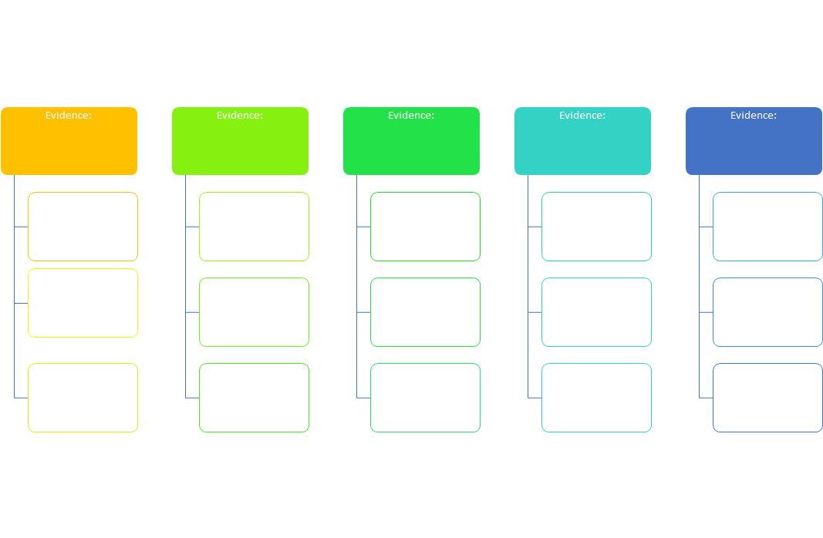

**Lesson 1 Student Sheet: Mass Calculation**

1. How many total cell phone cases are in all the households of your class?
2. What is the average mass of a cell phone case?
3. Calculate the mass of the cell phone cases for your class (*hint:* multiply the average mass by the number of cases for your class).
4. Calculate the mass of cell phone cases for your grade (*hint:* multiply the answer for question 3 by the number of classes in your grade).
5. Calculate the mass of cell phone cases for your school (*hint:* multiply the answer for question 4 by the number of grades in your school).
6. Calculate the mass of cell phone cases for the United States (*hint:* multiply the answer for question 5 by 24,280—the approximate number of middle/junior high schools in the U.S.).
7. Where do all of these cell phone cases go when they are no longer useful or wanted?

*Challenge Question:  What objects have approximately the same mass as all of the cell phone cases in the United States?

SOURCE # 6 : U.S. Department of Education, National Center for Education Statistics. (2016). *Digest of Education Statistics, 2014* (NCES 2016-006), [Table 105.50](https://nces.ed.gov/programs/digest/d14/tables/dt14_105.50.asp).

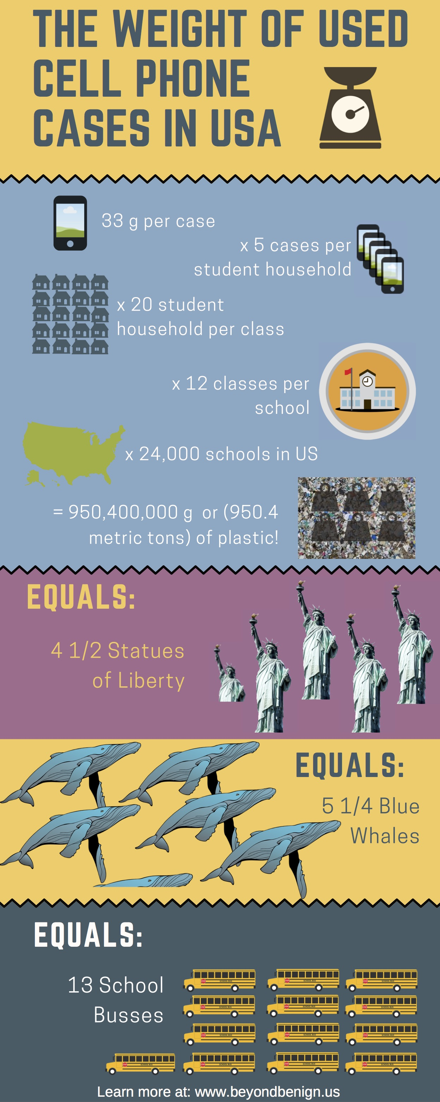

**Lesson 1 Student Sheet: Ecosystem Graphic Organizer - Teacher Key**

Article may be jigsawed by cutting on dotted lines or given to students as the whole article:

<https://www.theguardian.com/business/2016/jan/19/more-plastic-than-fish-in-the-sea-by-2050-warns-ellen-macarthur>

**More plastic than fish in the sea by 2050, says Ellen MacArthur; The Guardian, January 19, 2016**

One refuse truck’s-worth of plastic is dumped into the sea every minute, and the situation is getting worse. As a record-breaking sailor, Dame [Ellen MacArthur](https://www.theguardian.com/sport/ellen-macarthur) has seen more of the world’s oceans than almost anyone else. Now she is warning that there will be more waste plastic in the sea than fish by 2050, unless the industry cleans up its act.

According to [a new Ellen MacArthur Foundation report launched at the World Economic Forum on Tuesday](http://www.ellenmacarthurfoundation.org/publications/the-new-plastics-economy-rethinking-the-future-of-plastics), new plastics will consume 20% of all oil production within 35 years, up from an estimated 5% today.

Plastics production has increased twentyfold since 1964, reaching 311m tonnes in 2014, the report says. It is expected to double again in the next 20 years and almost quadruple by 2050.

Despite the growing demand, just 5% of plastics are recycled effectively, while 40% end up in landfill and a third in fragile ecosystems such as the world’s oceans. Much of the remainder is burned, generating energy, but causing more fossil fuels to be consumed in order to make new plastic bags, cups, tubs and consumer devices demanded by the economy.

------------------------------------------------------------------------------------------------------------------------------------------



 Illustration: Ellen MacArthur Foundation

------------------------------------------------------------------------------------------------------------------------------------------

Decades of plastic production have already caused environmental problems.

The report says that every year “at least 8m tonnes of plastics leak into the ocean – which is equivalent to dumping the contents of one garbage truck into the ocean every minute. If no action is taken, this is expected to increase to two per minute by 2030 and four per minute by 2050

“In a business-as-usual scenario, the ocean is expected to contain one tonne of plastic for every three tonnes of fish by 2025, and by 2050, more plastics than fish [by weight].”

------------------------------------------------------------------------------------------------------------------------------------------

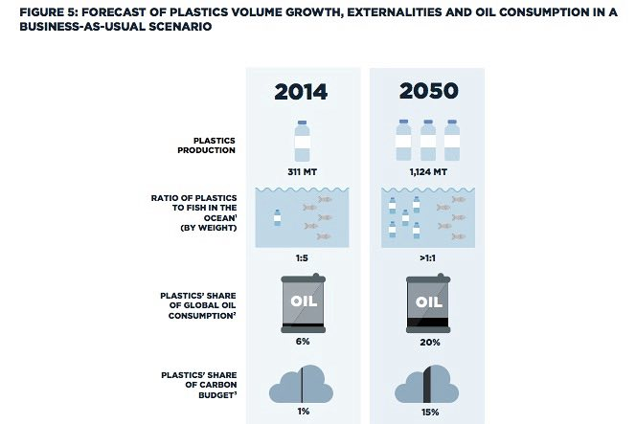

 Illustration: Ellen MacArthur Foundation

------------------------------------------------------------------------------------------------------------------------------------------

A carelessly discarded plastic bag can break down in the sea, especially in warmer waters, but the process releases toxic chemicals that may be digested by fish and end up in the human food chain.

Research released a year ago found there were more than 5tn pieces of plastic floating in the seas, many just 5mm across. Larger items can be a threat to sea life such as turtles and seals, which swallow them.

Scientists have also found that [countless tiny fragments drift to the bottom of the oceans, carpeting the sea bed](https://www.theguardian.com/environment/2014/dec/17/microplastic-deposits-found-deep-in-worlds-oceans-and-seas). The environmental and health impact of this is unknown.

The report concludes that the plastics industry is comprehensively failing to address these issues.

Dr. Martin R Stuchtey of the McKinsey Center for Business and Environment, who helped produce the report, said a wave of innovation could be transformative.

------------------------------------------------------------------------------------------------------------------------------------------

“Plastics are the workhorse material of the modern economy, with unbeaten properties,” he said. “However, they are also the ultimate single-use material. Growing volumes of end-of-use plastics are generating costs and destroying value to the industry. After-use plastics could, with circular economy thinking, be turned into valuable feedstock.”

The plastics recycling industry is also reeling from the recent plunge in the price of oil. At $30 (£21) a barrel, it is more expensive to recover plastics and process their hydrocarbons to recycle them than to use virgin crude.

Solving the problem will not be easy, especially as the industry is under pressure to produce more to meet growing demand from emerging markets. Bioplastics are currently more expensive to make than the petro-alternative, and recycling systems are inefficient.

------------------------------------------------------------------------------------------------------------------------

MacArthur, who broke the record for the fastest solo circumnavigation of the globe in 2005, says fundamental reform is needed. Her vision is for a “new plastics economy” in which the industry, governments and citizens work together to ensure that plastics never become waste and cut the leakage into natural systems.

“Linear models of production and consumption are increasingly challenged by the context within which they operate, and this is particularly true for high-volume, low-value materials such as plastic packaging,” she said.

One part of the solution is to rethink the way goods are packaged, cutting the demand for plastic. Water-soluble film, for example, can be used to wrap small items. Hard-to-recycle plastics such as PVC and expandable polystyrene could be phased out.

------------------------------------------------------------------------------------------------------------------------------------------

Manufacturers could redesign plastic items so they can be reused better, and rethink their production methods to make recycling easier. More products could be made out of plastics which can be composted on an industrial scale, including rubbish bags for organic waste and food packaging for outdoor events, canteens and fast food outlets.

The report admits, however, that a “moonshot” approach is also needed, to create plastics that can be both recycled and composted. Currently it is one or the other. Other options are to develop “bio-benign” plastics, or chemical tagging to stop used plastics slipping through the system and into the sea.