 

**ELEMENTARY SCHOOL**

**Sustainable Science**

**Blue Mussels:**

**Expert Sustainable Engineers**

**Lesson 4: Survival of the Stickiness**

**Teacher Background and Overview:**

While conducting research on any topic, scientists collect data through experimentation and then analyze their results. Trends in their data may lead them to either confirm or reject a hypothesis, as well as to form new hypotheses to test later. Green chemists, along with every other type of scientist, rely on this process to advance their research and, ultimately, their field of study.

This lesson wraps up this unit by having the students reflect on their experiments from the previous lessons and extend their learning about connections between biomimicry and green chemistry. Students will discuss the conclusions they drew from each experiment and analyze their data from Lesson 2 as a class. They will then consider how biomimicry can be applied to solve other problems in science and engineering.

**Time Required:**

30 minutes

**Learning Objectives:** Students will…

* Graph data and display for analysis.
* Draw conclusions about their experiments.
* Reflect on innovations that would be beneficial for the environment.

**Standards:**

***NGSS***

**3-LS3-2** Use evidence to support the explanation that traits can be influenced by the environment.

**3-5-ETS1-1** Define a simple design problem reflecting a need or a want that includes specified criteria for success and constraints on materials, time, or cost.

***Massachusetts Standards***

*STE*

**3-LS3-2** Distinguish between inherited characteristics and those that result from a direct interaction with the environment. Give examples of characteristics of living organisms that are influenced by both inheritance and the environment.

**3-LS4-2** Use evidence to construct an explanation for how the variations in characteristics among individuals within the same species may provide advantages to these individuals in their survival and reproduction.

**3.3-5-ETS1-1** Define a simple design problem that reflects a need or a want. Include criteria for success and constraints on materials, time, or cost that a potential solution must meet.

*ELA & Literacy*

**SL.3.2** Determine the main ideas and supporting details of a text read aloud or information presented in diverse media and formats, including visually, quantitatively, and orally.

**SL.3.3** Ask and answer questions about information from a speaker, offering appropriate elaboration and detail.

**SL.3.6** Speak in complete sentences when appropriate to task and situation in order to provide requested detail or clarification.

**Materials:**

* Student Lab Reports from Lesson 2 and Thread Lab Reports from Lesson 3

**Keys to Success:**

* Below is a basic example of how you may wish to graph your student data on the board. Each X represents one partner set. Your class’s graph should give a general average of how long it takes for Elmer’s glue to dissolve underwater.
* By asking students to create a scaled bar graph you can meet an additional math standard. (3.MD.3)

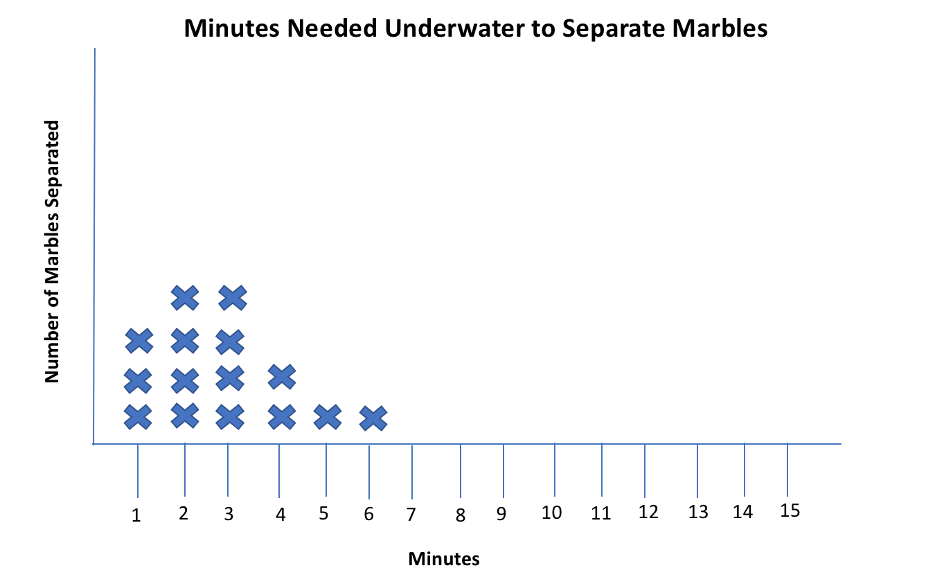

**Procedure:**

1. Hand out lab reports from Lessons 2 and 3.
2. Partner each lab pair with another to make teams of 4.
3. Have each team share their results within their group and compare their predictions from the lab reports to the results using the answer they wrote to the Conclusion question.
4. Bring the entire class back together. Create a simple bar graph of student data from Lesson 2 on the board with each team’s results. Ask the class what they observe when they look at the results.
5. Discuss any trends related to the data. Draw conclusions as a class about the length of time the marbles stayed glued underwater.
6. Ask students about the impact of products not breaking down safely (ocean plastics, pollution, etc.). Green chemistry criteria for technology are that they must be: 1) safe for the environment and human health, 2) cost effective, and 3) work just as well or better than the products they are designed to replace. One key green chemistry principle is biodegradation—safely breaking down into materials that are not harmful to the environment.
7. Discuss the following questions as a class, allowing students to use the answers to the discussion questions in their Lab Report from Lesson 3:

* What are some things in our world that need to hold together when wet or underwater?
* What are some things that we wouldn’t want to hold together when wet or underwater?
* How can we use threads and/or adhesives to benefit the ocean environment?

**Wrap-Up/Assessment:**

1. Have students in their small groups name another animal that is able to stick to both wet and dry surfaces and brainstorm how that adaptation helps the animal survive.
2. In their groups, ask students what scientists and engineers can learn from the animal they just named. (For example, a caterpillar climbs on both wet and dry leaves. Scientists could learn from the caterpillar how to make shoes that grip better on wet surfaces.) Either have students share their ideas with the class, or have students capture their ideas on paper to hand in.