 

**ELEMENTARY SCHOOL**

**Sustainable Science**

**Blue Mussels:**

**Expert Sustainable Engineers**

**Lesson 2: Stuck on Sustainability**

**Teacher Background and Overview:**

This lesson is designed to build off of the Lesson 1 biomimicry matching game and deepen students’ understanding that blue mussels helped to inspire a safer, more environmentally friendly glue. For a technology to be considered a green chemistry invention, it must meet three criteria: cost (about the same or less than the alternative), safety (safer for the environment and human health), and performance (works as well as or better than the existing alternative).

The purpose of this lab is to encourage students to think about the performance of a glue by investigating how changing the environment affects its adhesive properties. Students will gather data to later analyze and draw conclusions from as a class.

**Time Required:**

30 minutes

**Learning Objectives:** Students will…

* Make predictions about how changing the environment will affect adhesive properties.
* Conduct an experiment to test a hypothesis.
* Collect and analyze data.
* Use evidence to explain that traits can be influenced by the environment.

**Standards:**

***NGSS***

**3-LS3-2**Use evidence to support the explanation that traits can be influenced by the environment.

***Massachusetts Standards***

*STE*

**3-LS3-2** Distinguish between inherited characteristics and those that result from a direct interaction with the environment. Give examples of characteristics of living organisms that are influenced by both inheritance and the environment.

*ELA & Literacy*

**WS.3.1** Write opinion pieces on topics or texts, supporting a point of view with reasons.

b. Provide reasons that support the opinion.

**WS.3.2** Write informative/explanatory texts to examine a topic and convey ideas and information clearly.

b. Develop the topic with facts, definitions, and details.

d. Provide a concluding statement or section.

**WS.3.8** Recall information from experiences or gather information from print and digital sources; take brief notes on sources and sort evidence into provided categories.

*Math*

**3.MD.A1** Solve problems involving measurement and estimation of intervals of time, liquid volumes, and masses of objects.

**Materials:**

* Glued, disk-shaped marbles (prepared in advance; 3 per student team)
* Water
* Timer (1 per student team)
* Containers/pans to hold water (1 per student team)
* Copies of Student Lab Report

**Teacher Preparation: *Must be completed at least 12 hours before experiment!***

* Glue together three sets per team of students and let dry overnight. Each marble set must be held in place for 1–2 minutes for marbles to adhere (see Images 1 and 2).
* Prepare containers of water for class.
* Divide the class into teams of 2 to 4 students for this activity.

**Keys to Success:**

* Preparing 3 sets of marbles per student team allows teams to perform multiple trials of the experiment. Additionally, extra marble sets will come in handy if students do not follow instructions and pry marbles apart, or if the glue fails too quickly.
* Modeling for students how to pull apart disks is essential.
* To extend the experiment, or to generate more data, students can run multiple trials of the experiment. Simply add extra columns to the data table on the Student Lab Report.

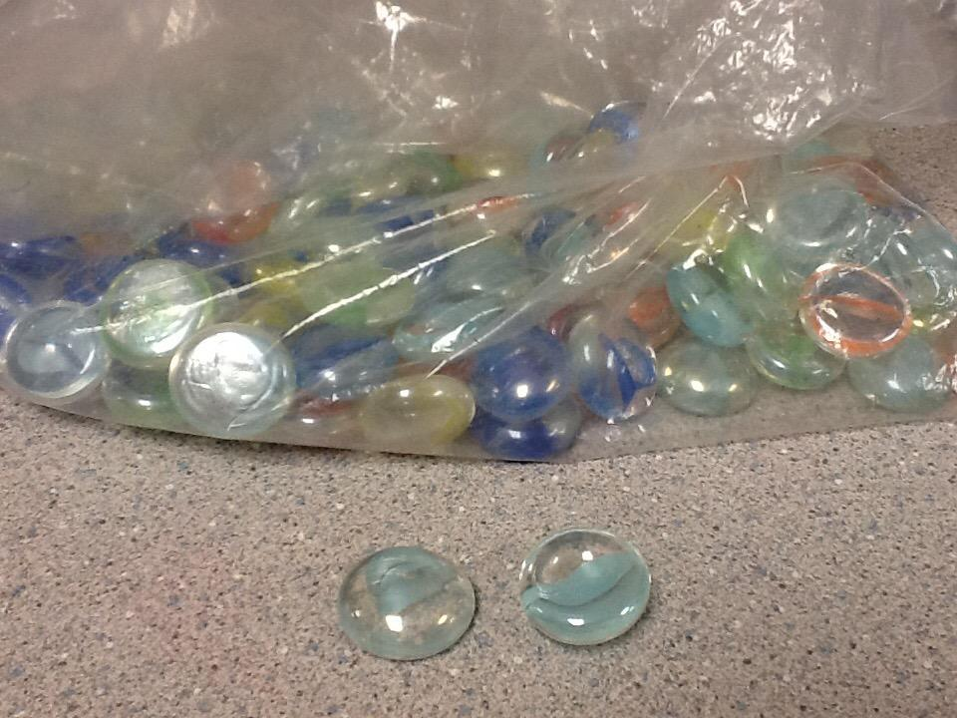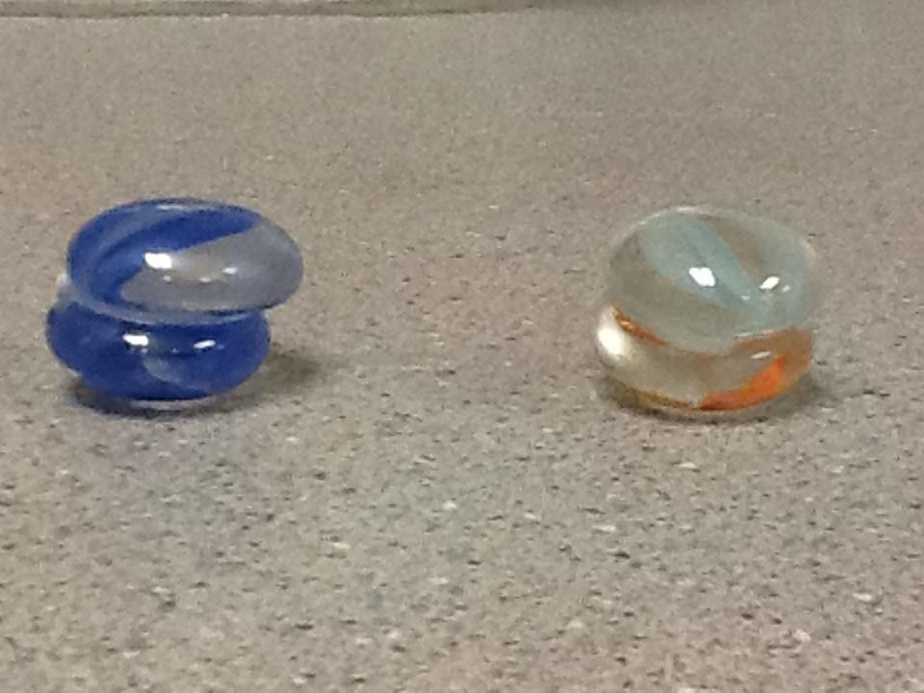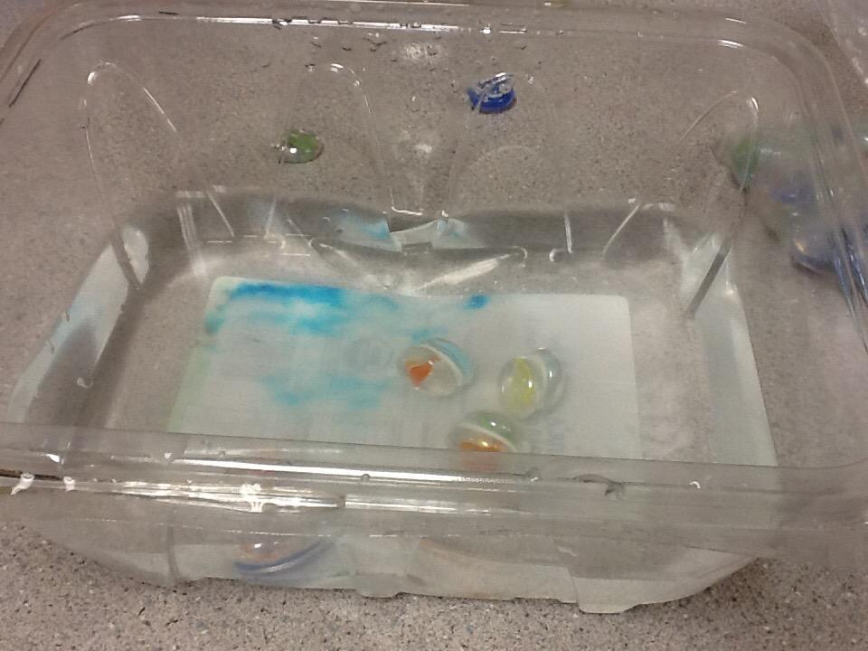

Image 1 Image 2 Image 3

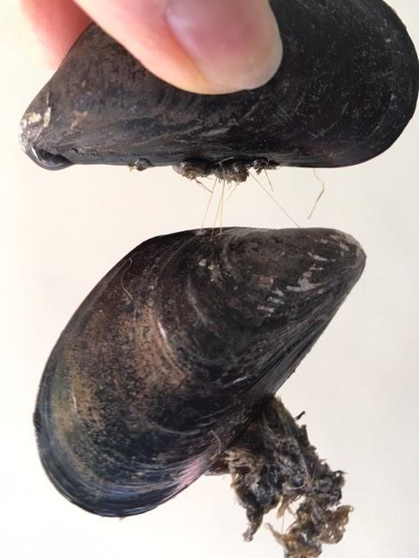

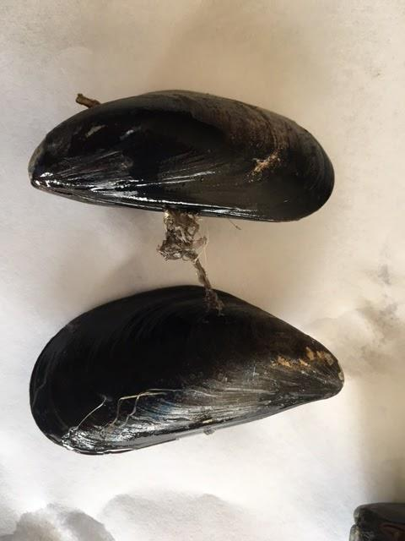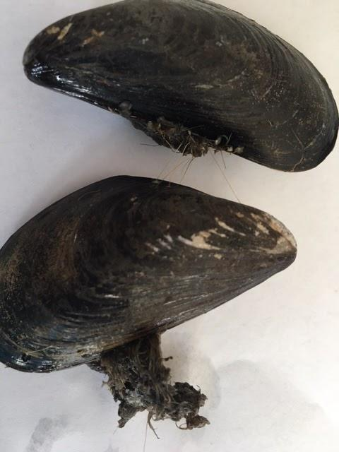

Image 4

**Procedure:**

1. Essential Question: How does changing the environment affect the adhesive properties? Review ways properties of matter are impacted: temperature, force, and water.
2. Ask students to name different types of glues and discuss the following questions:

* How are they used?
* Do they all have the same properties?
* What happens when you change their environment?

1. Discuss how mussels stick to wet surfaces that may be underwater or out of water, depending on whether it is high or low tide. In either condition, it is important that the mussels stay stuck. Let’s test a glue we have all used before to see if it stands up to the challenges faced by mussels.
2. Allow students to see examples of mussels. These can be collected from a marsh or shoreline, you can pass around pictures, or you can show the photos from Image 4 on the projector in front of class.
3. Show students these two short video clips:
   1. [Mussel glue video](https://m.youtube.com/watch?v=aYF5dl9WXEk) (skip first 30-second ad: video is 90 seconds)
   2. [Bio Mussel Glue Video](https://youtu.be/OEuQdQtaZwg) (2-minute video; more scientific)
4. Divide the class into teams of 2 to 4 students. Hand out and read over the lab report together. Take time to clarify expectations and instructions with the class. Summarize the main goal of the experiment to solidify students’ understanding of what they are about to do.
5. Explain and model how to pull on disks to try to pull them apart. Be sure to hold disks with thumb and forefinger on opposite sides, and pull each disk away from the other. DO NOT PRY OPEN WITH FINGERNAILS OR TWIST. The idea is that they do not pull apart when dry.
6. Have the teams discuss and write predictions on their lab reports.
7. Pass out the marbles and the containers with water for the experiment.
8. Suggest that each team member has a job: one student tries to pull the disks apart and another keeps the time and gives a signal or says “pull” at one-minute intervals. Students switch roles each time.
9. Have team members each try to pull apart their disk marbles from the sides and record what happens.
10. Next, have them submerge their glued disks under water in the pan and begin timing for 1 minute (see Image 3).
11. In one-minute intervals, have students try to pull the disks apart as they did prior to submersion and record the results in the data table on the lab report.
12. If the marbles pull apart immediately or too quickly, provide another marble set (if time permits).
13. Have teams discuss, then answer the discussion questions. If time allows, have teams compare their predictions to their results.

**Wrap-Up/Assessment:**

1. Collect Student Lab Reports for Lesson 4.

**Name(s): ___________________________________________________ Date: _____________**

***Stuck on Sustainability: Lesson 2 Student Lab Report***

Read through all of the directions before beginning.

**Prediction:**  What will happen when you try to pull apart the marble disks when they are dry? _____________________________________________________________________________

What will happen when you try to pull apart the marble disks after they have been submerged underwater? __________________________________________________________________

**Materials:**

* One set of marble disks glued together with Elmer’s Glue
* One container of water
* Timer or visible clock

**Procedure:**

Each partner will try to pull on the marble disks to separate them. Hold them on the sides of each marble and pull straight away from each other. Do not try to slide or twist them apart, or to use your fingernail to wedge them apart. What happened? __________________________________________________________________________________________________________________________________________________________________________________________________________________________________________

Place the marbles in the pan of water and keep them under water for one minute. One partner will time one minute and say “pull” when the minute is over. The other partner will repeat step one above and try to pull the marbles apart. Record the results in the table below. Switch roles. Place the disks back into the pan, and continue timing, recording, and switching roles each minute until the marbles separate.

**Results:**

**Table 1. Minutes Needed to Separate Marbles**

|  |  |  |
| --- | --- | --- |
| Number of minutes | Did the marbles separate? | |
| Yes | No |
| 1 |  |  |
| 2 |  |  |
| 3 |  |  |
| 4 |  |  |
| 5 |  |  |
| 6 |  |  |
| 7 |  |  |
| 8 |  |  |
| 9 |  |  |
| 10 |  |  |
| 11 |  |  |
| 12 |  |  |
| 13 |  |  |
| 14 |  |  |
| 15 |  |  |

How many minutes did it take for you to pull apart your disks? ____

**Discussion:**

What are some examples of when you might want an adhesive (glue) to hold together for a long period of time underwater? __________________________________________________________________________________________________________________________________________________________________________________________________________________________________________

What are some examples of when you might **not** want an adhesive to hold together for a very long time underwater? __________________________________________________________________________________________________________________________________________________________________________________________________________________________________________

Explain how Elmer’s glue compares to the blue mussel’s adhesive?

____________________________________________________________________________________________________________________________________________________________

**Conclusion:**

Do your results agree or disagree with the prediction you made at the beginning of this experiment? Why or why not?

____________________________________________________________________________________________________________________________________________________________

________________________________________________________________________________________________________________________________________________________________________________________________________________________________________________________________________________________________________________________