 

**ELEMENTARY SCHOOL**

**Sustainable Science**

**The Secrets of Sharks’ Skin**

**Lesson 4: Prototype Testing: Binder Clip Bacteria**

**Teacher Background** **and Overview:**

What is it about Sharklet film that makes it so effective in preventing the growth of bacteria on its surface? The etched pattern on Sharklet film is made up of millions of microscopic raised diamonds that prevent bacteria from aggregating, colonizing and developing into biofilms. Simply because there is not enough surface area on the Sharklet film for the bacteria to hold onto, they are kept at bay.

Sharklet works very differently than other methods of controlling germs. Many students will be familiar with Lysol’s tagline of killing “99.9% of bacteria.” However, how often do we think about the 0.1% of bacteria that is left behind? The disinfectant was not strong enough to kill these germs and have left them alive to reproduce. If we repeat this process of killing off all but the strongest bacteria over and over again, we run into the problem of antibiotic resistance, where the bacteria that are left are resistant to our traditional methods of controlling them. Because the effectiveness of the Sharklet relies purely on its surface structure, rather than antibiotics or chemical disinfectants, it does not encourage bacterial resistance.

In this lesson, students will evaluate their puffy-paint Sharklet surface models they made in Lesson 3. Students will use sticky notes and binder clips to simulate the accumulation of bacteria on both the Sharklet surface and a flat surface. As students compare their three models, they will collect data to compare with the rest of the class in Lesson 5. Ultimately, students will find that the shapes they used to make their Sharklet model are less important than the spacing of the puffy-paint dots within their pattern. They will also find that it is much more difficult for the sticky note to hold onto the models than to the flat surface.

**Time Required:** 45 minutes

**Learning Objectives:** Students will…

* Test multiple Sharklet model prototypes and evaluate their effectiveness.
* Compare their predictions with the generated results.
* Draw conclusions related to how Sharklet film works.
* Create a tableand bar graph with their collected data.

**Standards:**

***NGSS***

**3-5-ETS1-1** Define a simple design problem reflecting a need or a want that includes specified criteria for success and constraints on materials, time, or cost.

**3-5-ETS1-3** Plan and carry out fair tests in which variables are controlled and failure points are considered to identify aspects of a model or prototype that can be improved.

***Massachusetts Standards***

*STE*

**4.3-5-ETS1-3** Plan and carry out tests of one or more design features of a given model or

prototype in which variables are controlled and failure points are considered to identify which features need to be improved. Apply the results of tests to redesign a model or prototype.

**4.3-5-ETS1-5(MA)** Evaluate relevant design features that must be considered in building a

model or prototype of a solution to a given design problem.

*ELA & Literacy*

**RSIT.4.2** Determine the main idea of a text and explain how it is supported by key details; summarize the text.

*Math*

**4.MD.4** Use the four operations to solve word problems involving distances, intervals of time, liquid volumes, masses of objects, and money, including problems involving simple fractions or decimals. And problems that require expressing measurements given in a larger unit in terms of a smaller unit. Represent measurement qualities using diagrams such as number line diagrams that feature a measurement scale.

**Materials:**

* “Sharklet” models from Lesson 3
* Tape
* Sticky notes (6 per student team)
* Small binder clips (30 per student team)
* Copies of Lesson 4 Student Lab Report

**Procedure:**

1. Explain to students that they will be evaluating the effectiveness of the puffy-paint “Sharklet” models that they made in the previous lesson.
2. 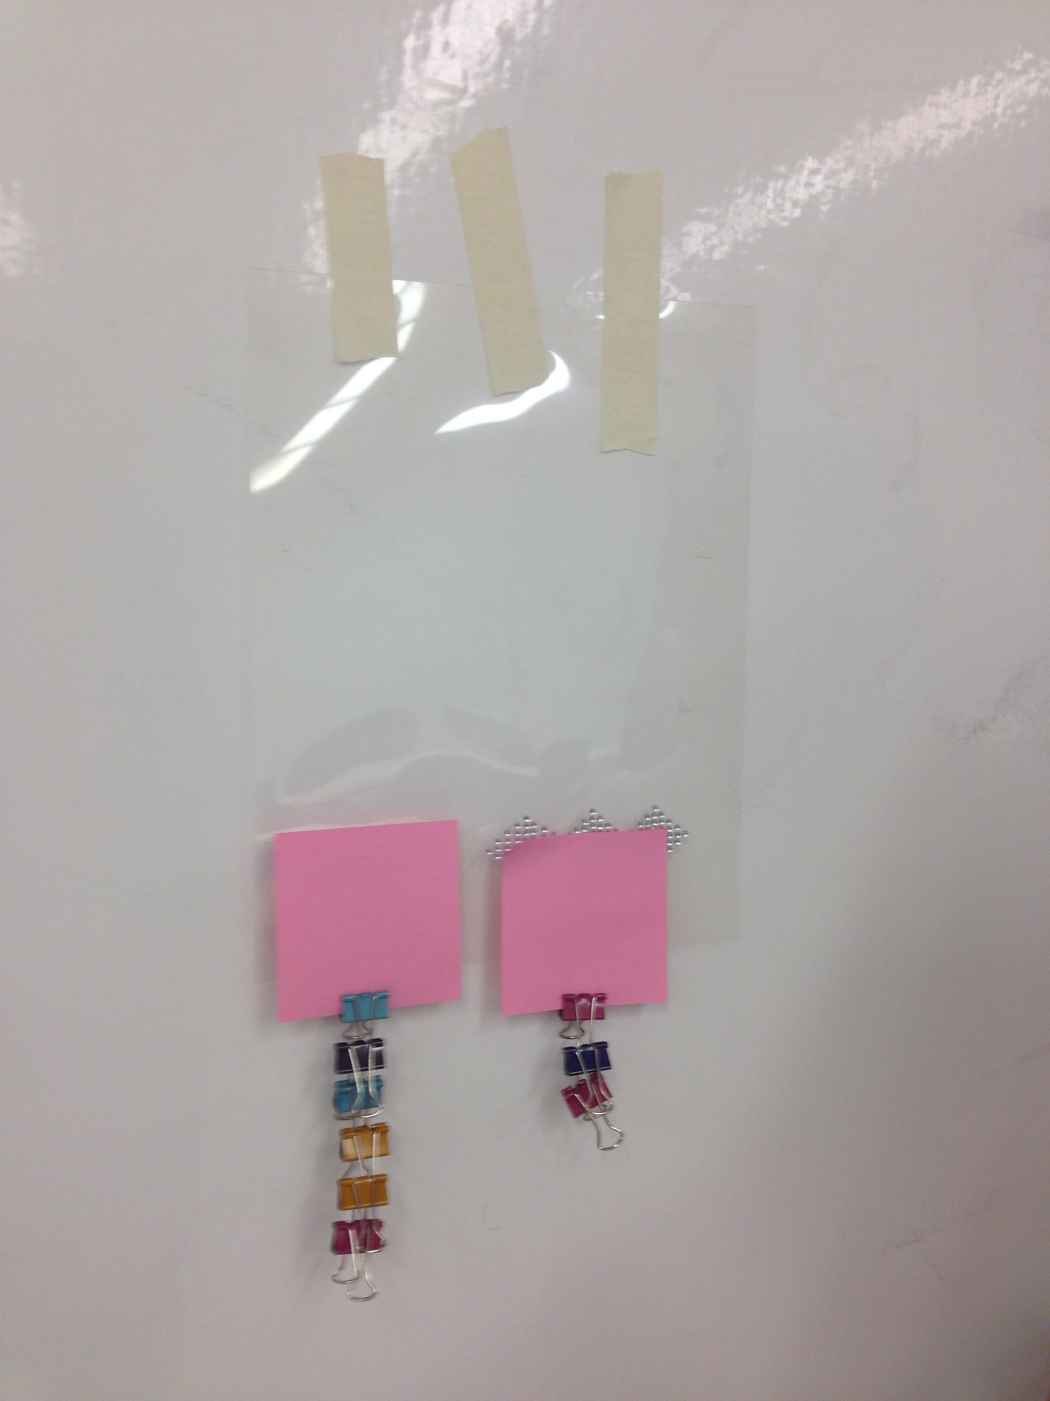Show the students how they will be attaching sticky notes and binder clips to their models to simulate the accumulation of bacteria on surfaces.
   * Hang the Sharklet model on the board in front of the class.
   * Attach one sticky note on top of the pattern and one sticky note on the flat surface of the transparency film next to the pattern.
   * Demonstrate how to attach the binder clips to the sticky notes using the sticky note on the flat surface.
3. Hand back the Sharklet models from Lesson 3 to the student teams.
4. Have students follow the instructions and fill in their answers on the Student Lab Report.

**Wrap-Up/Assessment:**

1. When teams have finished their experiments, collect the Student Lab Reports for discussion in Lesson 5.

**Name(s):________________________________________Date__________________________**

***Prototype Testing: Binder Clip Bacteria: Lesson 4 Student Lab Report***

Read through all instructions before beginning.

What shape did you use to make your model?__________________________________

**Predictions:**

Which surface will sticky notes and binder clips stick better to, the model or the flat surface?

Which of your models will hold the most binder clips attached to the sticky note?

**Materials:**

* Sharklet models (one inch, two inch, three inch)
* Tape
* Sticky notes
* 30 binder clips

**Procedure:**

1. Place one piece of tape on each of the top corners of your three-inch model and attach your model to your desk.
2. Place one sticky note across the puffy-paint pattern.
3. Predict how many binder clips you will be able to attach to your sticky note before it falls off of the model. Write down your predictions in Table 1.
4. Attach binder clips to your sticky note until the sticky note falls off.
5. Take the binder clips off of the sticky note you just tested. Record the total number of clips that this sticky note held in your data table.
6. Remove the tape from your three-inch model and attach your two-inch model to your desk.
7. Predict how many binder clips you will be able to attach to a sticky note on your two-inch model and write your number in Table 1.
8. Place a new sticky note on top of your two-inch model and attach binder clips like you did in Step 4. Again, record the number of binder clips held by your model in your data table.
9. Remove your two-inch model from your desk and replace it with your one-inch model.
10. Predict how many binder clips you will be able to attach to your one-inch model and record the number in Table 1.
11. Test how many binder clips your one-inch model will hold and capture the total number in your data table.
12. Place a sticky note directly on the transparency film next to your puffy-paint model. Predict how many binder clips this sticky note will hold, and write in Table 1.
13. Test how many binder clips this sticky note will hold and capture the total number in your data table.
14. Remove your model from your desk and undo all your binder clips. Return all supplies as directed by your teacher.
15. Complete the rest of your Student Lab Report with your team.

**Results:**

**Table 1: Number of Binder Clips Held by Each Surface**

|  |  |  |
| --- | --- | --- |
| **Type of surface** | **Predicted number of binder clips** | **Actual number of binder clips** |
| Flat surface/directly on transparency film |  |  |
| Three-inch model |  |  |
| Two-inch model |  |  |
| One-inch model |  |  |

Use the information in your table to make a line plot to represent how many binder clips each model held.

**Discussion:**

Which surface held the most binder clips? ________________________________

Use your line plot to determine the difference between the most binder clips held and the least binder clips held by the surfaces. Show your work below.

Which surface was most effective in preventing the sticky note and binder clips from sticking to it?

How do your results compare to your predictions? Do they agree or disagree? If they disagree, what about your results is different from what you predicted would happen?

**Conclusion:**

Based on your results, what conclusions can you draw about the model that worked the best at preventing the sticky note from sticking?

Based on your results, what conclusions can you draw about how the Sharklet film technology works?