 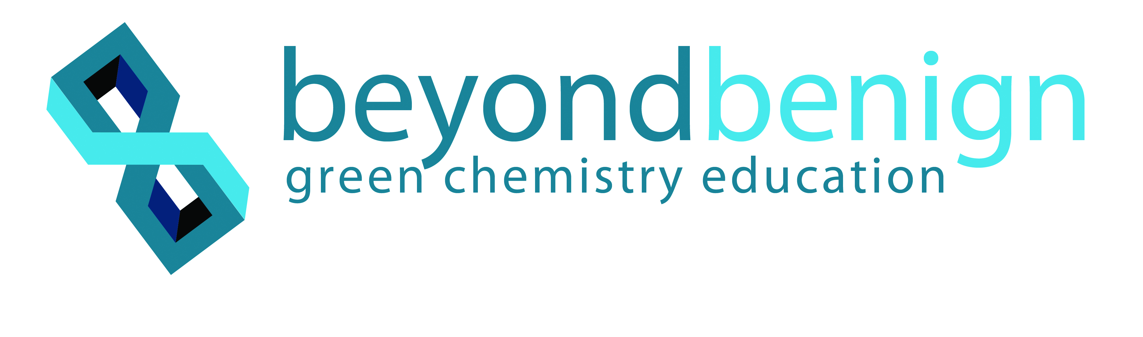

**ELEMENTARY SCHOOL**

**Sustainable Science**

**Blue Mussels:**

**Expert Sustainable Engineers**

**Lesson 1: Exploring Sustainable Innovations**

**Teacher Background and Overview:**

Biomimicry is the science and art of emulating nature’s best biological ideas to solve human problems. Chemists and materials scientists often use biomimicry to get ideas for their work, as the natural world is made up of excellent green chemists. If we consider how animals make their own shelter and get all the food they need, we see that they do this without having to use any gas or electricity, or taking more than they need, while only producing waste that can be used by other living things. When scientists look to nature for inspiration, they find green chemistry principles that provide sustainable ideas from unique places to help them design safer, more cost-effective, and better-performing materials and technologies.

This lesson will introduce students to biomimicry, first by decoding and defining the word, then by an interactive matching game. The lesson wraps up by introducing blue mussels through reading.

**Time Required:**

1 hour total:

30 minutes (activity)

30 minutes (additional reading during ELA time)

**Learning Objectives:** Students will…

* Explain how scientists derive inspiration from nature for technological innovation.
* Determine and explain the main idea of a text.
* Utilize decoding skills to identify the meaning of biomimicry.

**Standards:**

***NGSS***

**3-ESS3-1** Engineers improve existing technologies or develop new ones to increase their benefits, decrease known risks, and meet societal demands.

***Massachusetts Standards***

*ELA & Literacy*

**RSFS.3.3** Know and apply grade-level phonics and word analysis skills in decoding words.

a. Identify and know the meaning of the most common prefixes and derivational suffixes.

b. Decode words with common Latin suffixes.

c. Decode multisyllable words.

**RSIT.3.2** Determine the main idea of a text, recount the key details, and explain how they support the main idea.

**SL.1** Engage effectively in a range of collaborative discussions (one-on-one, in groups, and teacher-led) with diverse partners on grade *3 topics and texts*, building on others’ ideas and expressing their own clearly.

d. Explain their own ideas and understanding in light of the discussion.

**SL.3.6** Speak in complete sentences when appropriate to task and situation in order to provide requested detail or clarification.

**LS.3.5** Demonstrate understandings of word relationships and nuances in word meanings.

b. Identify real-life connections between words and their use.

**Materials:**

* Copies of biomimicry matching game from http://beyondbenign.us/home/K12education/biomimicry-2-picture-set-MS.pdf (one per team of four)

OR

* Computers or tablets (one per team of two)

**Keys to Success:**

* When debriefing the matching game, remind students that biomimicry is all about *inspiration*. If their match differs from the answer guide, it does not mean that they are wrong, it means that they were inspired differently!
* When accepting student answers to the matching game, try saving the blue mussel match to be explained at the end to aid your transition into talking about blue mussels in the reading.
* If the link for the memory game does not open through Word, copy and paste it directly into your browser. The link is active, though Word may not recognize it.

**Procedure:**

1. Introduce the term *biomimicry*. Decode the word by breaking up the term with the class.

* What does “bio” mean?
* What does “mimic” mean?
* What, then, might “biomimicry” mean?

1. Divide the class into either teams of four (if using cards) or teams of two (if using tablets or computers).
2. Hand out sets of the Biomimicry Matching Cards to teams of four or have students working in pairs with tablets or computers go to the online biomimicry matching game at <https://matchthememory.com/GreenChem>.
3. Each team will need to match the technology/product card to the animal card they believe was the inspiration.
4. Give teams 5–10 minutes to brainstorm and match the cards.
5. Ask teams to report their matches and explain their choice. Briefly review and clarify student answers using the matching game guide.
6. Wrap up the matching game by connecting biomimicry to green chemistry. Explain that scientists can learn from nature about how to design materials and chemical processes in an energy-efficient way, using materials that break down safely, which helps us perform green chemistry. Green chemistry provides the tools to turn biomimicry ideas into sustainable inventions.
7. Reflect on the blue mussel and glue pair from the matching game and explain to the class that you will be exploring that connection in more depth over the next lessons.
8. If time permits, read [*Russell the Mussel*](http://www.fishwild.vt.edu/extension/fiw/fisheries/streamsrivers/russell_the_mussell_files/russell.pdf) (online book)as a class.
9. Extended reading options include *Too Much Glue* by Jason Lefebvre or *About Mollusks: a Guide for Children* by Cathryn Sill.
10. Ask students to work in pairs to summarize and share highlights from readings.
11. Follow-up extension could include the YouTube video clip: [*Science Copies Nature's Secrets - Biomimicry*](https://youtu.be/2d1VrCvdzbY)*.*

**Wrap-Up/Assessment:**

1. Wrap up with guiding questions about glue:

* What do we use it for? (In pairs, have students make a list of items they glue together to make new items.)
* What materials do we use it on(examples: paper, wood, ceramics, glass)?
* How well does glue hold on these different materials?

**\*Preparation is required for Lesson 2 activity\***

Please note that materials for ***Lesson 2*** must be prepared at least one day ahead. See Lesson 2 for instructions.

**Online Biomimicry Matching Game Answers:**

Blue mussels are able to cling to the rocks, thanks to their unique adhesive chemistry. Advances in the glue used in plywood have already occurred and the hope is to create alternative waterproof adhesives that do not contain any harmful chemicals like a lot of glues used today.

The shape of the stick bug inspired the creation of heavy-duty machinery that has "walking legs." These legs are adapted to forest floors and cause very little damage to the terrain underneath, therefore causing less disruption to plants and animals.

The termite is one of nature's more accomplished builders. Their mounds maintain a constant temperature inside despite wide temperature changes outside. The mounds that they build are extremely durable structures of mud that optimize the effects of the sun. Many architects are using inspiration from the termites to build cost-efficient buildings.

The structure of the Eiffel Tower was inspired by the surprisingly light and immensely strong femur. Though it’s the largest bone in the human body, it contains many holes inside of it, just like the Eiffel Tower.

Scientists have developed a paint based on the textured skin of sharks that will help make airplanes fly through the air more efficiently. The researchers also believe this paint could save as much as 4.5 million tons of fuel if used on every plane.

**Biomimicry Matching Game Answers**

**(PDF card file link)**

<http://www.beyondbenign.org/lessons/intro-biomimicry-matching-game/>

Kangaroos have special bacteria in their stomachs that neutralize the digestive process of gases so they don’t release methane gas. Methane is a greenhouse gas and is linked to global climate change. Landfills and several manufacturing processes release methane gas. The bacteria in kangaroos could hold the key to transforming methane-producing systems to release a more benign gas.

|  |  |
| --- | --- |
| Kangaroo | Landfill |
| Blue Mussel | Toxin-free, waterproof glue |
| Termite | Electricity-free air conditioning for buildings |
| Gecko | Bandages |
| Chimpanzee | New sources of natural medicines |
| Shark | Faster boats and submarines |
| Blue Morpho Butterfly | Toxin-free paints |

Blue mussels live in the water and have to stick to the sides of rocks and hold on through stormy waves. The blue mussels are able to cling to rocks, thanks to their unique adhesive chemistry. Advances in the glue used in plywood have already occurred and the hope is to create alternative waterproof adhesives that do not contain any harmful chemicals (which are in a lot of glues used today).

Termites build their homes in a way that allows the space to stay cool all the time, even in really hot weather, without any air conditioning. Architects are copying the way termites build their homes to make buildings that stay cool in very hot weather without any air conditioning.

Geckos are very good climbers with special bristles (nanopillars) on their feet that allow them to walk on almost any surface, even upside-down, without falling. Even though their feet can hold onto any surface, they are not sticky and don’t leave any sticky residue behind. Scientists at MIT invented a bandage with glue consisting of thousands of nanopillars like the gecko. This innovation will replace sutures both inside and outside the body.

Chimpanzees are very similar to humans. They get injured and sick just like we do, but they don’t have any hospitals or medicine. Instead, they get better and stay healthy just by using things in their habitat. Doctors want to find out what the chimps eat to stay healthy and cure illnesses so they can make natural medicines by identifying and emulating the process in the lab.

Sharks are very good swimmers, being both fast and efficient. Engineers developed faster submarines using lessons learned from the hydrodynamic factors that allow sharks to swim fast. One of these factors is their special scales, called denticles, that reduce the amount of turbulence in the water and allow them to swim faster while using less energy.

Similar to many things in nature, blue morpho butterflies are very colorful. The pigments for our paints and dyes often contain hazardous materials. Scientists are learning how to use structural color, like that of the morpho butterfly, to make safer paints and fabrics.