

**MIDDLE SCHOOL**

**Biotechnology**

**Great Expectations Through Modifications**

**Teacher Background:**

There are, essentially, 3 ways that an organism can be modified: 1) natural selection over time, 2) cross-breeding and hybrids, and 3) genetic modification.

**Goal:** To understand the process of genetically modifying an organism as they learn how insulin is formed. To understand that many inventions/medications that sounded impossible years ago have already been developed. What does the future hold?

**Objectives**: Students will…

* Analyze an episode of The Jetsons and pictures of technology changes to conclude that many aspects once thought of as futuristic are now commonplace.
* Look at results from yesterday’s lab and discuss what happened.
* Discover the cause/symptoms of diabetes (optional)
* Sequence the discovery of insulin
* Discover the steps of Recombinant DNA in insulin production
* Create a poster showing the steps of Recombinant DNA

**Materials:**

* Computer access to view The Jetsons and 2 youtube videos
* Projection system
* Great Expectations Through Modifications overhead of boom boxes, early computers, original cell phone
* T chart on the board or on easel paper
* Agar plates from Real Cats Wear Pink lab activity
* Copies of the Insulin timeline
* Materials for poster making
* Poster board,
* Various artistic supplies: pipe-cleaners, glue, construction paper, straws, macaroni clay, markers

**Time Required**: 2 60 minute class periods

(poster production may take longer)

**Standards Met:**

* Science and Technology Standards: Understanding about science & technology
* History and Nature of Science: Science as a human endeavor

**Procedure**:

Day 1

* Ask students if they have ever watched The Jetsons television show. If some have, ask them to share with their knowledge with the class. Inform the class that Jetsons was a cartoon created in the early 1960s, that was futuristic. At its time of creation, all of the ideas were unheard of.
* Watch the following short video: “ The Jetsons Future of Technology”

<https://www.youtube.com/watch?v=e8SC6bny1SA&list=PLqisZr34AmZIgG7SgdrotlWL8P8igHPj0>

* As the students watch the video, they create a list of ideas/objects that they see in the show that are now part of our daily lives and a list of ideas/objects that are still not reality.
* Draw a t-chart on easel paper or on the board and ask students for items on the lists. What do we have now and what is still not a reality from the show?
* Discuss why some objects were invented and why some still have not been invented.
* Show the Great Expectations Through Modifications overhead.
* Ask the students to look at the pictures and decide what objects are now used. How have these inventions changed over time? Have the inventions changed for the better? Why?
* Read the questions on the bottom of the overhead and discuss answers.
* Remind the students that they were hoping to see some changes with their “bacteria plate” from Real Cats Wear Pink (lesson 1). What did they predict they would see?
* Each group receives their agar plate and observes the changes.
* Discuss these changes. What caused the bacteria in the agar plate to turn pink? Mention that this is genetic modification because the bacteria were changed due to a plasmid that was inserted into the bacterium.

Day 2

* Discuss how genetic modifications are helping the medical field.
* Redirect back to Sparky. Remind the students that Sparky had many medical problems. Ask the students how they chose to treat Sparky’s diabetes (Insulin and a diet regimen).
* Ask the class what they know about diabetes. Accept all answers.
* Optional-Watch a youtube video about diabetes for background information [http://video.google.com/videosearch?q=diabetes+mellitus&hl=en&emb=0&aq=0&oq=diabetes+melli#](http://video.google.com/videosearch?q=diabetes+mellitus&hl=en&emb=0&aq=0&oq=diabetes+melli)
* Ask the class what they know about insulin. Where does it come from?
* Pass out the insulin timeline and read through it together.
* Discuss how the production of insulin has improved overtime through the use of biotechnology and genetic modification.
* Ask the students if they know what Recombinant DNA is?
* Tell them that they “genetically modified bacteria with a carotenoid plasmid” using the recombinant DNA process.
* Watch a video about Recombinant DNA (this was created by a 9th grade student) <http://www.youtube.com/watch?v=AEINuCL-5wc&eurl=http://video.google.com/videosearch?q=recombinant+dna+insulin&hl=en&emb=0&aq=-1&oq=&feature=player_embedded>
* Watch the video once without taking notes and a second time, in which the students will take notes.
* Using the notes that they took, student groups will create a poster showing the process of genetic modification through the use of recombinant DNA.
* Student groups share their posters with the class



**Extension**:

* Students can research what genetic modifications have been successfully completed to date.
* Students can brainstorm genetic modifications that they would like to see in the future.
* Students can hypothesize a genetic modification that would help to eradicate diseases/illnesses.

**Great Expectations Through Modifications Overhead**

[](http://images.google.com/imgres?imgurl=http://www.istockphoto.com/file_thumbview_approve/5566166/2/istockphoto_5566166-old-boombox.jpg&imgrefurl=http://www.istockphoto.com/file_closeup/object/5566166-old-boombox.php?id%3D5566166&usg=__-b1FJWk8D21_4YcErcP24OhlmVM=&h=380&w=331&sz=40&hl=en&start=66&tbnid=pB0rQSPvqIwFLM:&tbnh=123&tbnw=107&prev=/images?q%3Dcarrying%2Ba%2Bboom%2Bbox%26start%3D60%26gbv%3D2%26ndsp%3D20%26hl%3Den%26sa%3DN)[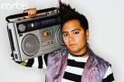](http://images.google.com/imgres?imgurl=http://pro.corbis.com/images/42-17511488.jpg?size%3D67%26uid%3D%7BD964B03F-59D6-46CD-AB71-CAC4B59A93F1%7D&imgrefurl=http://pro.corbis.com/search/Enlargement.aspx?CID%3Disg%26mediauid%3D%7BD964B03F-59D6-46CD-AB71-CAC4B59A93F1%7D&usg=__-kIf90LEzd08pv-RaYy6neRi4q8=&h=427&w=640&sz=85&hl=en&start=47&tbnid=oKfjVhcvNkljhM:&tbnh=91&tbnw=137&prev=/images?q%3Dcarrying%2Ba%2Bboom%2Bbox%26start%3D40%26gbv%3D2%26ndsp%3D20%26hl%3Den%26sa%3DN)

Then: Giant Boom Box Now: ________________

[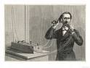](http://images.google.com/imgres?imgurl=http://imagecache2.allposters.com/images/pic/MEPOD/10042910~Using-Bell-s-Original-Telephone-Apparatus-Posters.jpg&imgrefurl=http://www.allposters.com/-sp/Using-Bell-s-Original-Telephone-Apparatus-Posters_i1873763_.htm&usg=__hJHYBCYgjDin7OvA5VnMbTI5YuU=&h=300&w=400&sz=32&hl=en&start=5&tbnid=C7u5q4QzplmReM:&tbnh=93&tbnw=124&prev=/images?q%3Doriginal%2Btelephone%26gbv%3D2%26hl%3Den)[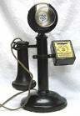](http://images.google.com/imgres?imgurl=https://www.msu.edu/~atchiso5/20al_files/image002.jpg&imgrefurl=http://www.msu.edu/~atchiso5/20al.htm&usg=__f4qbFLnBefBOtTXCwYS_awqb1xU=&h=684&w=472&sz=40&hl=en&start=2&tbnid=oDZJX4_OsQbWoM:&tbnh=139&tbnw=96&prev=/images?q%3Doriginal%2Btelephone%26gbv%3D2%26hl%3Den)

Then: Land Line Telephones Now: _____________

[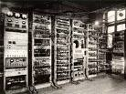](http://images.google.com/imgres?imgurl=http://www.ukoln.ac.uk/web-focus/events/workshops/webmaster-2005/social/figure-1.jpeg&imgrefurl=http://www.ukoln.ac.uk/web-focus/events/workshops/webmaster-2005/social/baby&usg=__GlNr3tYNh8dpGlhzo7sJ9vhy0jE=&h=488&w=655&sz=145&hl=en&start=25&um=1&tbnid=c5k8NGzsOLwa_M:&tbnh=103&tbnw=138&prev=/images?q%3Doriginal%2Bcomputer%26start%3D20%26ndsp%3D20%26um%3D1%26hl%3Den%26rlz%3D1T4ADBF_enUS251US257%26sa%3DN) [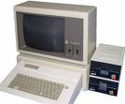](http://images.google.com/imgres?imgurl=http://www.solarnavigator.net/images/apple_IIe_original_personal_computer.jpg&imgrefurl=http://www.solarnavigator.net/computers.htm&usg=__F-UY_nWff8NJEX1iQECoWh4SgUk=&h=475&w=573&sz=25&hl=en&start=1&um=1&tbnid=wt-8H66DCcbYhM:&tbnh=111&tbnw=134&prev=/images?q%3Doriginal%2Bcomputer%26ndsp%3D20%26um%3D1%26hl%3Den%26rlz%3D1T4ADBF_enUS251US257%26sa%3DN)

Then: Huge Computers Now: _________________

What are some other inventions that have changed drastically over the years?

What are the differences in these inventions?

What areas could have an extreme increase in inventions/discoveries in the future?

What is something that you would like to see invented/discovered in your lifetime?

**Great Expectations Through Modifications:**

**Insulin Timeline**

**Insulin has 51 amino acids, 30 on one chain and 1 on the other.**

**The genetic code for insulin is found on the 11th chromosome.**

1. Insulin is discovered by Frederick Banting, Charles Best,

JJR Mcleod and James Collip.

1. Bovine and Porcine insulin given to humans

(Insulin is taken from the pancreas of slaughtered animals)

(Similar to humans but different compositions)

(Initially have several side effects)

**1974**- Bovine and Porcine insulin now has very few impurities

**1975**- Synthetic Insulin is created, but due to economic reasons, it is not undertaken.

**1978**- Biotech company, Genetech, in San Francisco genetically manipulates plasmid of *E.Coli* to create insulin with exact human sequence. (genetic modification and recombinant DNA)

**1980-** Recombinant DNA “human insulin” is tested on 17 volunteers.

**1982-** FDA approves Eli Lilly’s Humulin R and Humulin N, the first genetically modified insulin.

**Great Expectations Through Modifications:**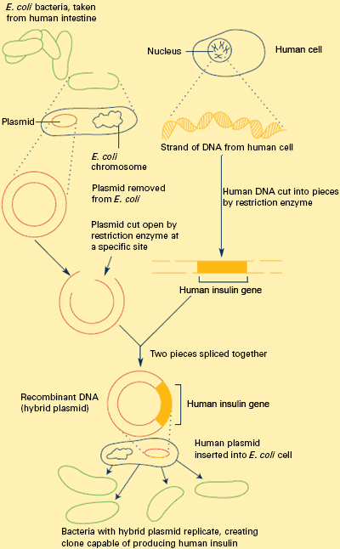

**Teacher Background**

**Examples of rDNA Process for Posters**

