Relationship Between pKa and Skin Irritation

Organic Chemistry Concept: pKa values
Organic Chemistry Concept Map: I.B.1.a. Stabilization of anions helps to explain pKa values and relative acidities of protons
Connects to other Organic Chemistry Concept Map Concepts: other concepts that this links to (where this can be used to build those concepts)
Toxicology Concept: Skin irritation prediction using pKa values.

What are skin irritants?

A substance that, while not corrosive, causes inflammation and damage to the skin surface at the epidermis of the skin due to a chemical reaction on the area being exposed. Effects of a skin irritant can be acute or chronic, and the effects do not involve a direct overactive immune system response like with an allergy. Instead, most skin irritation takes place on the erythema and epidermis layers of the human skin (Figure 1).

The epidermis is the outermost layer of skin. The dermis, which is located beneath the epidermis, is where there is connective tissue, hair follicles, and sweat glands. The deepest layer of the skin is the hypodermis, the subcutaneous tissue that is made of fat and connective tissue. Chemical skin irritation mainly takes place on the stratum corneum and stratum lucidum, a part of the epidermis, but other severe cases of skin irritation can permeate into the dermis region.

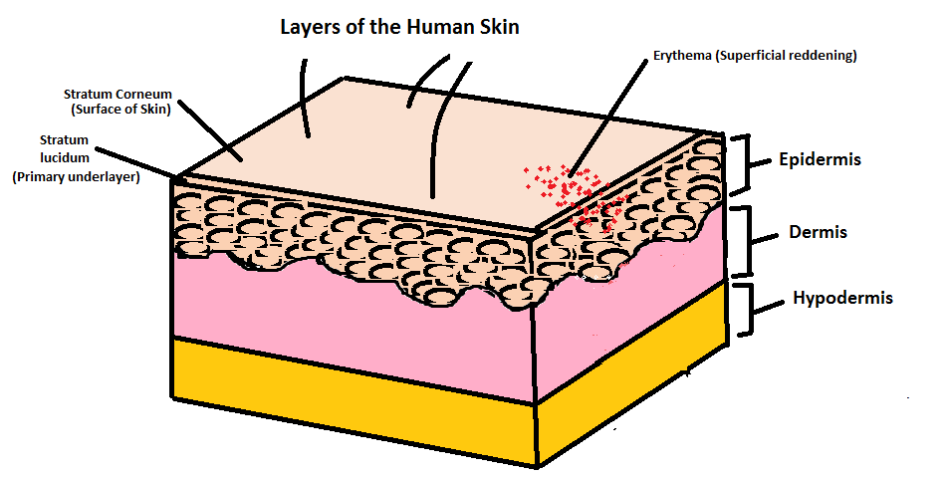
Figure 1: Layers of the human skin with Erythema skin irritation location.

Why is it important to predict skin irritation?
Toxicity testing of chemical mixtures are extremely important for avoiding regrettable substitution, however, they are very expensive and can take a long time to perform. Research has developed computational modeling tools for pKa determination, with some report correlations as high as 0.90 for toxicity experiments (Voutchkova et al. 2012). The pKa of a chemical can be a promising indicator of penetration for human skin in vitro and correlate with erythema, edema, and color meter readings.

In Berner et al., researchers found that the severity of irritation from reduced sets of organic acids and bases in humans correlated with the acid and base strengths measured by pKa. Bases with a pKa >8 and acids with pKa ≤ 4 have significant has been previously reported; pKa appears highly predictive of acute skin irritation for acids and bases in man.

- Find the structures of each compound and draw them in the corresponding box within the table below.
- Look up the pKa for each compound and make a prediction based on Berner et al.’s pKa value for skin irritants. Check to see if the prediction was correct based on the results of the reading.
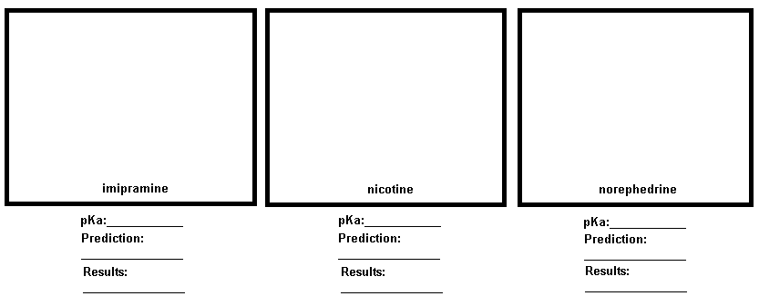
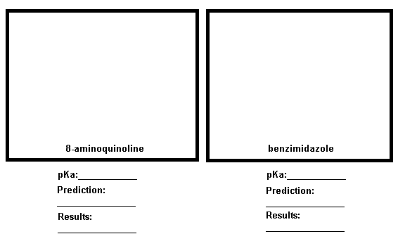

- Choose three acids and three bases outside of the reading; draw the structures; and then find out the pKa for each acid and base. Make a prediction of whether you think the compound could be a skin irritant.
- Look up the safety data sheet (SDS) for each acid and base to see if it is documented as a skin irritant.

Group Discussion

- Compare results in a small group. How far off were the predictions versus the results?

- How could skin pH play a role in the skin irritation and permeation of these chemicals?

- Do you think this type of exposure or risk of skin irritation manageable? Why or why not?

Literature Article/Reference:
- Berner, B., Wilson, D. R., Steffens, R.J., Mazzenga, G.C., Hinz, R., Guy, R.H., Maibach, H. I., “The Relationship between pKa and Skin Irritation for a Series of Basic Penetrants in Man”, Toxicol. Soc., 1990, 15(4), 760-766
- Berner, B., Wilson, D.R., Steffens, R.J., Mazzenga, G.C., Hinz, R., Guy, R.H., Maibach, H.I. (1990) The relationship between pKa and acute skin irritation for a series of basic penetrants in man. Fundamental and Applied Pharmacology 15, 760–766.
- Nangia, A., Anderson, P.H., Berner, B., Maibach, H.I. (1996). High dissociation constants (pKa) of basic permeants are associated with in vivo skin irritation in man. Contact Dermatitis i34, 237-242

https://www.osha.gov/dts/osta/otm/otm_ii/pdfs/otmii_chpt2_basicsofskin.pdf
In Vitro: performed or taking place in a test tube, culture dish, or elsewhere outside a living organism.
Erythema: superficial reddening of the skin, usually in patches, as a result of injury or irritation causing dilatation of the blood capillaries.
Edema: Swelling most common in the hands, arms, feet, ankles, and legs caused by excess fluid trapped in the body’s tissues.

